SCIENCE

States of matter: - Compare and group materials into liquid, solid and gas - Observe changes of state when heated and cooled and measure temperature - Evaporation and condensation in the water cycle.

ENGLISH

* Myths and Legends. Adventure Stories based on historical events and characters.
* Non-chronological reports.
* Reading comprehension.
* Present perfect verbs, pronouns, fronted adverbials, commas, adverbial phrases

HISTORY

* Development of language from Stone Age to Modern times.
* Different forms of communication – signals, gestures, words.
* Early writing implements, alphabets, picture books.

MATHS

* Dividing 3 digit numbers by 1 digit
* Word problems using multiplication and division.
* Drawing and interpreting graphs
* Understanding 100ths and finding equivalent fractions

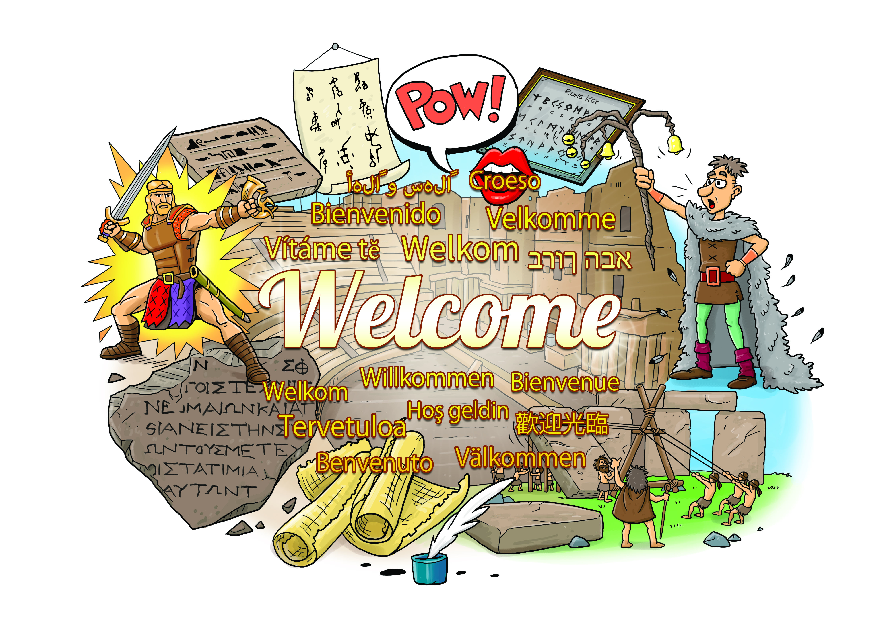

GEOGRAPHY

* Locate ancient civilizations on World Map.
* Locate home countries of the Romans, Saxons and Vikings on a map.

MFL (French)

Verbs, nouns and adjectives; sentence building, French towns, spelling common words

RE

Peace – what does peace mean and why it’s important; Jesus – why is Jesus inspirational to Christians

ART & DT

Draw and paint images of picture and script based languages.

COMPUTING

Desining toys using scratch

PE

Passing skills

Dodging skills

Applying to games such as basketball and netball

PSHE

Money Matters: Cost of Living; Budgeting; Charity Work.

Chocolate: Fairtrade: Real cost; Advertising.

MUSIC

Mamma Mia

Listening and appraising songs. Learning to sing and play instruments.