SCIENCE

* STEM challenge – Dam building
* Life Cycles – plant and animal
* Forces – air resistance, levers & pulleys.

ENGLISH

Main Texts – Dr Seuss, From the Mixed-up Files of Mrs Basil E. Frankweiler, Huckleberry Finn, Who was Martin Luther King Jr? Still I Rise (poem)

Biographies, similes, newspaper writing, making predictions, analysing writing styles, non-fiction.

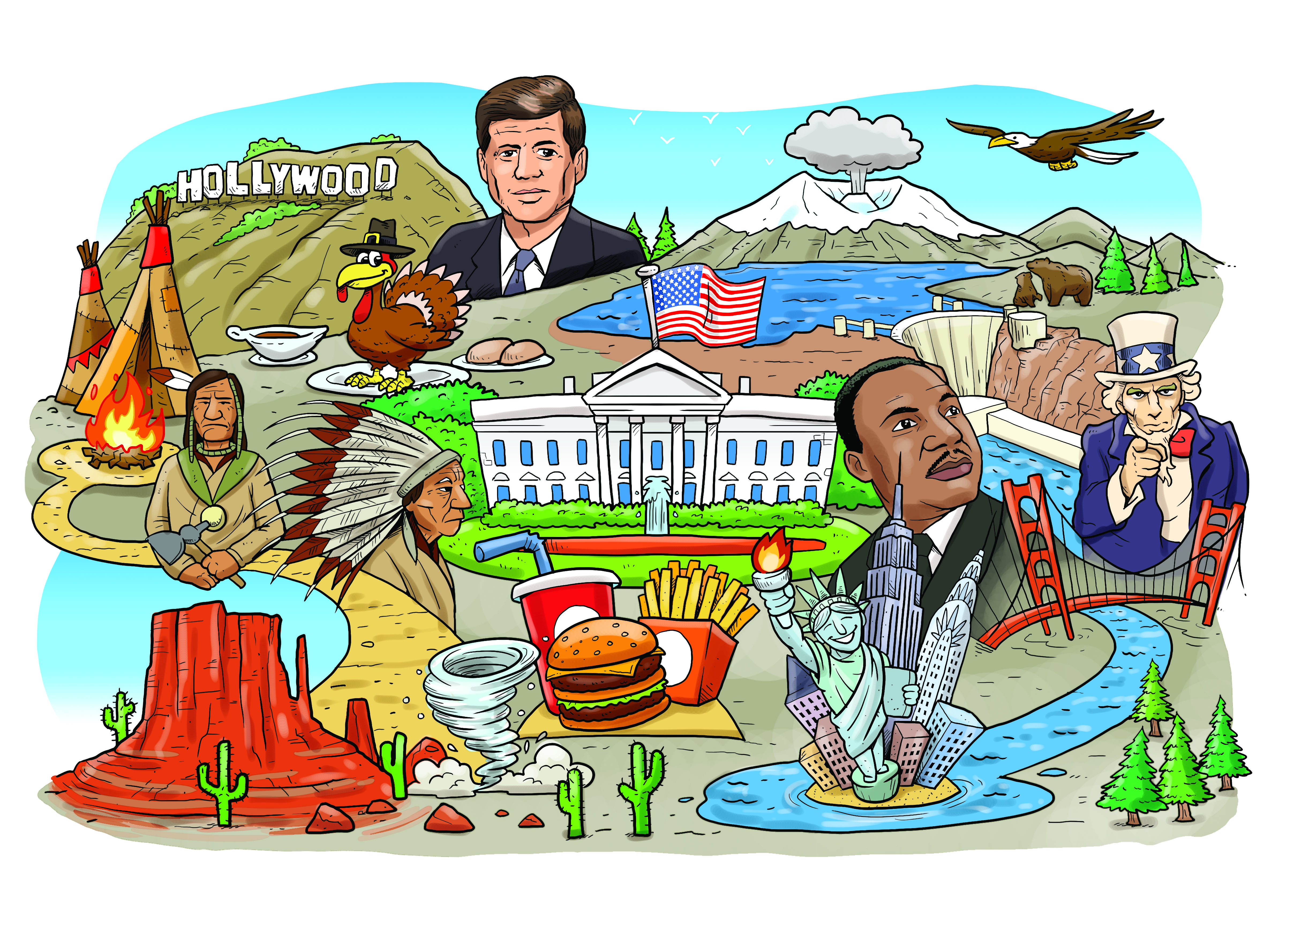

GEOGRAPHY

Geography of United States

• Rivers & Mountains

• States & cities

• Weather features

• Hoover Dam

HISTORY

History of significant American figures

* Martin Luther King
* Rosa Parks
* John F Kennedy

Thanksgiving

Native American people study

MATHS

* Numbers to 10 million
* Multiplication and division
* Fractions
* Decimals
* Measurements
* Word problems

MFL (FRENCH)

Times tables in French.

Songs & Stories

Sentence Structure

RE

Words of wisdom from Christianity, Sikhism and Islam.

ART & DT

Lichtenstein

New York Skyline

Georgia O’Keeffe

Dam designing & building

COMPUTING

Animations using iMovie.

Internet for research

PE

Real PE

Core strength

Scorpion Handball

Dodgeball

Throwing & catching skills

PSHE

Risk taking

Safe Spaces

Drugs

MUSIC

Selection of American Composers and performers