SCIENCE

**Earth & Space** – Explaining night & day, looking at models of the solar system and understand the different parts.

**Changing Materials** – evaporating, filtering, sieving, melting, dissolving, burgning, rusting…

ENGLISH

* Millions – Frank Coterill Boyce
* Street Child – Berlie Doherty

Ongoing reading comprehension skills, character studies, descriptive writing, tenses, higher level punctuation, writing for range of purposes, author’s ‘voice’.

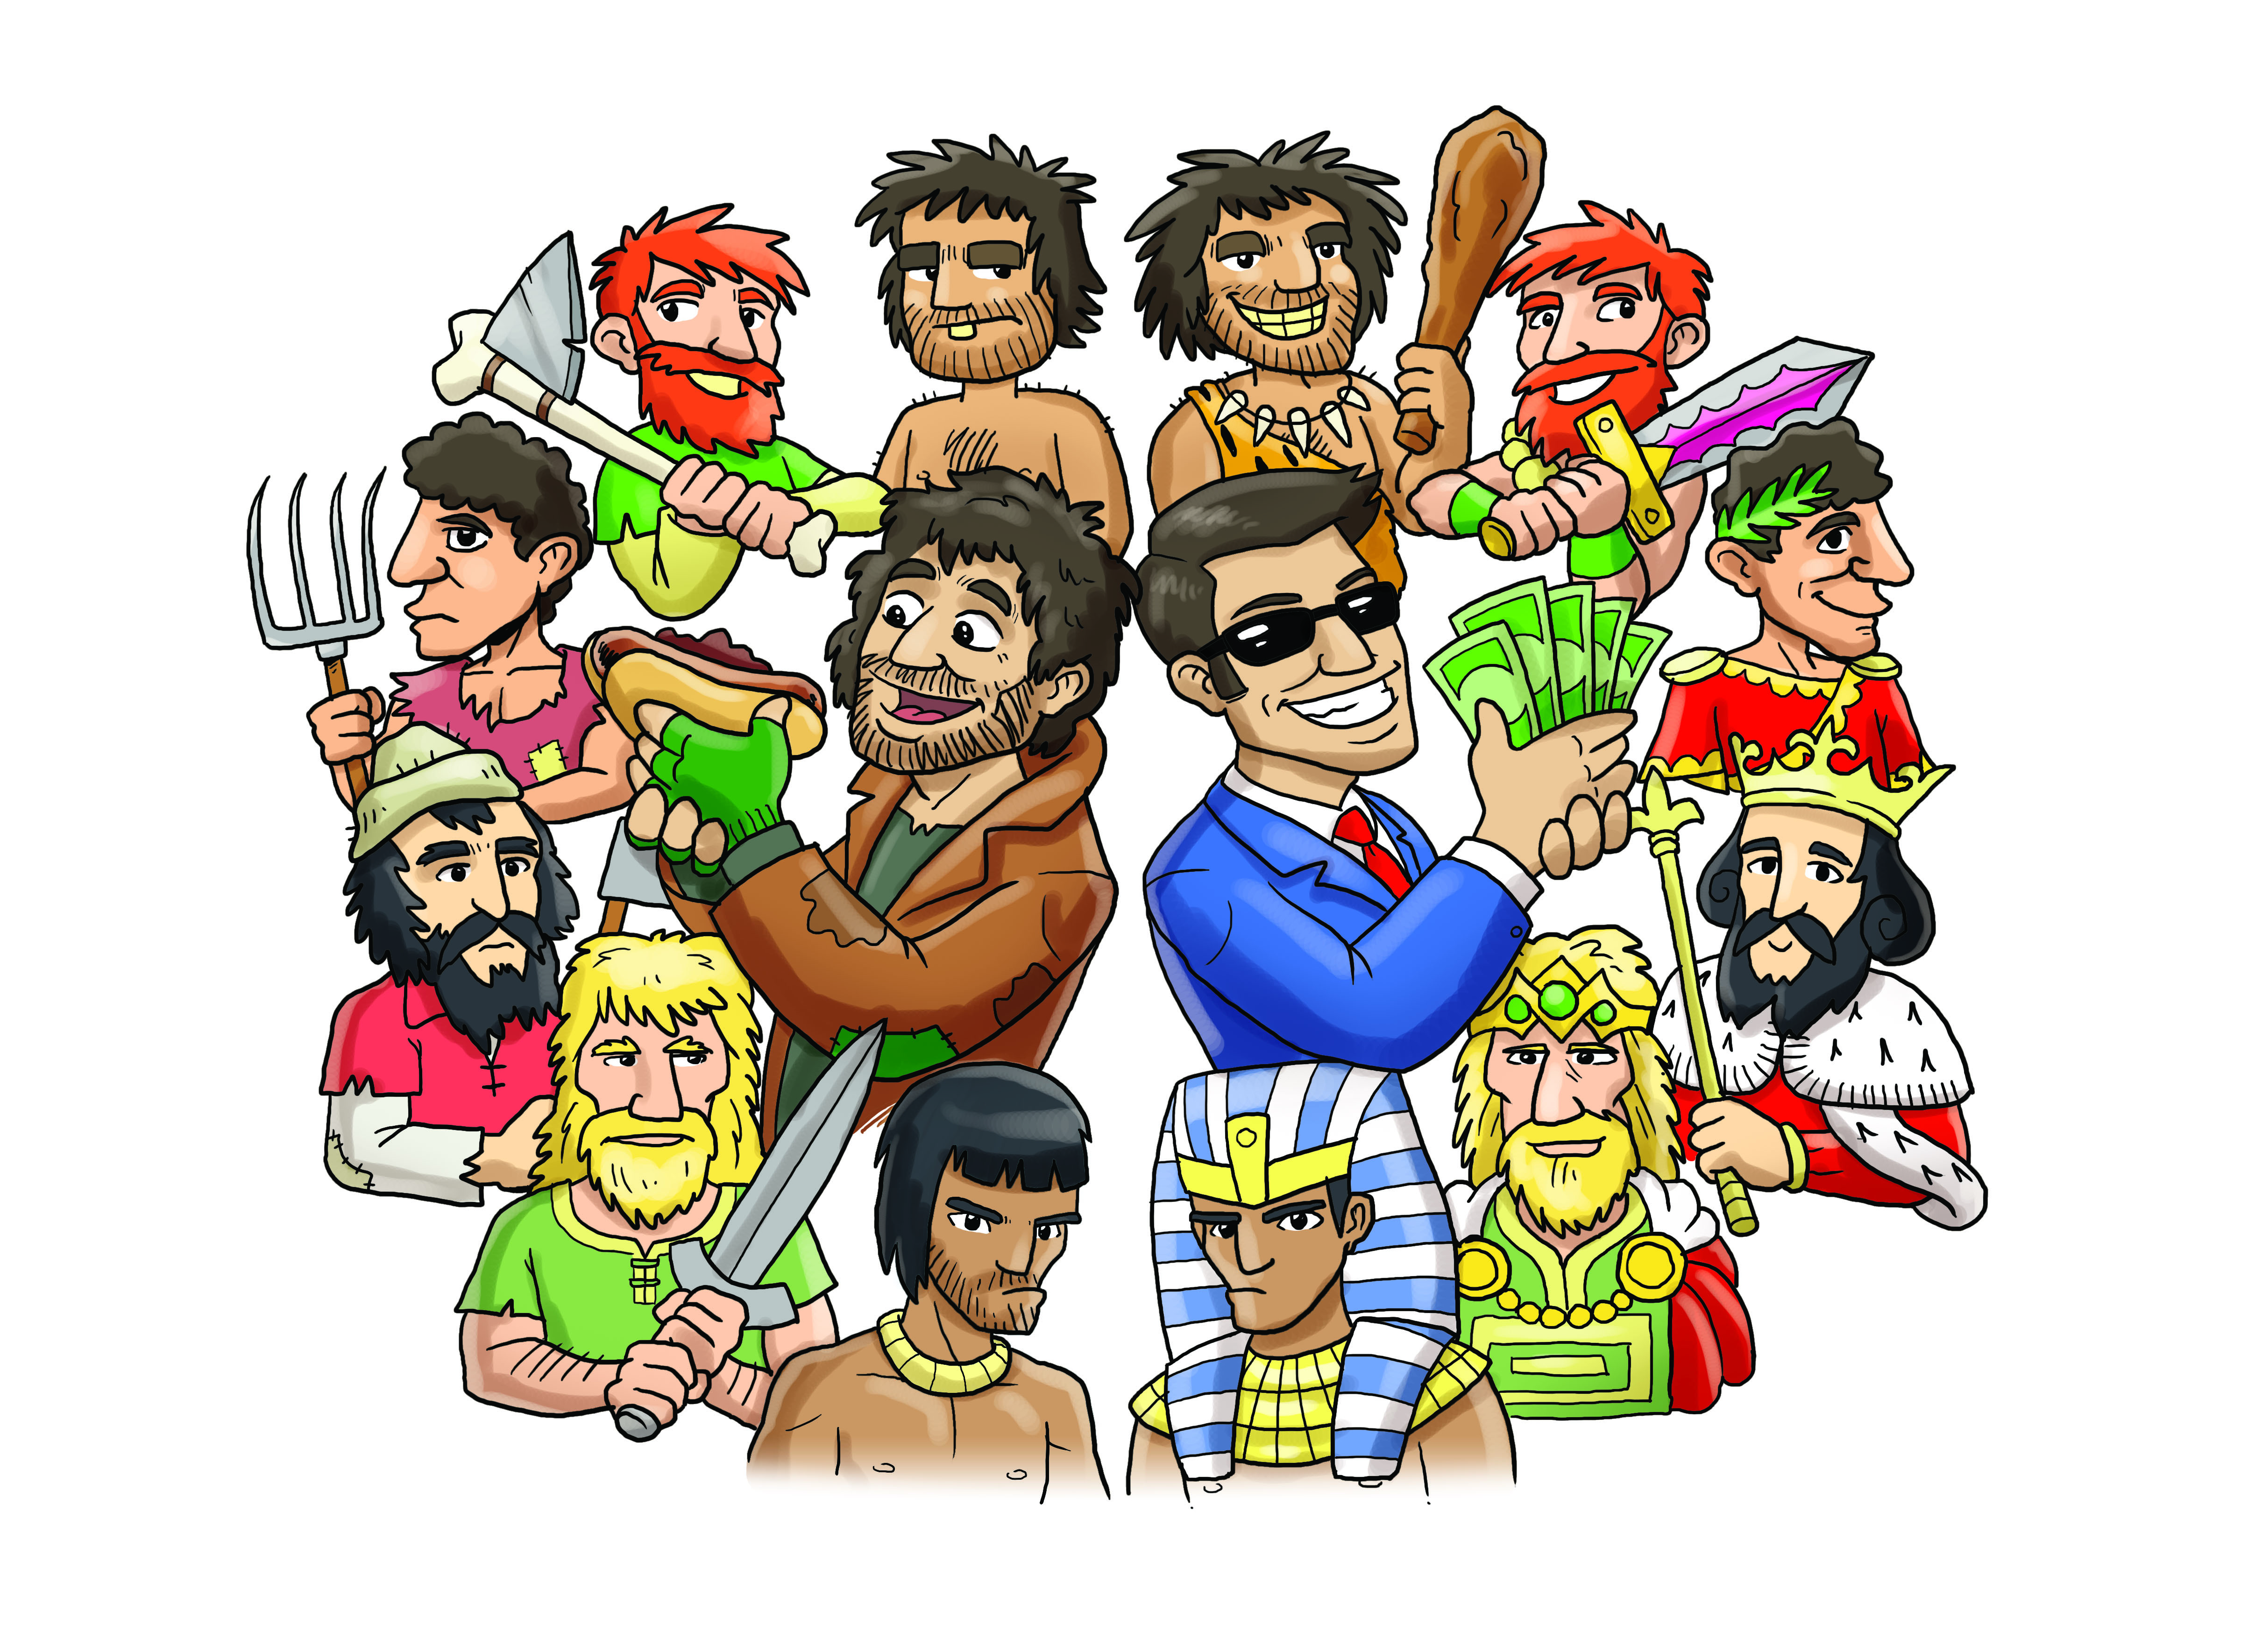

GEOGRAPHY

HISTORY

We will be looking at evidence of rich and poor in British & Ancient World History. How did society develop into status groups?

What lifestyle differences are there in clothes, houses, jewellery, burial, transport etc.?

MATHS

* Decimals
* Percentage
* Ratio
* Algebra
* Measurements

MFL (FRENCH)

RE

ART & DT

Drawing and painting jewellery, buildings and people throughout history

COMPUTING

PE

Team games

Tactics

Ball skills

Sports Hall athletics.

PSHE

Money – Why do we have it? How do we spend it? How can we earn it?

MUSIC

TBC