MUSIC

Bringing Us Together – A Disco song about friendship, peace, hope and unity.

ENGLISH

* Instructions and Explanations
* Adventure Stories
* Non-chronological reports
* Poetry – Shape & Expressing emotions
* Reading comprehension; Verb tenses; Commas, Paragraphs; Pronouns; Conjunctions.

MATHS

* Time
* Weight and Capacity
* Picture and Bar Graphs
* Fractions
* Angles
* Shapes
* Perimeter

SCIENCE

* Keeping Healthy
* Light and Shadows

The Arts

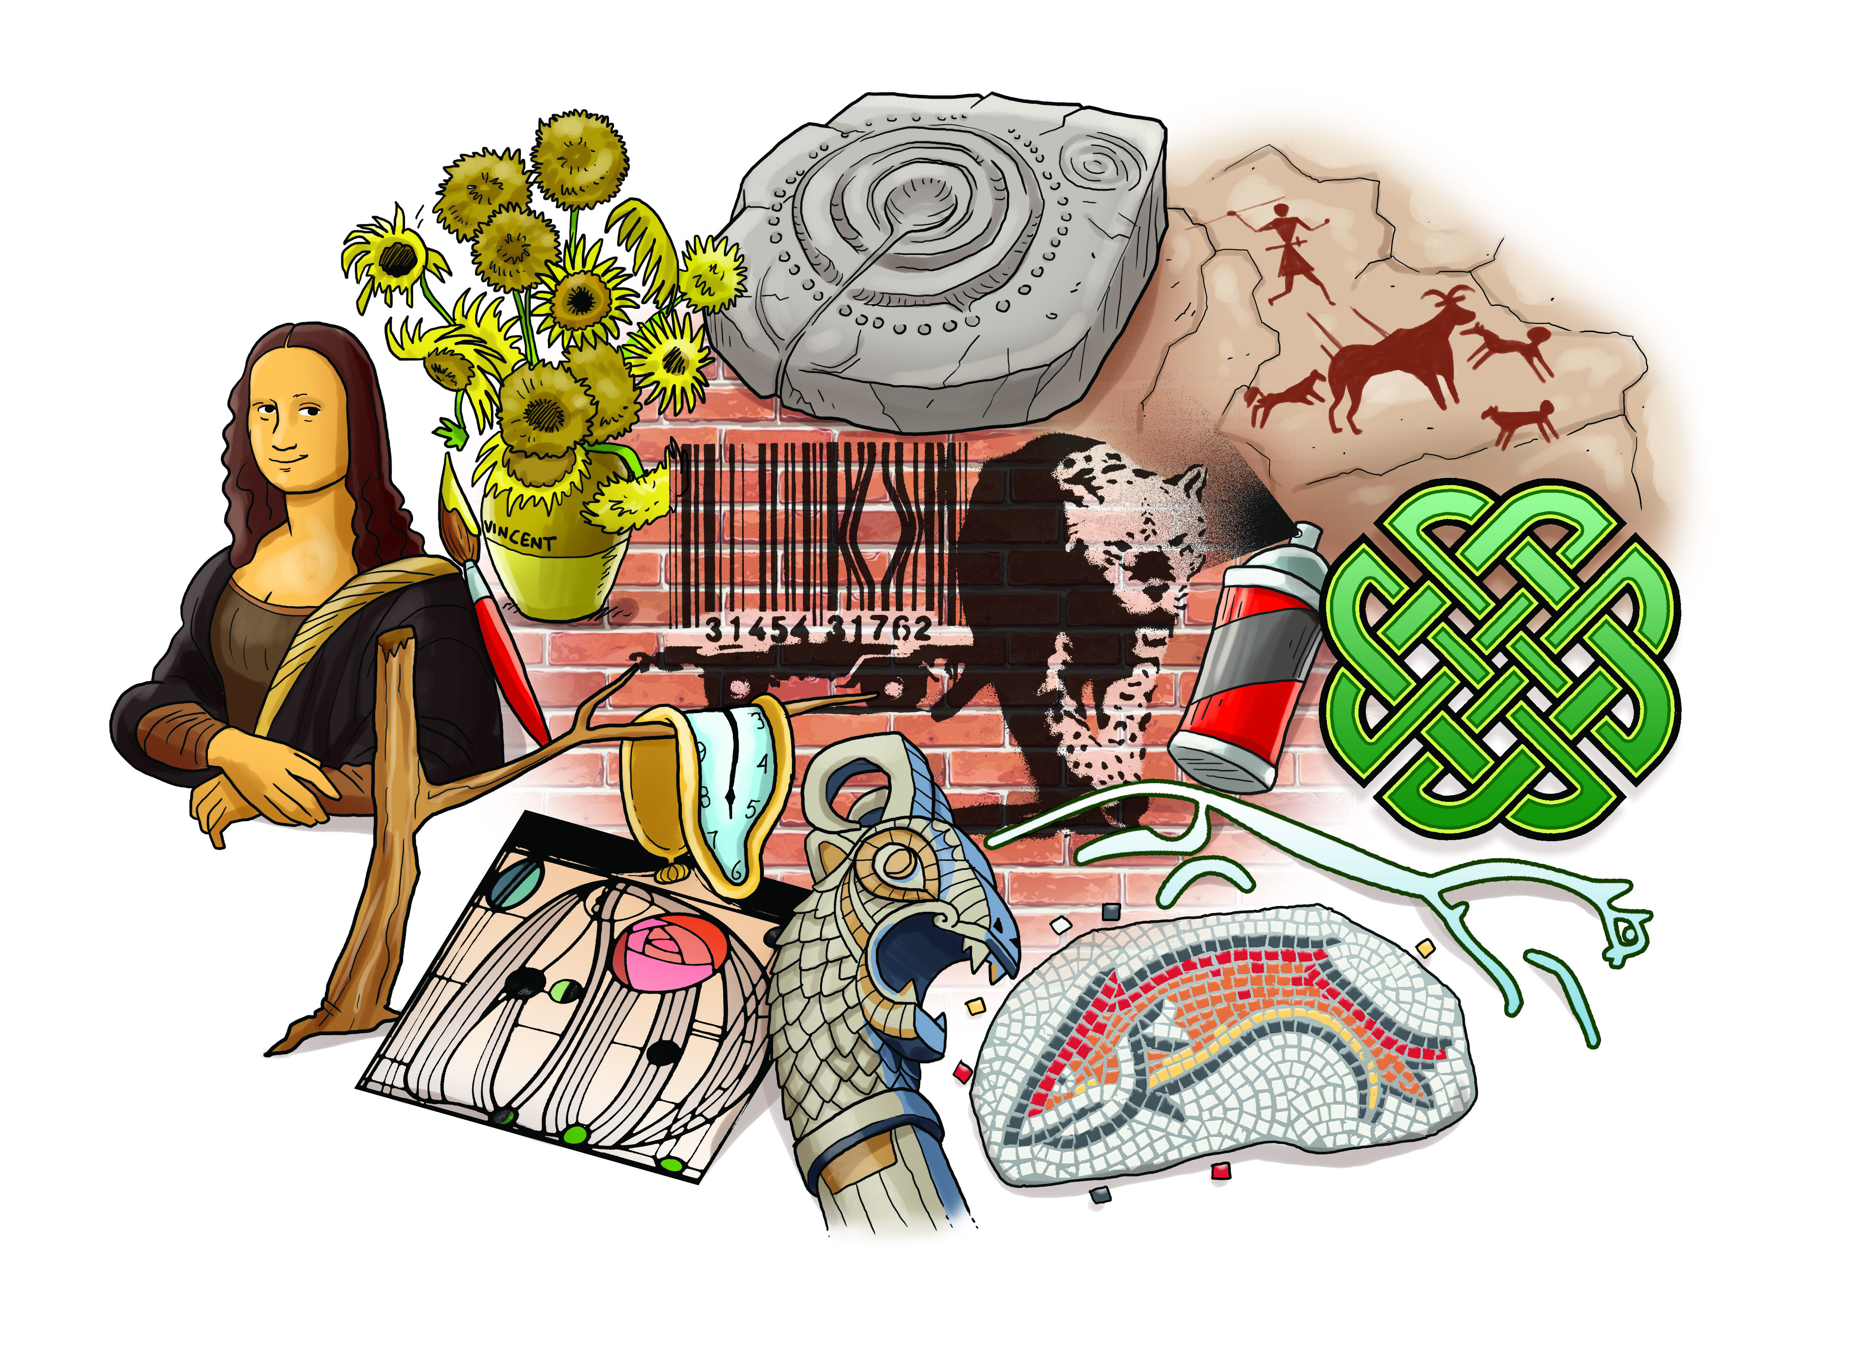

GEOGRAPHY

* Locating countries on maps.
* Our school and locality.

HISTORY

* World’s most recognised art works and artists
* Importance of the arts in society.
* Local Artists.
* Art of ancient civilisations.

MFL (French)

Finger rhymes.

Traditional songs.

Asking and answering questions.

Spelling

RE

The Five Pillars of Islam.

Spiritual ideas through the arts.

ART & DT

Developing paintings using different medium.

3D art – sculpture.

COMPUTING

Using I-pads to research and present information.

PE

Athletic Skills

Team games

Catching and Throwing

PSHE

People Around Us

Growing Up and Individuality