SCIENCE

Properties of Materials – which materials are best suited to which purpose? Thermal insulators & conductors.

Human Life Cycle

ENGLISH

Our main text this term will be The Amazing Tale of Ali Pasha, by Michael Foreman, but we will also be looking at a range of other texts set during times of Conflict. We will be looking at diary writing, interviewing, non-fiction, and a range of grammar.

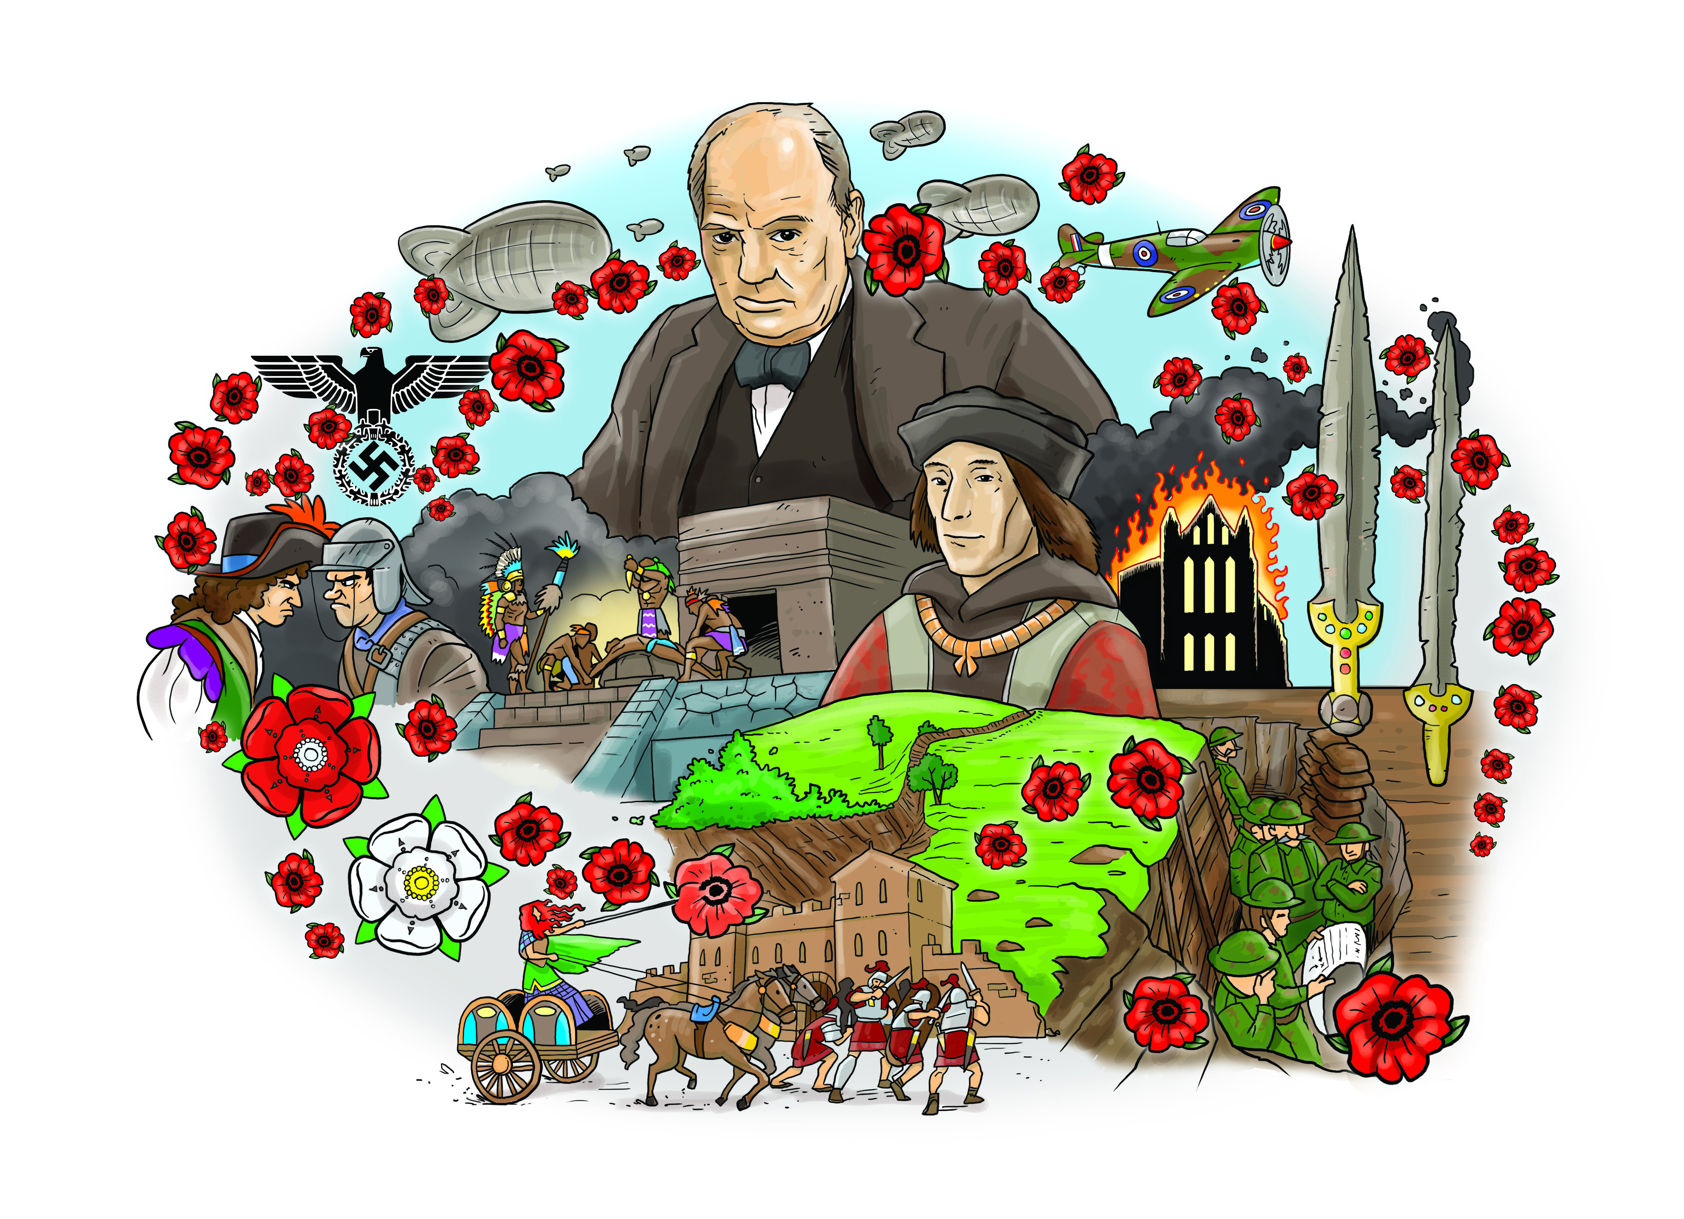

GEOGRAPHY

Geography related to World War One and World War Two.

Geographical patterns of invaders and settlers.

HISTORY

Conflict throughout the ages, spanning Iron Age Warriors to WWI and WWII. What are the reasons for conflict? How have battles been fought and what defences have been employed for protection?

MATHS

Y6 – Area & Perimeter, Angles, SATs Revision, Position and Movement.

Y5 - Position & Movement, Measurements, Roman Numerals, Area & Perimeter, Volume.

MFL (FRENCH)

Sentence Building

Asking Questions

RE

Beliefs & Actions in the World

How can following God bring freedom & justice?

ART & DT

Weaponry & armour

Flanders Field artwork

COMPUTING

Programming using Scratch to retell historical events.

PE

Outdoor games

Athletics

Dance

Swimming

PSHE

People Around Us

MUSIC

Music will be related to our KS2 production in Summer Term 2