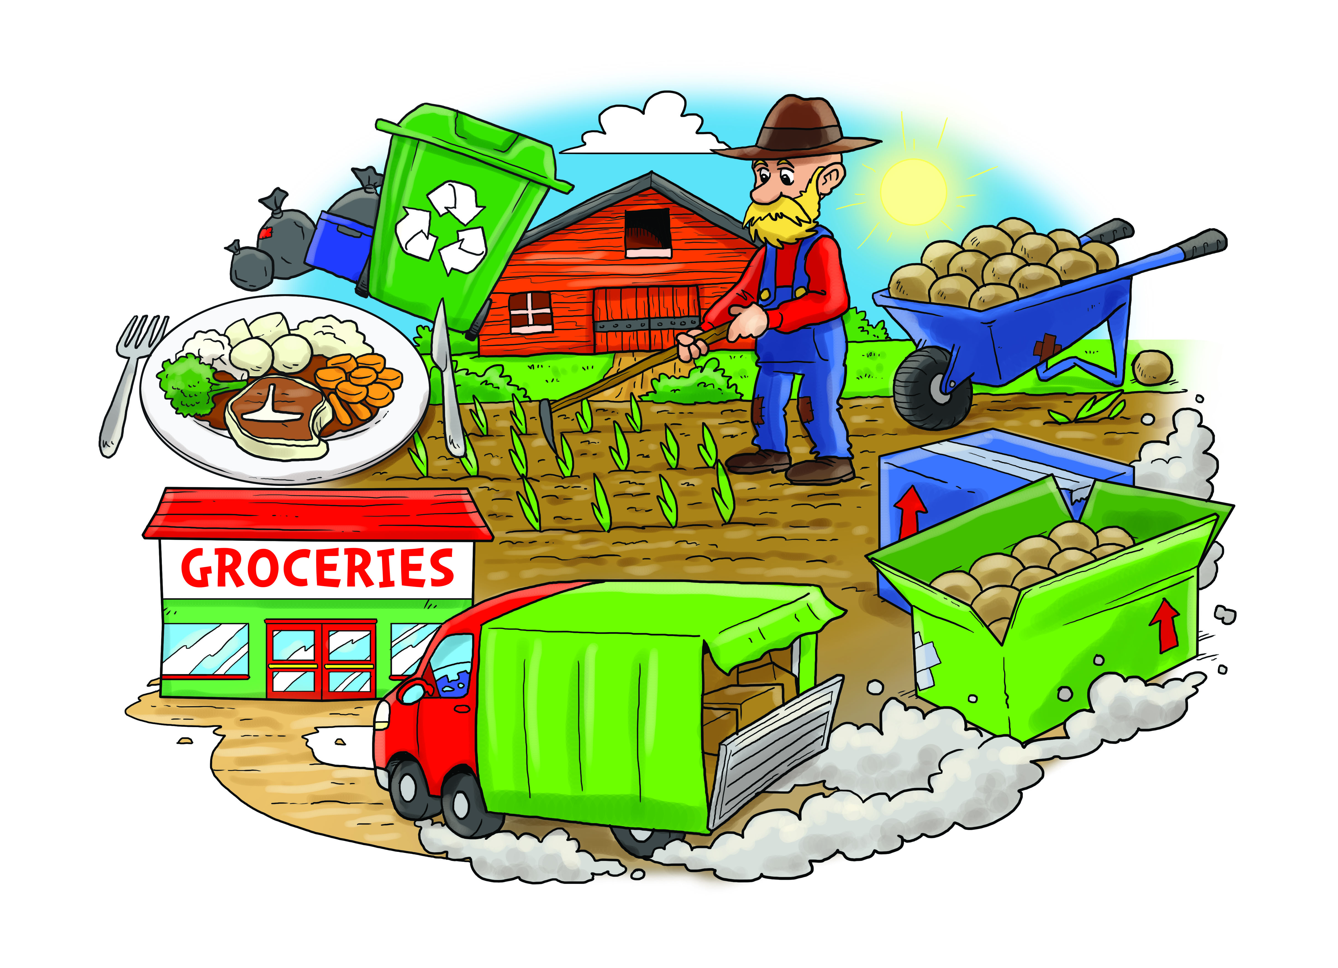

MUSIC

Your Imagination

* Listening
* Performing
* Composing

ENGLISH

* Recipe writing
* Instructions
* Persuasive writing
* Food poems
* Food related stories especially Traditional stories

MATHS

* Division
* Fractions
* Numbers to 100
* Time
* Money
* Volume and Capacity
* Mass
* Space

SCIENCE

Plants

* Identify, classify and describe basic parts of plants and trees.
* Observe and describe conditions needed for growth

Animals and humans

* Identify, classify and observe
* Look at growth, basic needs, exercise, food and hygiene.

From Field To Fork

GEOGRAPHY

* Understand where in the world food comes from.

RE

Questions about God

ART & DT

Looking at food in art

Designing packaging

Still Life

COMPUTING

Creating our own TV chef videos

PE

Coordination and agility using small apparatus.

PSHE

Zippy’s Friends