MATHS

* Time
* Decimals
* Money
* Mass, length and volume
* Area and perimeter
* Geometry
* Roman Numerals

SCIENCE

Sound: - identify how sounds are made

* Recognise how sound travels

Electricity: - recognise appliances which run on electricity

* Understand an electrical circuit

ENGLISH

* Persuasive writing linking to India
* Adventure based stories
* Writing non-chronological reports
* Poetry

HISTORY

* World’s most recognised art works and artists
* Importance of the arts in society
* Local artists
* Art of ancient civilisation

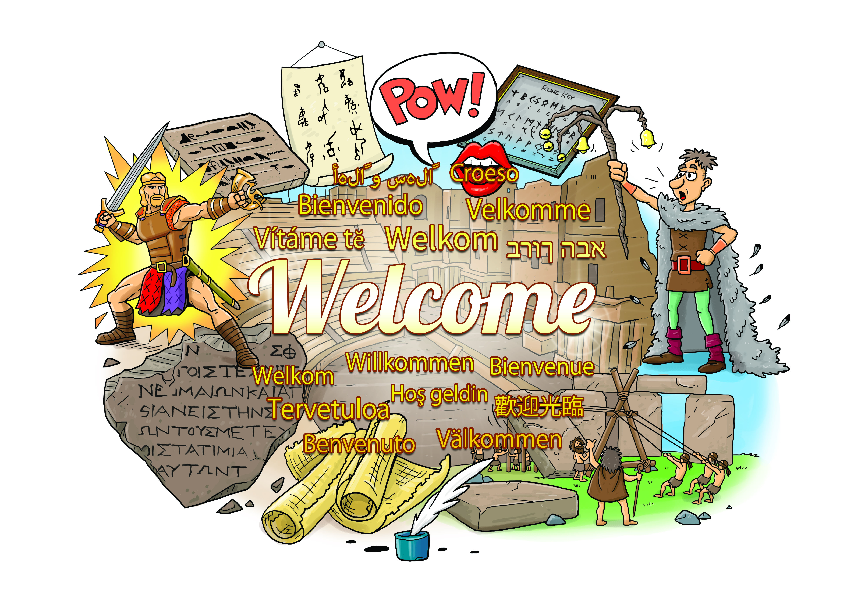

GEOGRAPHY

* Locating countries on maps
* Our school and locality

MFL (French)

Verbs, nouns and adjectives; sentence building, French towns, spelling common words

RE

Values - what are important values to have

Christianity in Action

ART & DT

Developing paitingins using different medium

3D art - sculpture

COMPUTING

Using iPads for programming

PE

Dance

Gymnastics

Games such as tennis and roundres

PSHE

People around us

Growing up and individuality

MUSIC

Lean on Me

Listening and appraising songs. Learning to sing and play instruments.