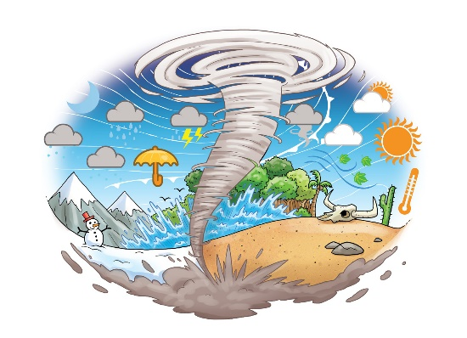

**COMPUTING**

Using programmeable toys.

Filming the steps of a recipe.

**MUSIC**

Hey You – Hip Hop music

Rhythm in the way we walk-Reggae music

Christmas songs

Extreme WEATHER

**PSHE**

Class Charter

Protective Behaviours

All About Me

**PE**

* Floor movement patterns
* Static balances
* Invasion games - rugby

**ART & DT**

* Make and use weather instruments.
* Seasonal art by significant artists such as Monet.
* Designing flood proof houses.

**RE**

The family in Judaism

Why does Christmas matter to Christians?

**HISTORY**

Whole school special focus event:

* WWI
* Pattishall 100 years ago

**ENGLISH**

* Daily RWI reading sessions • Daily handwriting
* Sharing books related to our topic.
* Learning about what makes a sentence.
* Writing sentences independently using correct punctuation.
* Beginning to join sentences to form short narratives.
* Reading poetry and writing our own versions
* Using adjectives for description
* Beginning to become familiar with some of the key grammatical terms (noun, verb, adjective)

**MATHS**

* Numbers to 10/20
* Number bonds
* Addition and subtraction within 10/20
* Positional language

**SCIENCE**

* Learn how the weather is measured and recorded.
* Observe seasonal changes.

**GEOGRAPHY**

* Learn about some of the amazing weather around the world such as tornadoes, hot deserts, floods and monsoons.
* Investigate weather patterns and climate around the world and in relation to the equator.