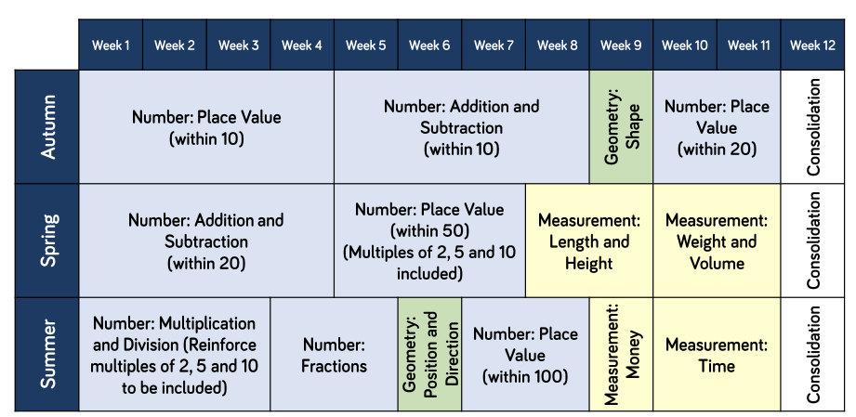
Year 1: Maths Long Term Plan

