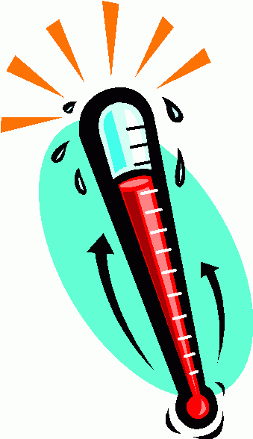
When KID-MERGENCIES Happen

Tips for parents on when to call

your pediatrician or go to the ER

GO TO THE ER:
- Your child is less than 2 months old and has a fever. Fever is defined as a temperature 100.4 degrees Fahrenheit (38 degrees Celsius) or higher.
- You suspect your child has a broken bone, particularly if there is visible swelling or unevenness and bumps in the injured area — a sign that the broken bone is misaligned.
- Your child hits his head and appears to pass out or lose consciousness for a few seconds
- Your child has had a seizure
- Your child has signs of dehydration, such as very dry lips and mouth, absence of urination for more than 12 hours, lethargy and confusion
- Your child has heavy, fast breathing, is gasping for air or manages to utter only two or three words before taking a breath.
CALL YOUR PEDIATRICIAN:
- Your child has a sore throat, fever, cough, runny nose, congestion, body aches, or chills
- Your child has a minor cut
- Your child has a minor injury such as a sprain or strain or head injury without loss of consciousness
- Your child has an earache or sinus pain
- You child may be having an asthma flare-up
- Your child has nausea, vomiting, or diarrhea
- Your child has symptoms of a localized infection—redness, swelling, warm to touch

Still unsure? Call us at (828) 322-2550 (anytime of the day) to be assisted in the right direction.

