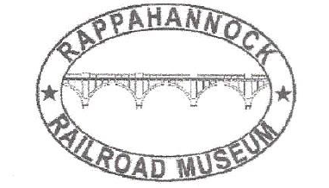

Membership Application/Renewal Form

Rappahannock Railroad Museum, Inc.

Please type or print legibly

New Renewal if renewal Updated information Y N

Name:

Street Address:

City: State: Zip:

Phone:

Email:

Family Membership(S) if Joining:

Membership

Regular $15.00

Family $1.00 each

Museum Donation

Total:

Please mail to the following address or hand in at meeting.

Rappahannock Railroad Museum, Inc.
P.O. Box 9088
Fredericksburg, VA. 22403-9088

I agree to be a member in good standing and follow safety rules of
the Rappahannock Railroad Museum, Inc.
Membership dues for January 1, 2021 to December 31, 2021

Signature: Date:

