STANISKY & COMPANY
A PROFESSIONAL CORPORATION
CERTIFIED PUBLIC ACCOUNTANTS

We Provide Complete Payroll Services
Our comprehensive, full service, payroll solution
Simply send your payroll data and we do the rest
We process your federal, state and local
payroll taxes for you
Complete Payroll helps you escape time-consuming payroll
headaches and tedious paperwork, giving you more time to
focus on what you do best:
running your business.

The Complete Payroll Solution
Here's What You Get Every Payroll Period:
Payrolls ready for signature and distribution
Employee earnings statement(s)
Completed payroll tax forms ready for filing
Timely and accurate notifications of tax liabilities and deposits



Member
American Institute of Certified Public Accountants

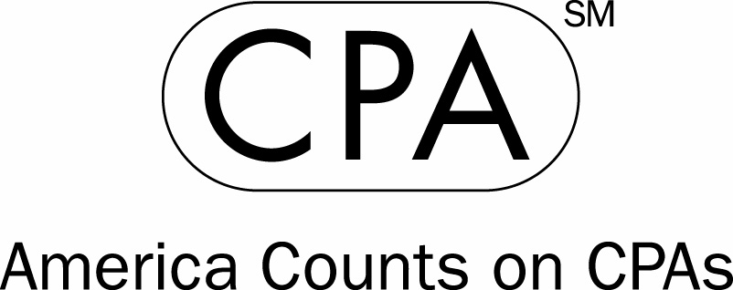

2550 LEECHBURG ROAD
LOWER BURRELL, PA 15068
P| (724) 339-7340 F| (724) 339-3040
www.staniskycpa.com

