

Lift Up Atlanta’s mission is to provide the homeless and low income families in the metro Atlanta area with safe housing, food, clothing, educational services and more designed to help them meet their basic needs, to support their education, and to empower them to reach self sufficiency.

This holiday season Lift Up Atlanta has a mission to feed at least 500 families in need and provide 3-5 new toys / gifts to 1000 children in need.

This will happen with your help.

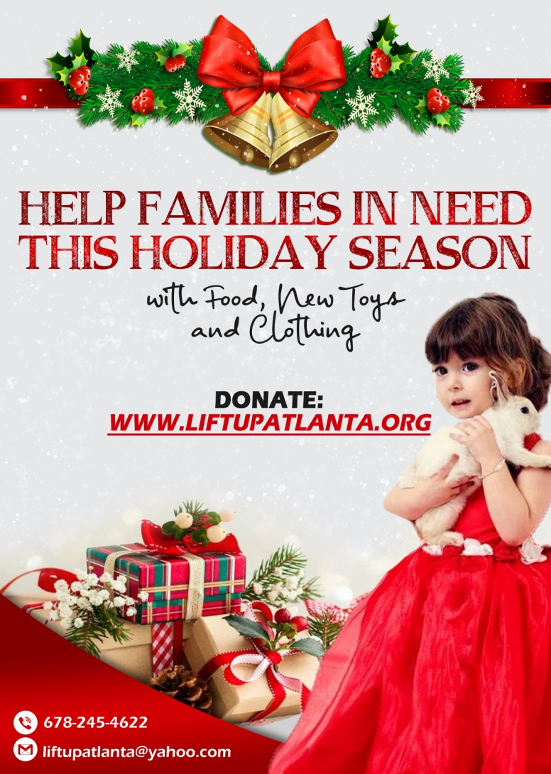

|  |  |  |  |
| --- | --- | --- | --- |
| Platinum Level Sponsor  $5000 | Gold Level Sponsor  $2500 | Silver Level Sponsor  $1000 | Bronze Level Sponsor  $500 |
| Sponsorship will help at least 10 children in need with 3-5 new toys/gifts or 4 families in need with new toys, clothing and gifts.  Food baskets given to 10 families in need  Promotion as platinum level sponsor on social media – includes logo and hyperlink on website. Billboard, local advertising and social media promotion included | Sponsorship will help at least 5 children in need with 3-5 new toys/gifts or 2 families in need with new toys, clothing and gifts  Food baskets given to 5 families in need  Promotion as gold level sponsor on social media – includes logo and hyperlink on website. Local advertising and social media promotion included. | Sponsorship will help at least 2 children in need with 3-5 new toys / gifts or 1 family in need with new toys, clothing and gifts  Food baskets given to 2 families in need  Promotion as silver level sponsor on social media – includes logo and hyperlink on website Social media promotion | Sponsorship will help at least 1 child in need with 3-5 new toys / gifts  Provide food basket to family in need  Mention on website |

Your company will be promoted to thousands of potential customers and the goodwill to our families in need is priceless.

Thank you in advance for your time and consideration.