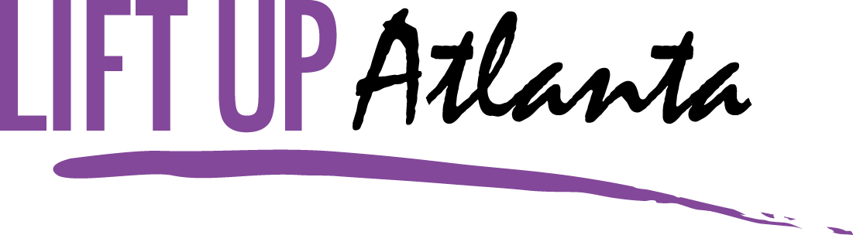

Lift Up Atlanta’s mission is to provide the homeless and low income families in the metro Atlanta area with safe housing, food, clothing, educational services and more designed to help them meet their basic needs, to support their education, and to empower them to reach self sufficiency.

Lift Up Atlanta has ONE major fundraiser and that is the Summer Fun Festival. Everything from the petting zoo to the live entertainment. There is something for everyone.

This fundraiser benefits all our families in need and helps provide food, clothing, household goods, school supplies, school uniforms, new toys and much more.

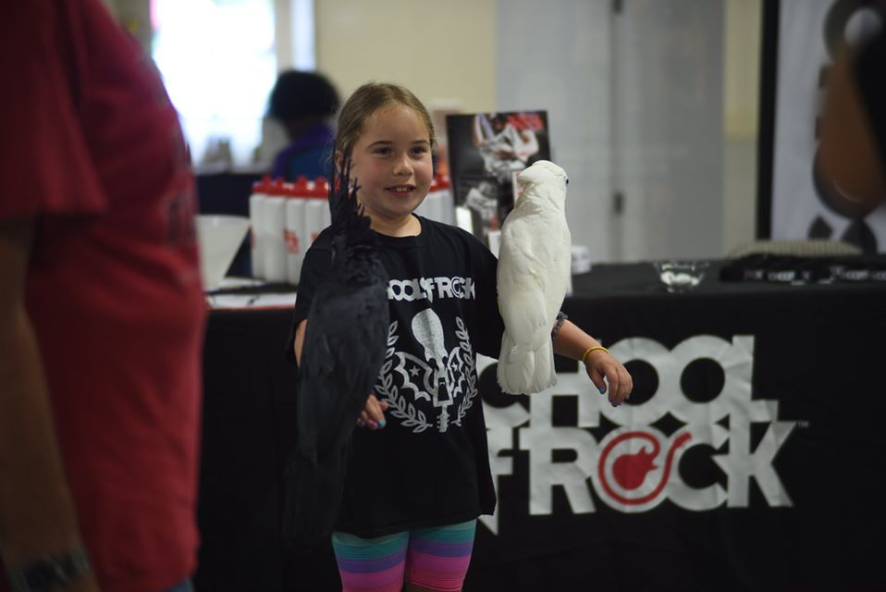



**Founded in September 2011 by Rosalind Garner, Lift Up Atlanta is designed to meet the basic needs of the homeless and low income families which includes food, clothing, hygiene needs, educational services, empowerment workshops, school supplies and much more. It seeks to fill the gaps in the current provision of services for the homeless and needy families.**

Lift Up Atlanta provides several services to local homeless shelters, other nonprofit organizations and the homeless and needy families directly. The programs include:

* **Basic Care Program** – Lift Up Atlanta will provide basic necessities for residents of local shelters, the homeless/needy families such as hygiene items (toothpaste, deodorant etc). This will be provided in easy to carry bags. The agency will also provide clothing for every day wear and dress for success wear for job interviews. We will provide blessing bags filled with packaged snacks and water to carry during any day.
* **Backpack/School Supply Program** – Every summer, Lift Up Atlanta will provide backpacks filled with school supplies to needy children.
* **Life Skills/Empowerment program** – Volunteers will be recruited to provide life skills classes that provide information about credit, budgeting, resumes, interviews etc. This program includes free computer training classes and our women’s empowerment program. This program is designed to give the clients skills to get jobs and basic life skills.
* **Food Drives** – Lift Up Atlanta will continuously build a food pantry to provide food to the local homeless shelters and food banks. We will also provide Easter, summer, Thanksgiving and Christmas baskets.
* **Annual Christmas Toy Drive** – Lift Up Atlanta will help provide new toys to needy children for the holiday season.



**Lift Up Atlanta**

**Board Members**

President

Deborah Banks

Secretary

Althea Miller

Treasurer

Gladys Branch

Volunteers Committee

Holly Yan

Mark Cruz

Tawanna Kelley

Founder/Executive Director

Rosalind Garner

**Partner with Lift Up Atlanta’s 2022 Summer Fun Festival**

**Estimate Attendance - 5000**

The biggest fundraiser for Lift Up Atlanta of the year. The goal is to raise funds for our community programs

This is also well promoted through local publications, billboards, social media, internet banner ads





**Business Sponsorship Levels**

**Platinum Level Sponsor $10,000**

Inclusion on billboard advertisement

10’ x 10’ tent and booth space on site for company marketing & promotion

Dedicated social media posting, including link to business

Exclusive branding sponsorship of festival feature

(i.e. kid fun zone, main stage etc)

Recognition as Platinum Sponsor in all advertising (all included levels)

Recognition during all on stage announcements

Full page ad space in event guide

**Gold Level Sponsor** $5000

Includes everything from silver level sponsorship

Plus – inclusion in all print advertising

10’ x 10’ tent and booth space on site for company marketing & promotion

Dedicated social media posting, including link to business

Recognition as Gold Level Sponsor in related postings

Recognition during all on stage announcement

½ page ad space in event guide

**Silver Level Sponsor** **$2500**

Includes everything from bronze level sponsorship

Plus – inclusion in all social media promotion

10’ x 10’ tent and booth space on sit for company marketing & promotion

Dedicated social media posting, including link to business

Recognition as Silver Level Sponsor in related postings

¼ page ad space in event guide

**Bronze Level Sponsor** **$1000**

Includes logo / hyper link on website

10’ x 10’ tent and booth space on sit for company marketing & promotion

1/8 ad space in event guide

**Friend of the Festival Sponsor** **$500**

Includes logo/mention/hyperlink on website



Box 1745, Hampton, GA 30228

[www.liftupatlanta.org](http://www.liftupatlanta.org)

[luasponsors@yahoo.com](mailto:luasponsors@yahoo.com)

Corporate Sponsor Pledge Form

Date ___________________________

Contact Name __________________________________________________________________

Company Name _________________________________________________________________

Address ________________________________________________________________________

_______________________________________________________________________________

Phone Number __________________________________________________________________

Email __________________________________________________________________________

|  |  |  |  |  |
| --- | --- | --- | --- | --- |
| Sponsorship Levels | Platinum  $10000 | Gold  $5000 | Silver Level  $2500 | Bronze Level  $1000 |
|  |  |  |  |  |
| Summer Fun  Festival |  |  |  |  |

Friends of the Festival Sponsorship $500 ____________



**For supporting Lift Up Atlanta**

**www.liftupatlanta.org**