
MC-May 17^{th –} 23rd 2026

Sunday, May 17th
HAPPY BIRTHDAY LINDA
8:30 Breakfast
10:00 Mass
12:00 Lunch/break
2:30 Movie: TBA
7:00 Andre Rieu

Tuesday, May 19th
8:30 Breakfast
10:30 Exercise/Yoga
12:00 Lunch/break
2:30 Snack/Bingo
7:00 The Golden Girls

Thursday, May 21st
8:30 Breakfast
10:30 Activity W/Ryan (Patriot)
12:00 Lunch/break
2:30 Snack/Bingo
4:00 Mass
7:00 The Andy Griffith Show

Saturday, May 23rd
8:30 Breakfast
10:30 Browsing/The price is right
12:00 Lunch/Break
2:30 Snack/Coloring
7:00 The Lawrence Show


Monday, May 18th
HAPPY BIRTHDAY SHIRLEY WISE
8:30 Breakfast
10:30 Sing Alone with Sr. Marie
12:00 Lunch/Break
2:30 Snack/Birthday Party (Linda & Shirley)
7:00 AGT

Wednesday, May 20th
Hair Stylist Day
8:30 Breakfast
10:30 Roundtable with Sr. Marie
12:00 Lunch/Break
2:30 Snack/Pamper Nails
7:00 Leave It to Beaver

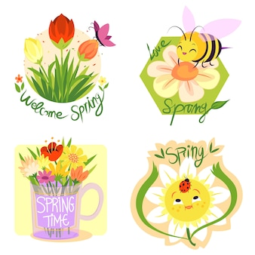
Friday, May 22nd
8:30 Breakfast
10:30 Memorial Parade
12:00 Lunch/Break
2:30 Snack/Activity W/Mary (Patriot)
7:00 I Love Lucy

