**The Deadliest Fires in U.S. History: Lessons Learned from Worcester Cold Storage and Warehouse Fire**

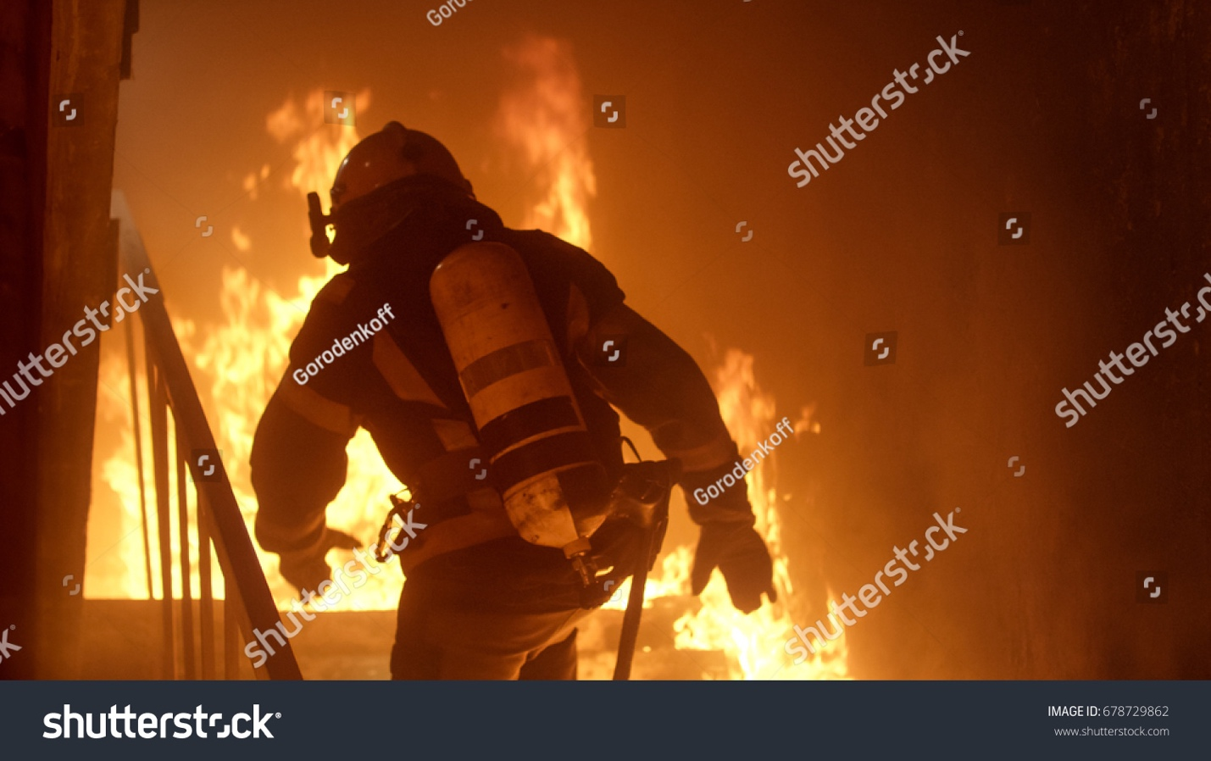

Source: [Shutterstock](https://www.shutterstock.com/image-photo/brave-firefighter-runs-stairs-raging-fire-678729862)

**What made the Worcester and the cold storage facility unique offers lessons about large, abandoned structures**

Many of the [deadliest fires in US history](https://www.qrfs.com/blog/236-the-deadliest-fires-in-us-history-lessons-learned-part-1/) occurred before US fire safety recommendations were recorded or codified. In 1871, the [Great Chicago fire](https://en.wikipedia.org/wiki/Great_Chicago_Fire) burned over three square miles of the city, killing 300 before burning itself out. At the time, the [National Fire Protection Association (NFPA)](https://www.nfpa.org/) did not exist.

By the time the [Iriquois Theatre fire](https://www.smithsonianmag.com/history/how-theater-blaze-killed-hundreds-forever-changed-way-we-approach-fire-safety-180969315/) killed over 600 patrons in 1903, the NFPA was a fledgling organization just [seven years old](https://www.nfpa.org/About-NFPA/NFPA-overview/History-of-NFPA). It was no coincidence that one of first [committees](https://www.nfpa.org/-/media/Files/Codes-and-standards/Standards-development-process/HistoryNFPACodesStandards.ashx?la=en) they formed (in 1904) was “Theatre Construction and Protection.”

Eight years after the NFPA began writing fire safety code--including conducting investigations after major incidents--the Triangle Shirt Waist fire forced workers to jump from windows and killed 146 (mostly women and girls) while factory owners [had ignored fire safety recommendations.](https://www.osha.gov/oas/trianglefactoryfire.html)

Horrific events like these early 20th century fires are less frequent today due largely to the lessons of tragedies transformed into improved fire safety code. Better NFPA code has informed changes in how buildings are designed and [building materials](https://home.howstuffworks.com/home-improvement/construction/materials/5-fire-resistant-building-materials.htm) are selected , as well as recommending the use of effective fire-suppression systems like [sprinklers](https://www.qrfs.com/blog/284-guide-to-dry-sprinkler-systems-part-11-annual-dry-sprinkler-tests/).

Fires that burn unabated and kill multiple firefighters or civilians seem unthinkable in modern times. The Worcester Cold Storage Fire, however, harkened back to earlier times—it happened in a building almost a hundred years old.

The abandoned Worcester Warehouse and Cold Storage Company, built in 1905, was the stuff of firefighter’s nightmares: maze-like passageways, rows of identical rooms with identical flush-mounted handles, highly flammable [insulating materials](https://www.nfpa.org/News-and-Research/Publications-and-media/NFPA-Journal/2019/March-April-2019/Features/Cold-Storage-Safety), and a vast interior with few vertical escape routes.

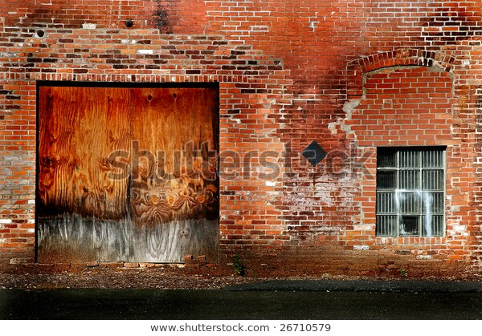

*Vacant buildings pose numerous challenges for firefighters, from lack of light to minimal exits and entrances. Source:* [Shutterstock](https://www.shutterstock.com/image-photo/detail-old-brick-warehouse-26710579)

After the fire, reports circulated that Worcester fireman were by turns [concerned](https://www.esquire.com/lifestyle/a1098/perfect-fire-0700/) and terrified about ever having to fight a fire inside.

Is fire prevention, firefighting or training firefighters part of your job? Consider our selection of tools to aid in navigation, including [Night Saver](https://www.qrfs.com/150-45-72-m-night-saver-rope-glow-in-the-dark-rope-polyproylene) glow-in-the-dark rope for escape. The Night Saver is a breadcrumb trail out of the darkness, aids in all low light conditions, and can be used as versatile guide rope.. Are you in the market for [life safety rope](https://www.qrfs.com/blog/171-life-safety-rope-for-firefighters-the-bulwark-safety-x/)? We also offer highly rated [Bulwark X](https://www.qrfs.com/600-static-kernmantle-rope-bulwark-safety-x-7-16-11-mm) for both safety training and field use.

**Worcester witnessed the birth and rise of US manufacturing**

The Worcester Warehouse and Cold Storage Company was a huge brick edifice built at the turn of the 20th century, standing on the edge of downtown [Worcester, Massachusetts](http://www.worcesterma.gov/quick-facts) where it gobbled up an entire city block. The ancient facility, once bustling with workers storing and shipping meat by rail, sat empty and silent at the turn of the 21st century, except for a handful illegal tenants: the town’s homeless population.

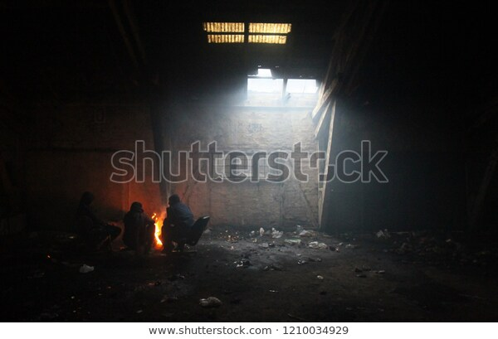

*Abandoned buildings provide safety, privacy and shelter for the homeless, but are also create high risk of fires due to the need for heat and light. Source:* [*Shutterstock*](https://www.shutterstock.com/image-photo/refugee-camp-on-balkan-route-migrant-1210034929)*.*

Worcester is an old town, settled by Europeans in the early 1700s. It swelled as a manufacturing hub when the Worcester and Boston Railroad put down tracks in 1835. Today the city has a population of over 185,000 and is part of the larger Boston metropolis, considered the [sixth largest metropolitan area](https://en.wikipedia.org/wiki/Greater_Boston) in the world.

The cold storage facility got a substantial addition in 1912. While its original scope reached 88 by 88 feet, climbing 80 feet high in six stories and a basement, the expansion added significant square footage; ultimately, its [64,000 square feet](https://www.usfa.fema.gov/downloads/pdf/publications/tr-134.pdf) of enclosed space formed an L with a single (unplanned and informal) firewall between its vertical and horizontal legs.

The 1912 expansion created twice as much square footage, but only added minimal windows to a second floor office, two elevators and an additional staircase the terminated on the 3rd floor. The total staircases numbered three, but only one climbed from basement to roof.

Aside from the warehouse floors (1 and 2), the vast interior held rows and rows of indistinguishable cold storage units: sometimes one unit opened into three more, also identical. Reports indicated that when the facility was in operation, it was not unusual for workers to get lost due to the inherently confusing network of meat lockers. Its primary purpose was to store beef from Chicago slaughterhouses, then haul the meat right out the back door for distribution via railroad cars.

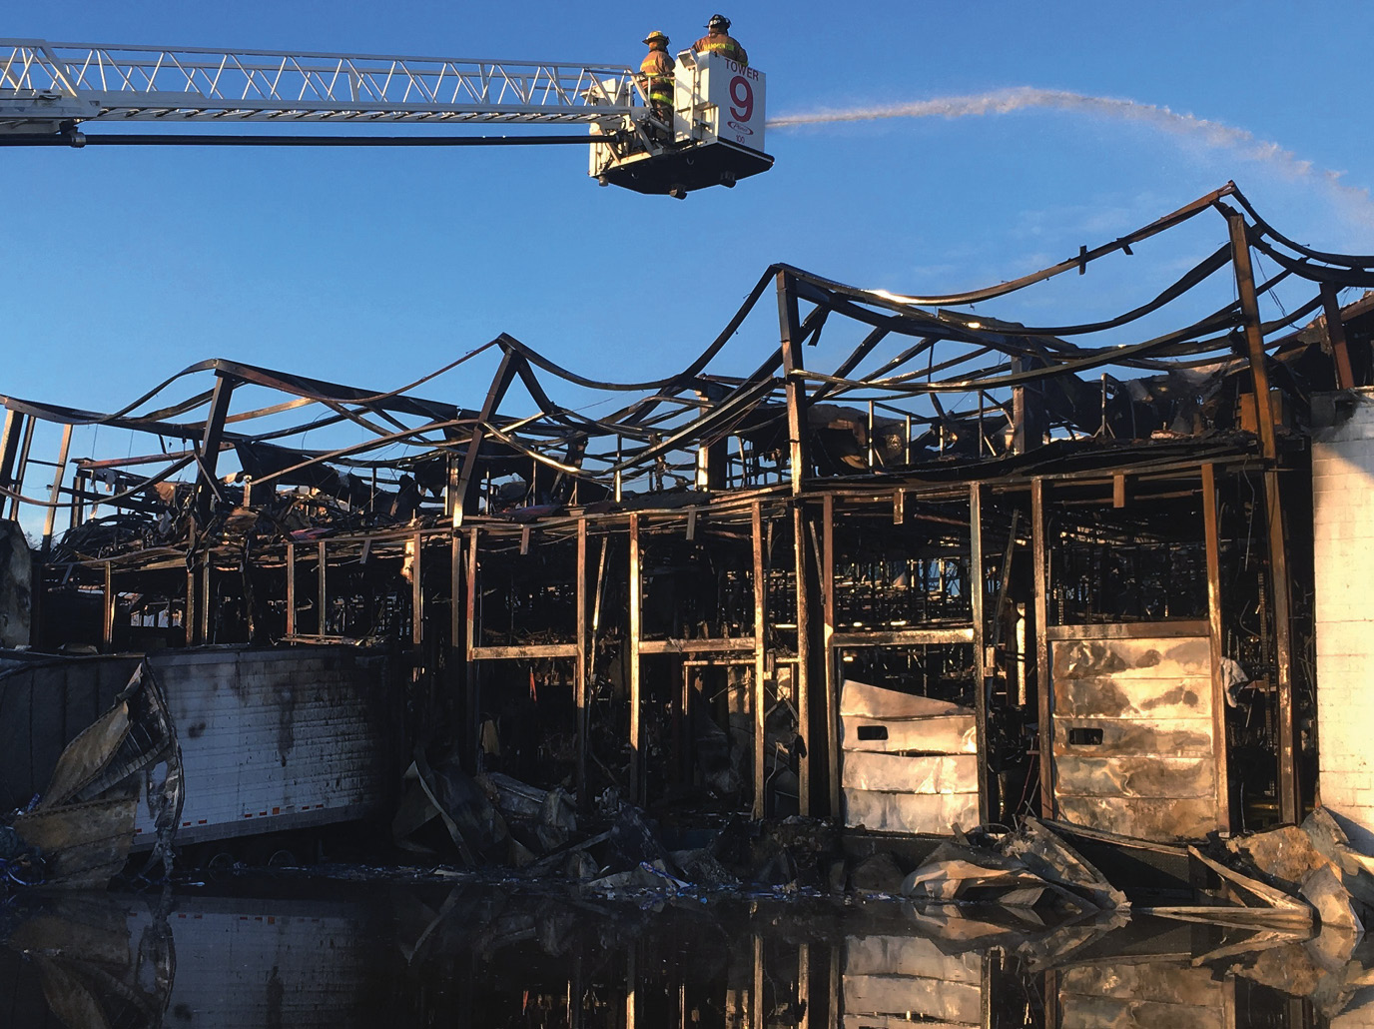

*A 2017 fire in a cold storage unit at Buffalo Farms Freezer resulted in 3.5 million dollars in damage and a total loss, and required the services of five fire departments. Source:* [*NFPA*](https://www.nfpa.org/-/media/Images/NFPA-Journal/2019/March-April-2019/Images/fire_photo_sized_CC_CMYK.ashx?la=en)

The facility was designed to optimize insulation, so only the first floor included windows, except in stairwells. The massive brick exterior walls were 18” thick—but that was only the beginning. Another 18” layer of cork insulation was combined with [polystyrene](https://en.wikipedia.org/wiki/Polystyrene#Expanded_polystyrene) foam, tar and polyurethane. As materials improved over the decades, more insulation was periodically added. The end product was [a nightmare of combustibles](https://www.cdc.gov/niosh/fire/reports/face9947.html).

After the building was abandoned in 1989, its thick walls and small, cozy rooms offered shelter, privacy and warmth. Squatters sometimes built fires or brought candles with them to find their way. In April 1999 the Worcester Fire Prevention Unit [filed an official complaint](https://www.cdc.gov/niosh/fire/reports/face9947.html) and ordered the building’s owners to secure the facility because gaining illegal access to the interior was too easy.

The combination of layout, darkness, only one usable staircase and an endless series of identical meat lockers—in addition to its sheer scope—created a bewildering blueprint where navigation in the best of circumstances proved challenging.

It was here, one cold night in December two decades ago where six firefighters, intending to search for anyone inside, never found their way out.

**Trapped in a maze**

According to a [report](https://www.usfa.fema.gov/downloads/pdf/statistics/v12i4.pdf) by FEMA, three factors are frequently implicated building fires: detection time, building construction, and building contents. All of these played supporting roles in the Cold Storage and Warehouse fire. But the loss of life can be squarely pinned on a variety of factors that made escaping the structure’s interior close to impossible.

The cold storage building was estimated to have been burning between 30 and 90 minutes before it was detected. The [call came in](https://www.esquire.com/lifestyle/a1098/perfect-fire-0700/), “Franklin and Arctic, for a fire at 266 Franklin.” Thus, detection was slow—due in part to the time it took for the smoke to become visible outside the building.

The fire likely started around 5pm on December 3rd when Thomas Levesque and Julie Ann Barnes were camped inside the cold storage facility and toppled a candle during an argument. Unable to quell the flames, they fled the building, electing not to tell anyone. A business owner next door informed the firefighters there could be people in the vacant building, but even without that warning it is likely firefighters would have felt compelled to search the building based on common knowledge about how this building was used.

The alarms sounded at 6:13. Four engines carrying two ladders and a rescue company arrived with a district fire chief to this [three-alarm fire](https://www.nola.com/news/traffic/article_3055c160-4269-5176-afef-54fbd7ed1334.html). Those arriving on scene were divided into two crews to conduct a search of the building. Official review after the fire and extensive reports revealed the following timeline:

* At 6:20, Ladder 1 reported they were on the 2nd floor putting in several 2 and ½” lines
* At 6:46 and 6:47, two radio reports come from inside from Rescue 1: two of the firefighters sent to search the interior of the building had an emergency
* At 6:53, Rescue 1 was directed by Car 3 to activate their [PASS devices](https://en.wikipedia.org/wiki/PASS_device)
* Additional firefighters were sent inside the building to find victims 1 and 2 (from Rescue 1), who had been identified following a headcount by [Incident Command (IC)](https://en.wikipedia.org/wiki/Incident_Command_System)
* At 7:10 one of two firefighters (victims 3 and 4) sent in to search for victims 1 and 2 radioed an urgent message to command stating they were lost and running low on oxygen
* At 7:14, victims 3 and 4 radioed the same message again. The message from this team stated, “Ladder 2 to command, we’re done….” This transmission was the last from the search team of four men sent from Ladder 2/Engine 3.
* At 7:24, IC conducted another headcount and discovered 6 firefighters, total, were missing
* At 7:31, a second fire department from Millbury arrived with a thermal imaging camera to help locate the lost men
* At 7:49, a crew from Engine 8 [unrelated to victims 1 and 2, 3 and 4, or 5 and 6], reported that on the 4th floor the structural integrity of the building seemed compromised
* At 7:53 a report from Car 4 states that the thermal imager has stopped working
* At 8:00 pm, IC ordered all firefighters out of the building and switched from offensive to defensive firefighting

Later, it was determined that victims 5 and 6, who were not seen entering the cold storage building, had not radioed any type of message. Transcripts from Central Dispatch imply these two men may have joined victims 3 and 4 on the 5th floor. [Recovery efforts](https://www.courant.com/news/connecticut/hc-xpm-1999-12-05-9912050045-story.html) lasted for eight days.

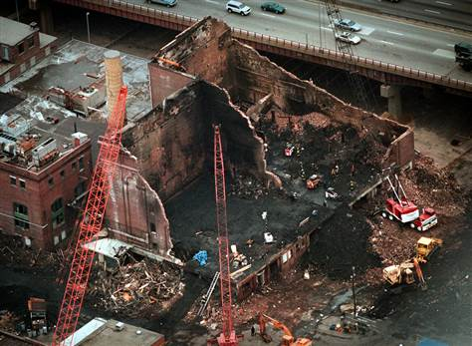

*Aftermath showing the “L” configuration of the building and the scope of the search. Source:* [*NBC News*](http://www.nbcnews.com/id/16991877/ns/us_news-life/t/cdcs-fire-investigation-unit-no-go-team/#.XfpSHS2ZPjA)

The six men who perished are remembered by the city and community as “The Worcester Six.” While Worcester reeled from the deaths, the fire department (with support from [multiple agencies](https://www.usfa.fema.gov/downloads/pdf/publications/tr-134.pdf) beyond the city of Worcester and the state of Massachusetts) took a hard look at the tragedy to prevent any such event in the future.

**The fire’s aftermath brought lawsuits, tears and action**

The city of Worcester vowed to never forget this fire and it has kept that promise. [Memorials](https://www.masslive.com/worcester/2019/12/the-worcester-6-twenty-years-ago-six-firefighters-died-fighting-the-cold-storage-fire-now-several-of-their-sons-carry-on-the-firefighting-tradition.html) are held each year, some with ceremonies at 6:13 p.m., the time the first alarm rung on the December evening, now 20 years ago. The ruins of the Worcester cold storage facility were cleared and a new fire station, The Franklin Street Station, was built on the ashes.

The building’s owner was [sued](https://web.archive.org/web/20140611111259/http:/www.highbeam.com/doc/1P2-20993496.html) by the families of the six men who died, ultimately resulting in small [settlements](https://web.archive.org/web/20140611112939/http:/www.highbeam.com/doc/1G1-62332047.html) of between $167,000 and $250,000 each, out of court. The homeless couple were charged with involuntary manslaughter, but after the case was dismissed and reinstated it was finally dismissed in 2010, and both eventually received probation.

The closely knit community of Worcester created a scholarship fund that has raised over half a million dollars to support local high school students, while [fundraisers](https://www.masslive.com/news/worcester/2014/12/new_memorial_honors_fallen_wor.html) and nonprofit [foundations](https://www.facebook.com/learyfirefighters/) were also established.

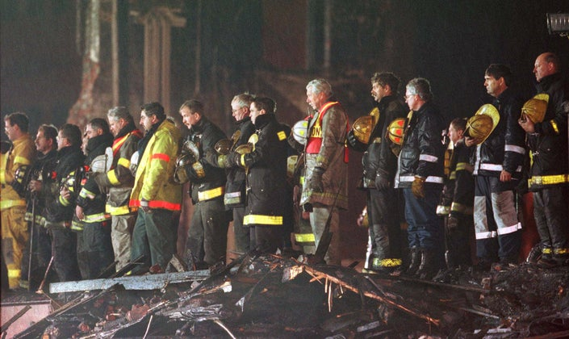

*Exactly one week after the fire alarm sounded, at 6:13 pm, the Worcester Fire Department honors its lost men on the ruins of the cold storage facility. Source:* [*Associated Press*](https://patch.com/img/cdn20/ap/22906546/20191202/074732/styles/raw/public/processed_images/AP_99121001719.jpg?width=725)

Firefighters in Worcester turned their grief into concrete action by investigating why the men were lost and assessing how events could have unfolded differently.

**Vacant buildings and modern combustibles**

Despite [hundreds of volumes](https://www.nfpa.org/Codes-and-Standards/All-Codes-and-Standards/List-of-Codes-and-Standards) of written NFPA code dedicated to optimal safety procedures, vacant buildings are sometimes [renovated with flammable materials](https://www.qrfs.com/blog/196-grenfell-tower-two-years-after-the-fire/), typically lack working [fire extinguishers](https://www.qrfs.com/fire-extinguishers-and-cabinets) and older buildings may be without fire suppression systems such as a sprinkler systems. Abandoned buildings are often boarded up, limiting both lighting and exit options. Responders who arrive on scene also encounter inherent navigational risks because they lack knowledge about what’s inside.

The cold storage building brought together the worst possible architectural design (from a fire safety perspective) and highly flammable materials, in one building.

At the twentieth anniversary of this historic firefighter tragedy, a hometown report published by NFPA, “[After Affect](https://www.nfpa.org/News-and-Research/Publications-and-media/NFPA-Journal/2019/November-December-2019/Features/Worcester),” notes that the Worcester Warehouse and Cold Storage fire became one of the [deadliest fires in US history](https://www.qrfs.com/blog/237-the-deadliest-fires-in-u-s-history-lessons-learned-part-2/) because the building could have been the set of a horror movie:

Polystyrene, polyurethane, and Styrofoam—like the asphalt infusion, all petroleum products—were later layered over the cork, creating a sandwich of insulating materials that, given the right conditions, could pack the combustibility of gasoline. There were few windows in the building, and most had been boarded over. Most of the floors were mazes of storage lockers; wayfinding was nonexistent….

More information about the building layout and hazards could have better prepared the incident commander to make an informed decision. Noting the dangers of both arson fires and fires in abandoned buildings, the Massachusetts [Fire Marshal Peter Ostroskey](https://www.telegram.com/news/20180506/lessons-learned-in-worcester-on-fires-in-vacant-buildings) recently noted the dangers in abandoned buildings and measures taken to improve conditions, such as more frequent patrols to discourage vagrants and enforceable fines for non-compliant building owners. Additionally, fire code in the state now includes [marking vacant buildings](https://web.wpi.edu/Pubs/E-project/Available/E-project-042618-084307/unrestricted/MQP_AHistoryOfWorcestersDeadliestFireIncident_26042018.pdf).

The National Institute of Occupational Safety and Health (NIOSH) issued a [report](https://www.cdc.gov/niosh/fire/reports/face9947.html) following the cold storage disaster that detailed eight pre-fire plan points to consider before entering a vacant building:

(1) potential hazards inside

(2) water supply

(3) defensive strategy

(4) exposure protection strategy

(5) mutual-aid considerations

(6) collapse dangers

(7) apparatus positioning

(8) venting strategies

The Department of Homeland Security/Federal Emergency Management Agency (FEMA) also issued a report which summarized the [key issues](https://www.usfa.fema.gov/downloads/pdf/publications/tr-134.pdf) involved in the cold storage fire, as follows:

* Abandoned building left unprotected and unsecured
* No barriers to prevent the spread of fire and smoke in a large space
* Fire spread via combustible interior finishes
* Delayed fire reporting
* Access limitations for fire suppression and rescue
* Unusually long interior travel distances

These findings almost all highlight the unique nature of the Worcester Cold Storage and Warehouse building itself, rather than lapses in the fire department or firefighting strategy. NIOSH does not that improved navigation could have mitigated the outcome of the cold storage fire.

**Escape rope doubles as communication and a way out**

Safety gear such as oxygen and protective suits were of limited value when firefighters become lost and/or separated from one another. [Escape rope](https://forums.firehouse.com/forum/firefighting/firefighters-forum/73329-personal-escape-rope) may have helped, as the NIOSH report noted in one of its summative [13 recommendations](https://www.cdc.gov/niosh/fire/reports/face9947.html).

6. Use guide ropes/tag lines securely attached to permanent objects at entry portals and place high-intensity floodlights at entry portals to assist lost or disoriented fire fighters in emergency escape.

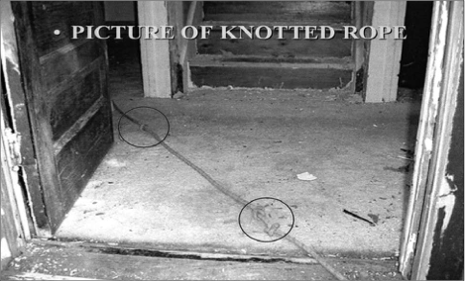

*Photograph of a knotted rope. While any rope can be used as a guide, rope with more flame-resistance is preferred as well as rope that is easier to see in low light. Source:* [*FEMA*](https://www.usfa.fema.gov/downloads/pdf/publications/tr-123.pdf)

Recommendation 9 noted that a marking system could have been established. When combined with use of escape rope, such a system would have provided a much need orientation point, or points, in a building that lacked navigational waypoints. By knotting ropes in a particular pattern, a firefighter can feel his way out of the building (e.g. two knots tied together indicates relative location).

While it is difficult to conceive of a setting less maneuverable than this building, NIOSH reviewers also recommended posting information outside all vacant buildings about interior conditions:

1. Ensure that inspections of vacant buildings and pre-fire planning are conducted that cover all potential hazards, structural building materials (type and age), and renovations that may be encountered during a fire so that the incident commander will have the necessary structural information to make informed decisions and implement an appropriate plan of attack.

10. Identify dangerous vacant buildings by affixing warning placards to entrance doorways or other openings where firefighters may enter.

With proper training and practice, using escape rope can mean the difference between staying connected to another firefighter or having the ability to find a building exit in darkness and/or heavy smoke. [Rapid egress](https://www.youtube.com/watch?v=GbFQ_wEr1vc) when ladders are not available is another reason firefighters use escape rope.

Escape rope is only one tool, and not a cure-all for an incident as complex as the cold storage fire. Yet with proper training, escape rope may act as a means of communicating in dim conditions--especially when high-tech means of navigation fail. In the cold storage fire, for example, thermal imaging was brought on scene, but failed to operate correctly.

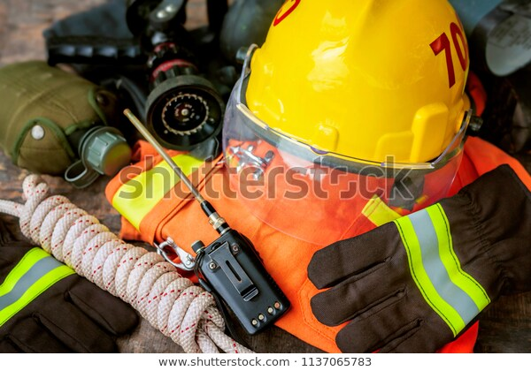

*Fire rescue gear includes an array of safety tools. Source:* [*Shutterstock*](https://www.shutterstock.com/image-photo/outfit-firefighter-placed-on-wooden-table-1137065783)

Reports following the fire also indicated that although many tools were available to the firefighters, including [Self-Contained Breathing Apparatus](https://en.wikipedia.org/wiki/Self-contained_breathing_apparatus) (SCBA) with 30 minutes of air issued to the firefighters who entered the building, as well as PASS units—a consistent problem in the cold storage fire was [incident commanders not knowing](https://www.wbur.org/news/2019/12/03/20-years-worcester-cold-storage-fire-anniversary) where to send a rescue team and losing track of men who entered the building. This problem was due, in part, to the scale and size of the structure.

**Lessons learned from this “perfect fire”**

An article following the Worcester Six tragedy was published in the high-profile magazine, [*Esquire*,](https://www.esquire.com/) shortly after the cold storage fire embers settled. “The Perfect Fire,” echoed the words of another Massachusetts tragedy in the loss of six fishermen chronicled in the 1997 bestseller, “[The Perfect Storm](https://en.wikipedia.org/wiki/The_Perfect_Storm_(film)).” In that loss of life aboard a vessel called the *Andrea Gale*, multiple factors converged to create a storm so vast and treacherous no captain or crew could have anticipated, or adapted to it.

The fire highlighted a pressing need to develop [effective technology](https://web.wpi.edu/Pubs/E-project/Available/E-project-042618-084307/unrestricted/MQP_AHistoryOfWorcestersDeadliestFireIncident_26042018.pdf) to use in fire departments. The thirteen NIOSH recommendations have largely been deployed in Massachusetts. For example, fire departments have adopted a marking and placard system for abandoned buildings.

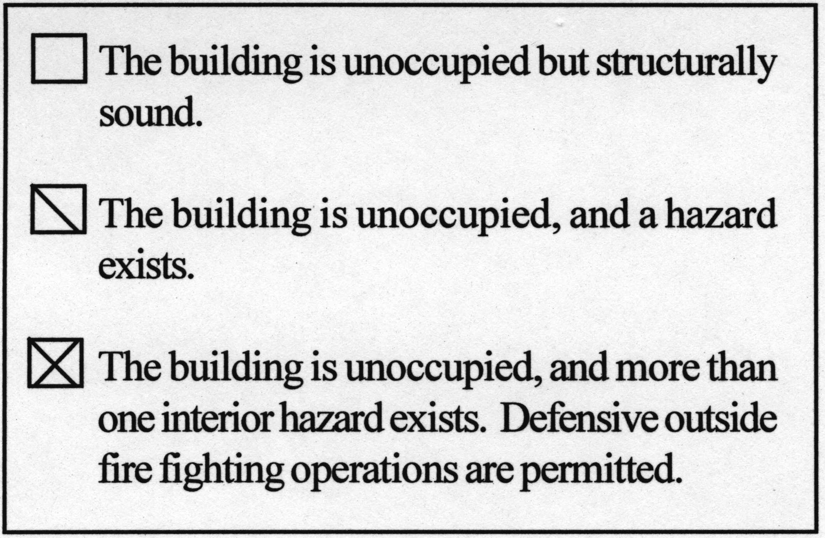

*Example of warning placards to provide information to firefighters about building conditions. Source:* [*NIOSH*](https://www.cdc.gov/niosh/fire/images/9947tbl1.jpg)*.*

The cold storage fire serves as a reminder that all firefighting tools, low and high tech, must be employed when navigation is compromised. As noted in the NIOSH report, the death toll could have been much worse had the decision to stop sending men into the building not been made.

Difficulty locating firefighters among multiple teams spread out in a large structure has led to the formation of [Rapid Intervention Teams [RIT]](https://www.mass.gov/files/documents/2019/02/06/256%20-%20Rapid%20Intervention%20Training.pdf) that now operate across Massachusetts. These firefighters are specially trained in locating and rescuing other firefighters and carry [special equipment](https://www.fireengineering.com/2009/07/15/289307/turk-device-designed-for-rit-operations/#gref).

Perhaps this result, more than any other, pays tribute to the Worcester Six who died tried to rescue their team members.

Ultimately, the cold storage fire doesn’t have easy answers. Reports from state and federal agencies noted many of the same problems in hindsight, and some of the problems have solutions. Marking vacant buildings and using special teams like RIT, for example, will improve the odds. By the same token, knowledge of the true conditions within the building would still have force a tough call: enter a risky building, or choose to fight defensively knowing people may have been inside.

*Wondering how you can prepare for firefighting in worst case scenarios? QRFS offers a selection of* [*escape rope*](https://www.google.com/search?client=safari&biw=1199&bih=770&tbm=shop&ei=NtL7Xc3zFsL6sAXS_I-oDA&q=qrfs+escape+rope&oq=qrfs+escape+rope&gs_l=psy-ab-sh.3...124327.125981.0.126452.11.9.0.0.0.0.273.1067.0j4j2.6.0....0...1c.1.64.psy-ab-sh..5.0.0....0.Garob30YwVk) *as well as sophisticated* [*thermal imagining technology*](https://www.google.com/search?q=qrfs+thermal+imaging&client=safari&source=univ&tbm=shop&tbo=u&sa=X&ved=2ahUKEwju_v_fu8LmAhUrFjQIHUyDCKMQsxh6BAgIEC4&biw=1199&bih=770#spd=8819638658799021958) *that can be ordered by calling us at 888.361.6662 or* [*filling out our contact form*](https://www.qrfs.com/contact-qrfs-by-phone-or-email)*.*

For more information about QRFS products, call us at +1 (888) 361-6662 or email [support@qrfs.com](mailto:support@qrfs.com)

This blog was originally posted at [QRFS.com/blog](https://www.qrfs.com/blog). Check us out at [Facebook.com/QuickResponseFireSupply](https://www.facebook.com/quickresponsefiresupply/) or on Twitter [@QuickResponseFS](https://twitter.com/quickresponsefs).

Page Title: The Deadliest Fires in U.S. History: Lessons Learned from Worcester Cold Storage and Warehouse Fire

## Meta description: The Worcester Cold Storage fire killed six firefighters in 1999 in a blaze that required eight days to recover their bodies, and led to a different approach to firefighting in Massachusetts.