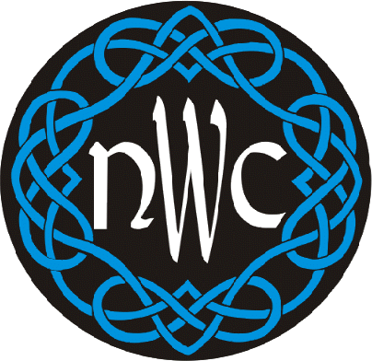
New World Celts - Dunedin Chapter Scott Morse Diversity Scholarship

The Dunedin Chapter of the New World Celts strives to reward the talents of young people who demonstrate an interest in learning and promoting Celtic culture and heritage in our community.

To do this, the Dunedin Chapter of the New World Celts offers financial assistance to aid individuals under the age of 25 in their Celtic culture and heritage endeavors.

The Dunedin Chapter of the New World Celts is proud to offer this scholarship in honor of our member Scott Morse, and in celebration of diversity in our amazing community. Applicants do not need to already be enrolled in a dance or music program, currently participate in a pipe and drum band, or be a current heavy athlete.

This scholarship is specifically offered to:
- Individuals of color
- Individuals who are differently abled
- Individuals of other than Scottish or Irish descent
- Individuals along the LGBTQ+ spectrum

Activities this scholarship can be applied to (not an extensive list):

- Celtic Studies (college or privately offered classes)
- Celtic Language Classes
- Celtic Art, Music or Literature (either classes in, or your own production)
- Pipe and Drum Instruction
- Celtic Dance Instruction
- Celtic Heavy Athletic Training

Scholarship awards are granted based upon receipt of a qualified application with a clearly written statement of intent and description of proposed activity. Applicants wishing consideration for financial assistance in the form of a scholarship program award should complete the information and follow the submission requirements and instructions outlined below. The New World Celts, Dunedin is a non-profit, non-political, non-religious organization and is open to everyone in Celtic culture regardless of race, creed or color.

Diversity Scholarship Application

NAME AGE

ADDRESS

STUDENT EMAIL PHONE

PARENT EMAIL PHONE

Please include on a separate page(s), letters and documents containing the following information:

- A description of the proposed activity, including clear evidence that it relates to the goals of learning and promoting Celtic arts, culture or heritage
- A personal statement of intent, stating why you want to be involved in this activity, and how you intend to benefit from such activity relative to your own understanding of Celtic arts and culture
- A letter of recommendation from a member of the New World Celts, the Scottish American Society, the St. Andrews Society, other individual involved with an organization with Celtic related interests, Clergy member, School Official/Administrator/Teacher
- A signed copy of the Minor Media Release Form which can be found on our website

I certify that the information given in this application is true and correct to the best of my knowledge. Further, the Dunedin Chapter of the New World Celts has my permission to make whatever inquiries may be necessary to validate the information I have presented in this application.

SIGNATURE DATE

MAIL COMPLETED APPLICATION AND REQUIRED DOCUMENTS TO: NEW WORLD CELTS - DUNEDIN, PO BOX 1632, DUNEDIN, FL 34697

