CLAY TILE ROOF MOUNTING INSTRUCTIONS

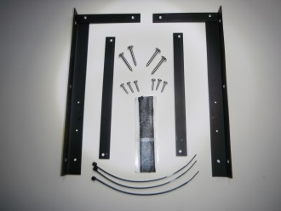 | 1.Your installation package should include 4 -2” roof screws, 6 – ¾” self-drilling mount screws, 4” of sealing tape, 3 Ty-raps and the panel mount.
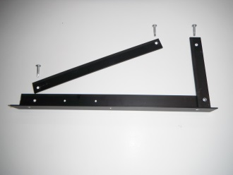 | 2. Locate the 6 – ¾”. Notice the adjustable 9” leg holes are offset. Attach the 9” leg to the bottom mount with the offset closest to the inside of the angle. (Depending on your roof pitch, this may have to be moved for best adjustment later)
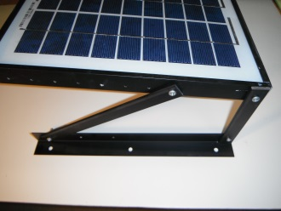 | 3. Attach the roof mount to the solar panel. The 5” leg mounts at the single hole.
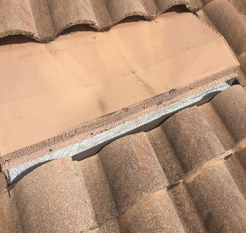 | 4. Existing Oversized Attic Vent Installation (No new penetration created). Locate two static vent hoods in separate locations of attic (if not possible than use a single vent as shown in step 8). Gently remove pest screening on vent from roof.
 | 5. Fan Install: enter the attic and locate oversized attic vent. Use ¾”-1” wood screws with washer to secure fan assembly to underpart of roof sheathing. (If sheathing is 1/2” or less do not fully seat screw)
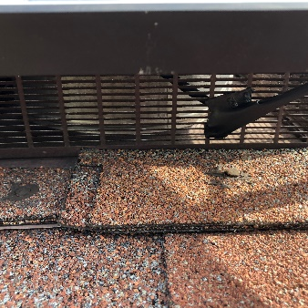 | 6. Feed fan power cord through opening of vent to outside by going over internal air dam and out. Fan should be positioned at a slight angle to ensure proper attic air exit. Seal cord feed thru with provided compound to prevent intrusion.
 | 7. If necessary, carefully cut scored lines on fan plenum to fit and insert fan into space.
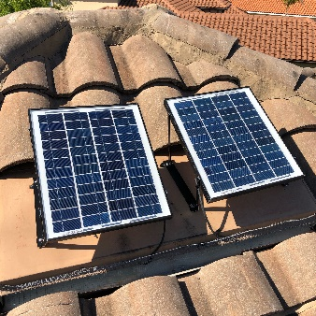 | 8. Vent Hood Mount Mount the solar panel to vent with 6 screws using the included sealing tape cut into 6 equal pieces at each screw location. (Heavy gauge Aluminum rivets can be used in place of screws)
9.Direct to Clay Tile Mount
Mount the solar panel directly to clay tile using optional bracket adapter kit; or position panel rails in troughs of tiles, mark screw holes, and drill ¼” diameter holes through clay tiles without going through sheathing then mount panel to roof using 4 provided screws with sealing tape ensuring adequate compression into sheathing.
 | 11. Connect the fan cable to the solar panel and adjust solar panel. *
12. Capturing Maximum Sun
After connecting the fan cable to the solar panel, adjust solar panel to approximately 10 degrees from horizontal towards the south or southwest if possible. *
 | 13. After securing the panel to its most efficient adjustment, Tie-wrap the cable to an adjustment leg to secure the cable.
 | 14. Finished unit
* Typically, the hottest days are in summer and are also the longest day. If possible, point the solar panel, flat to the sun, (the most exposure possible for maximum power) at approximately 3 PM. Peak heat and sun times may vary in your location.

International Solar Solutions Inc.
2126 Burnhamthorpe Rd. West
P.O. Box 67067, Mississauga, ON
Canada L5L 5V4

WARNING: To protect yourself and others from injury, always exercise caution and use appropriate safety gear (restraints, safety glasses, gloves, etc.) when using a ladder, working on a rooftop, using power tools or handling a vent unit. Installation work and electrical wiring must be completed in accordance with all applicable building codes and standards, including fire requirements. We strongly encourage you to get a professional to help you install your new SOLAR ATTIC FAN properly so you can take full advantage of what it has to offer. Please remember that iSolar is not liable for any injury or harm caused by attempts to install your SOLAR ATTIC FAN. Safety first!

NOTE: On a new roof installation,
DO NOT NAIL DOWN FAN GASKET ASSEMBLY TO THE ROOF SHEATHING

