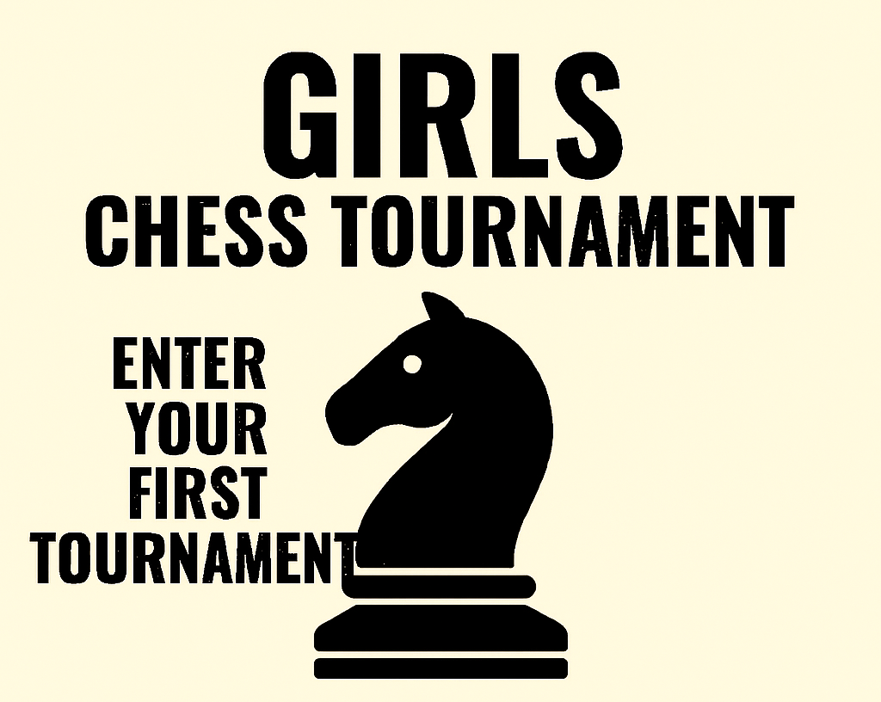

USCF Rated and UNRATED (FIRST TIME PLAYERS WELCOMED)
WHEN: Nov. 22, 2025 at 9 AM
WHERE: Houston Chess Studio: 260 Patton St., Suite H, Houston, TX 77009
FORMAT: 4 Swiss Rounds at 9am, 12pm, 2pm and 4pm
Breakfast, lunch and dinner included along with snacks.
Transportation available.
All tournament fees and memberships covered.
CHESS LESSONS PROVIDED
MAKE YOUR MOVE!
RSVP to Evie Laskaris at evieal2021@gmail.com
Sponsored by checkmateforkids.org

