Ave Maria 3008 Newsletter Sept. 2019

Food 4 Family program donated in August was $113 into a value of $390. See photo below- big ticket was cereal for back to school kids.

New uniforms cost discussed again. Looking at other Assembly plans.

SEPT 11th -had your flag displayed❓ Then remember Nov 11th, veterans day.

Color Corp cannot have mixed attire.

In Planning - Get ready, we are looking into some patriotic/veterans activity. Get the parish and local community involved. Your inputs are appreciated.

Assumption Church hosted the 4th degree this year.

Birthday Brothers (one has been 4th degree 65 years) Sept Food 4 Family
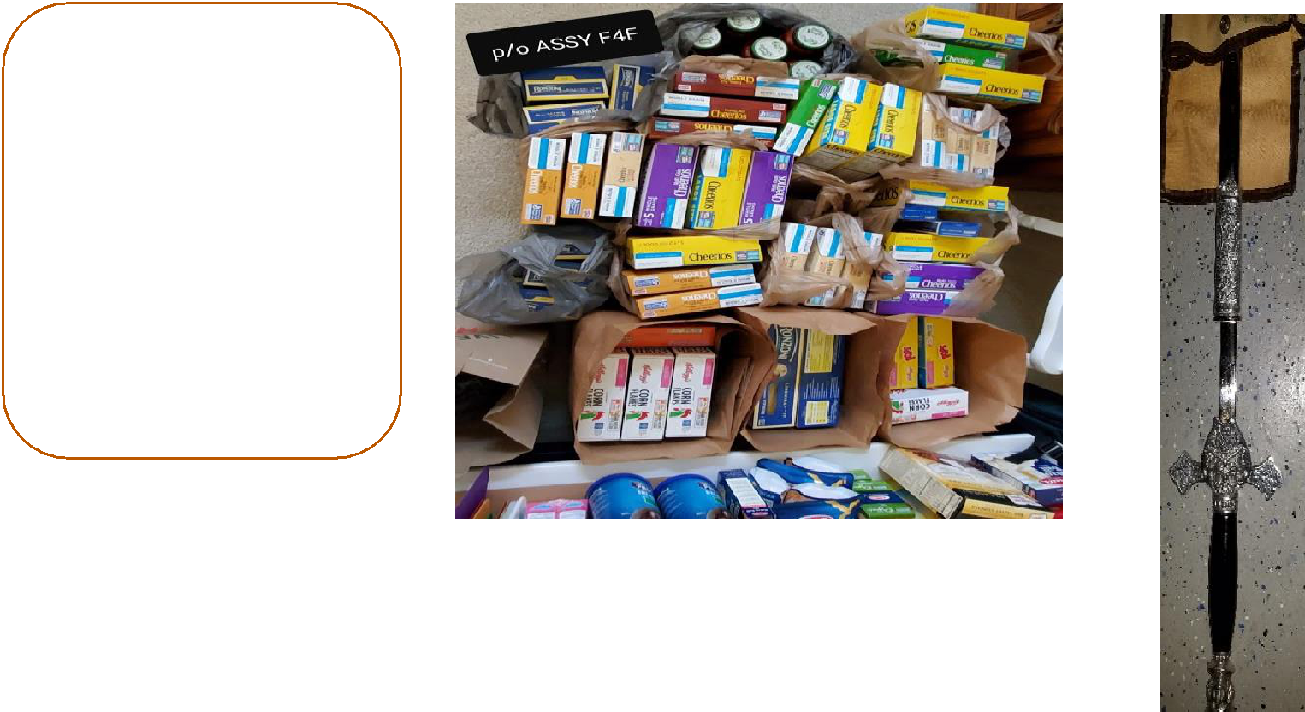

William Koenig

William Roberts

Jim Denkler

Francis Durnin

Michael Trull

Salvador Rivera

Michael Davis

Patrick Pollizzi

Derek Holmes

Lawrence Mulinda

Tell you 3ed degree brothers the Assembly Officers have approved gifting a sword passed down from retired brother knights. The sword would go to knights buying the new Uniform and presently not have a sword. See photo below.

Read the minutes for more details

