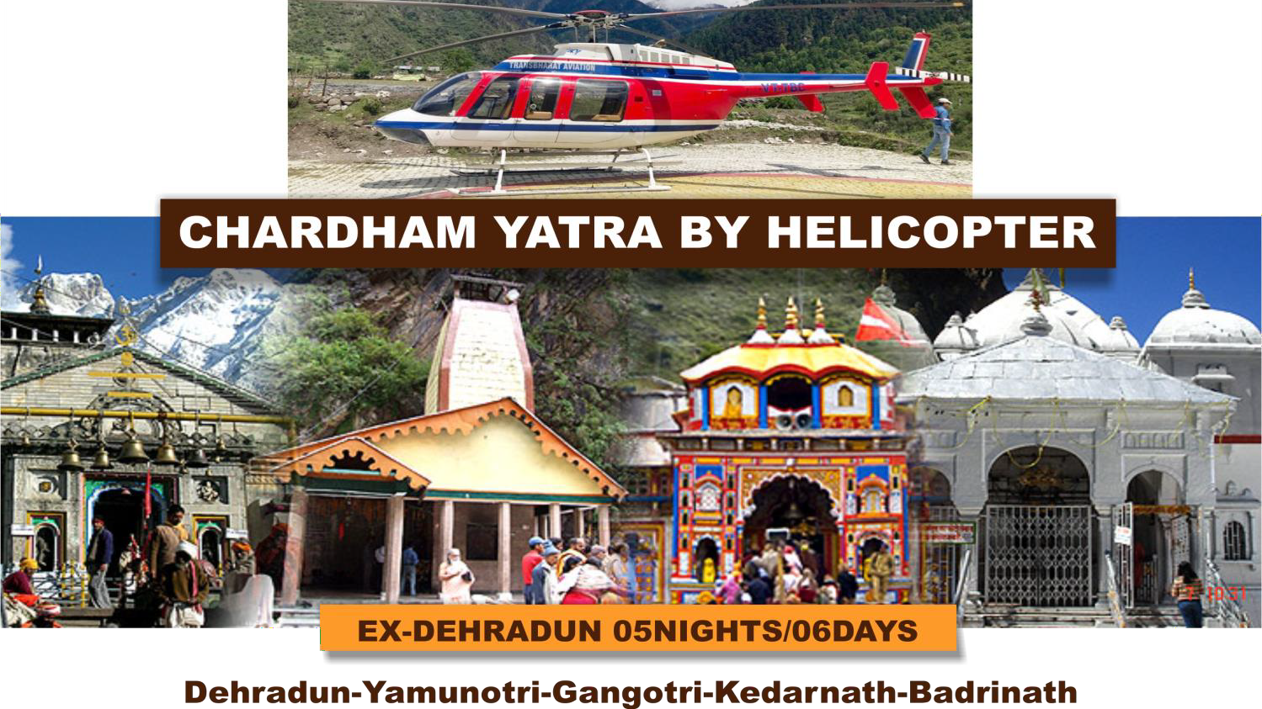

Uttarakhand, also known as Dev Bhoomi or the Land of Gods, is home to numerous temples and welcome devotees all year round. In Hindi, ‘CHAR' means four and ‘DHAM' refers to religious destinations.
Char Dham Yatra is one of the most famous pilgrimage tours in India. Char Dham Yatra covers four major Hindu temples- Yamamori, Gangotri, Kedarnath and Badrinath. It is believed that this yatra provides blessings from the God and a chance to attain salvation. If you are planning to start your Char Dham Yatra from your chosen location (i.e. Domestic or International), the best time to plan your tour is from May to November. You can also see the scenic attractions on the way to Char Dham such as small valleys, waterfalls, mountain ranges, and ancient temples. Our Char Dham 2025 packages we provide all the necessary arrangements for your pilgrimage tour. We will provide you with a perfect itinerary and guide you during the entire duration of your tour. We also provide you with comfortable accommodation, meals, and transportation facilities. If you book a Char Dham Yatra package from us, we make sure that you have a safe and comfortable journey that you will cherish for a long time.

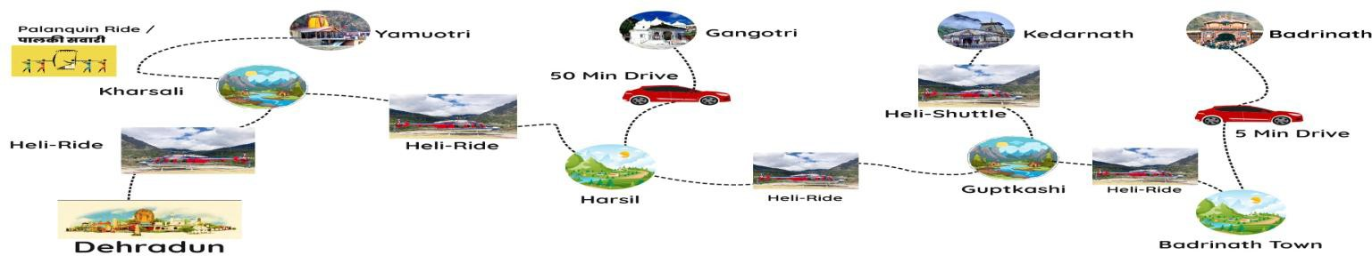

CHARDHAM ITINERARY
DAY 01: Arrival at Dehradun
The tour Commences with pick up from Dehradun airport or Railway station one day prior to the Chardham Yatra departure, followed by drop to the hotel. In the evening, our team will brief the guests about the entire Chardham Yatra which will be conducted at 20:30Hrs. Duffle bag will be provided during the tour briefing in which necessary luggage will have to be packed by the passengers (Maximum 5Kg per person will be permitted). The overnight stay at Dehradun with dinner awaits you.

Note: Our staff will take the body weight of each pilgrim during the tour briefing; hence kindly ensure you attend the same.

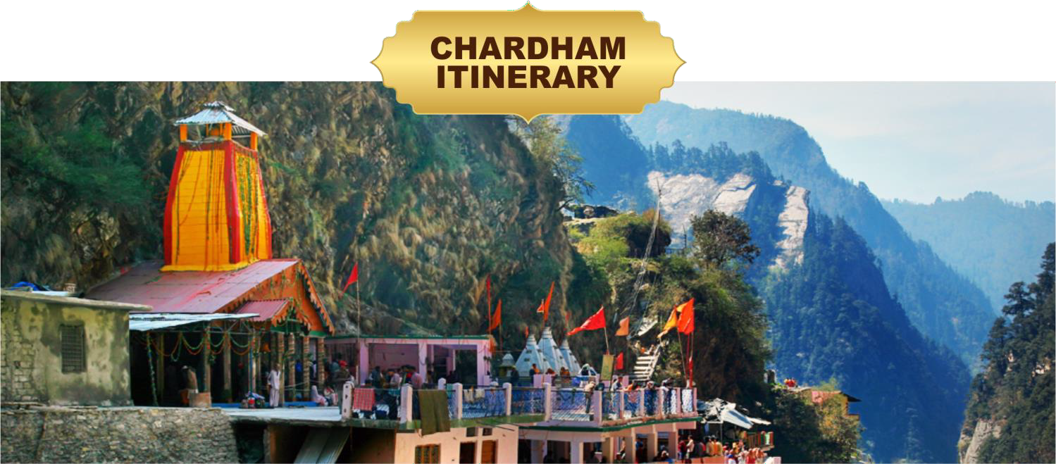

DAY 02: Yamunotri
6:30/9:30 AM- Departure Sahastradhara
helipad, Dehradun
Arrival Kharsali helipad, Yamunotri

The auspicious Chardham Yatra will begin from the Sahastradhara helipad, Dehradun. Guests will check out from the hotel at the designated time, our representative will pick them up and transport them to Sahastradhara Helipad.
Our ground Personnel will warmly greet the guests and assist them in settling into the waiting lounge. Where, they will receive the Pre-Flight instructions before being boarded into the helicopter.
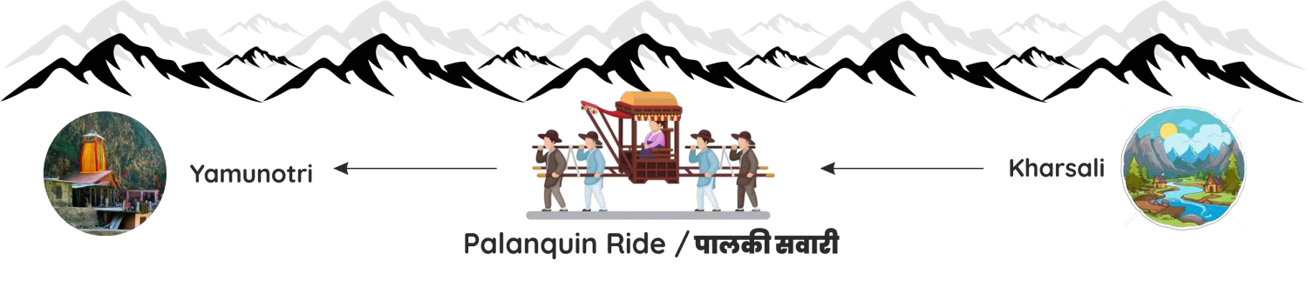
Upon arrival at kharsali guests are welcomed by ground staff and transfer to yamunotri temple by palkis/ Pony. This trek from helipad to temple is 6 kms and return trip by palki takes about 5 hours. After Darshan return back to Helipad. Overnight stay at Kharsali

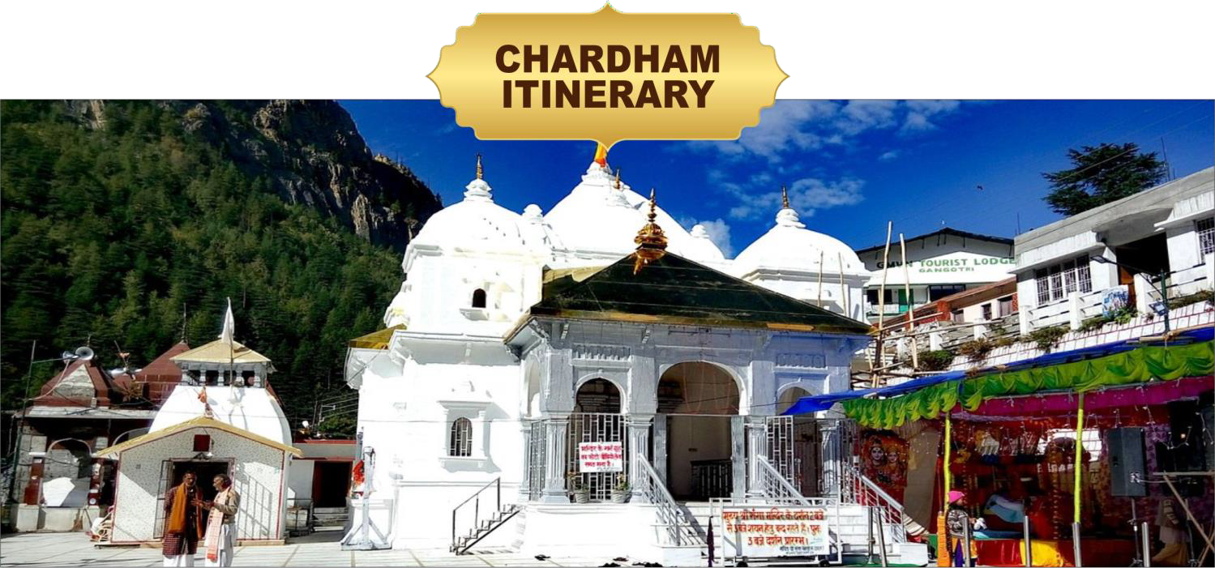

DAY 03: GANGOTRI

Departure Kharsali helipad, Yamunotri Arrival Harsil Helipad

Guests are expected to check out from the hotel at the designated time and will board the helicopter from Kharsali helipad. Arrive at the Harsil helipad, Gangotri within an estimated time. Harsil is one of the most beautiful and picturesque valleys in Uttarakhand. Some people also call it Mini Switzerland. Gangotri temple is about 22 kms from Harsil helipad and the drive by car takes 50 minutes.
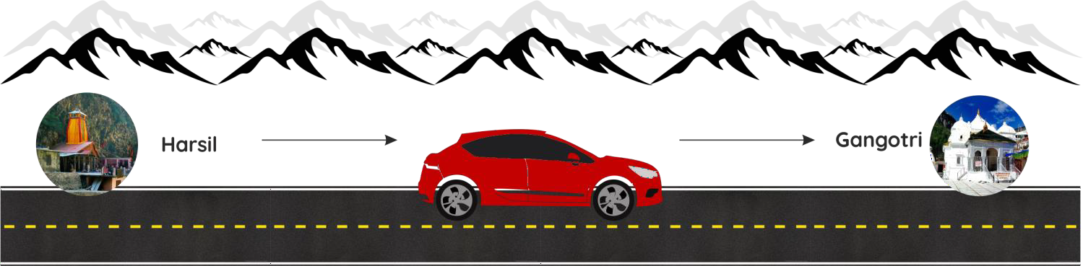
It is advisable that passengers leave straight for temple from helipad. Our ground staff will assist the passengers with darshan at Gangotri temple. After return from temple passengers can take lunch in resort and thereafter relax and have campfire in the evening. It is recommended to visit the nearby village for an evening walk and buy pure wool stuff (sweaters, shawls n mufflers) made by local tribal womenfolk.

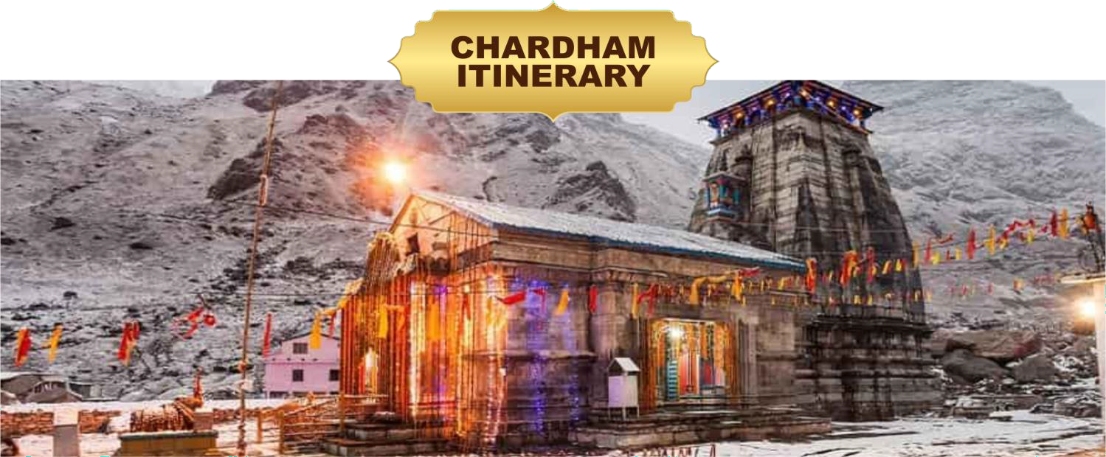

DAY 04: KEDARNATH

Departure Harsil Helipad
Arrival Kedarnath helipad
Guests are advised to check out from their hotel at the designated time, and will arrive at Harsil helipad. From there they will fly towards the Guptkashi. Guests will be ferried to Kedarnath Dham from Guptkashi in helicopter shuttle.
The helicopter will land at Kedarnath helipad which is at a distance of 500 meters from the temple. Our ground staff will be there to assist you for VIP darshan. It takes approximately 2 hours for darshan and helicopter shuttle takes around 10 minutes one way. After Darshan Guests will be ferried back to Guptkashi and will be transferred by road to their hotel. Night halt will be at Guptkashi or Kedarnath.

NOTE: Night halt at Kedarnath on triple and quad sharing basis on direct payment basis. The quality of accommodation available at Kedarnath Dham is just above average so passengers should not have very high expectations.
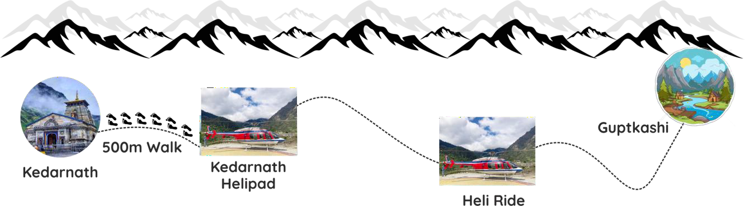

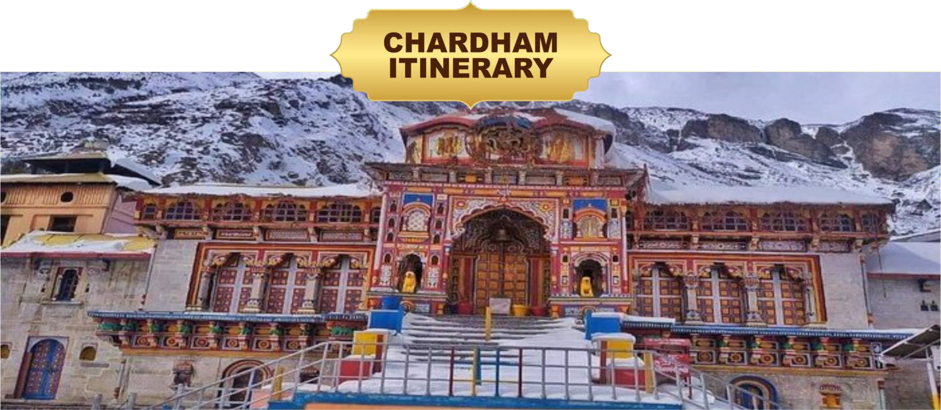

DAY 05: BADRINATH

Departure Kedarnath / Guptkashi helipad
Arrival Badrinath helipad

After breakfast, guest will check out from Guptkashi hotel and will be transferred to Guptkashi helipad. From there they will fly towards the Badrinath Dham. After arrival at Badrinath helipad passengers can check-in at Hotel which is Near to the temple. Our ground staff will assist the passengers in taking darshan at the temple.
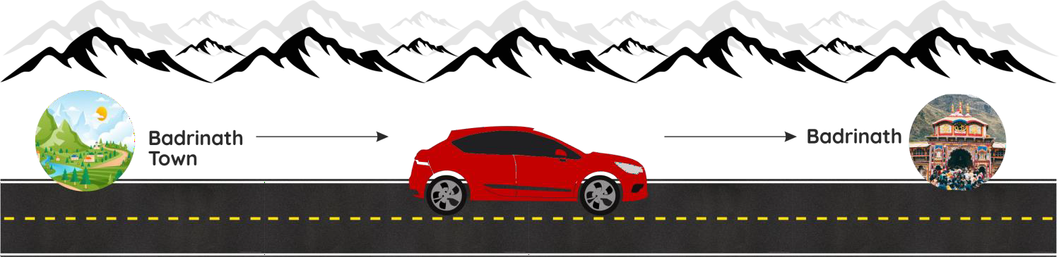
A visit to Mana village in evening is highly recommended as this is the first village after international border with China.

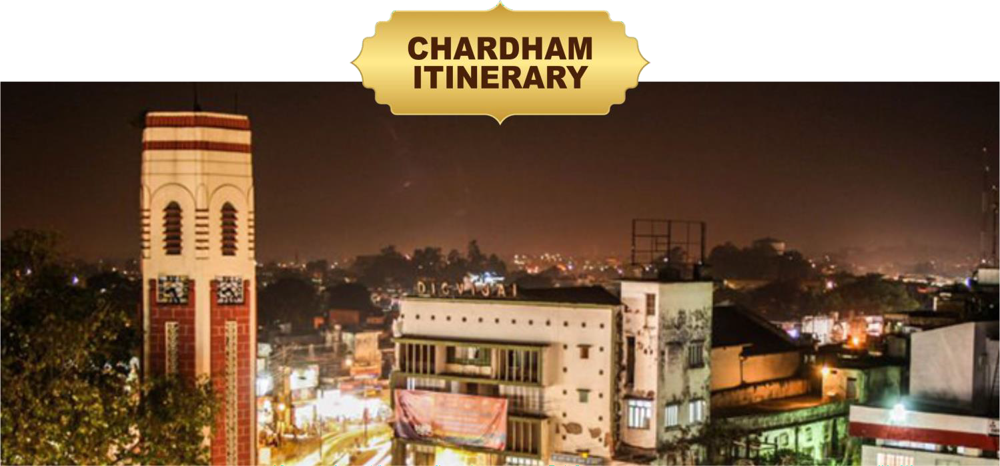

DAY 06: RETURN TO DEHRADUN

Departure Badrinath helipad Arrival Sahastradhara helipad, Dehradun
Early Morning ready for Special Abhishek Puja (at your own cost) at Badrinath temple is the highlight of this entire yatra. It starts sharp at 4.30 am in the morning and lasts for 2 hours. Passengers will get an opportunity to sit inside the temple and have darshan of the shringar of the deity from very close quarters. After darshan return back to hotel have breakfast and fly for Dehradun. On arrival at Dehradun helipad you will transfer to Airport / Railway station. Here Helicopter tour ends here with happy memories to be cherished forever.

This is the end of Chardham Yatra.

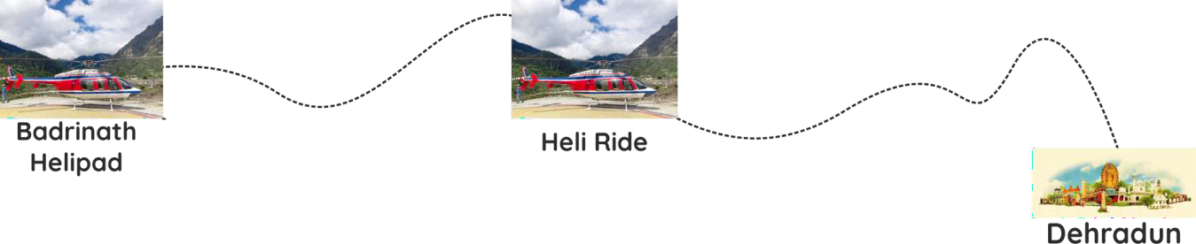

CHAR DHAM ACCOMMODATION DETAILS

OPTION 1
PACKAGE COST PER PERSON
INR-205000/-(Weight up to 75kg) Extra Weight @2000/- per kg Inclusive of applicable GST

05N-06D

Dehradun | Hyatt Centric
Kharsali | Kalindi Hill Top
Harsil | Nine Apple Resort
Guptkashi | Amritara Sun INN/ Similar
Badrinath | Yoga Premium

- OPTION 2 PACKAGE COST PER PERSON
INR-2,15,000/-(Weight up to 75kg) Extra Weight @2000/- per kg Inclusive of applicable GST

05N-06D

Dehradun | Hyatt Regency
Kharsali | Kalindi Kunj New wing
Harsil | Himalayan Paradise
Guptkashi | Amritara Sun Inn /  Similar
Badrinath | Amritara Avadh / Similar

- Note: Due to bad weather / or any other reason extra accommodation cost will be bear by guest at own direct basis
- Rooms are booked on double or triple sharing basis only.
- For a separate single occupancy room, it will be extra chargeable @ INR- 30, 000 /- per person (tax inclusive) with Hyatt Centric & INR 35,000/- per person(tax inclusive) with Hyatt Regency.
- The quality of accommodation available at Yamunotri and Kedarnath Dham is just above average and so passengers should not have very high expectations. However, at Harsil, Guptkashi and Badrinath the accommodation standard is 3 stars.

PACKAGE INCLUDES
- Helicopter Trip from Dehradun to Dehradun
- All meals in hotels at all Dham (Breakfast, Lunch & Dinner).
- Breakfast & Dinner during the stay in Dehradun.
- Palki / Doli Charges service at Yamunotri.
- VIP darshan arrangement at all temples.
- Landing & Parking charges at Sersi /Sitapur/Guptkashi helipad.
- Local Transport for darshan and sightseeing at Gangotri, Badrinath and Kedarnath as per itinenary.
- Hotel accommodation in best Hotels for 04 nights at Yamunotri, Gangotri, Kedarnath (Guptkashi) and Badrinath
- 5 Nights stay, 1 Night at each Dham in Luxury Hotels
- Dehradun Airport Pickup & drop Facilities

ADD ON SERVICES
Maha Abhishek Puja at Badrinath ji – INR 4,700/person.
Total amount has to be paid in cash to SM TOUR & SERVICES LLP Representative at Dehradun, so that we can arrange and book the Puja in advance on behalf of each passenger.
Note – Maha Abhishek Puja will not be included in our package or billing cost, since the total amount for the same goes directly to Badrinath ji Mandir Samiti. Vehicle charges will be extra for attending early morning Mahabhishek Pooja on direct basis. (approx. INR 1,000/- per Innova).

Rudra Abhishek Puja at Kedarnath ji – INR 6,500 for 05 people.
Total amount has to be paid in cash to SM TOUR & SERVICES LLP representative at Dehradun, so that we can arrange and
book the Puja in advance on behalf of each passenger.
Arrangement of Rudra Abhishek puja will be done subject to availability of rooms at Kedarnath-Top, as passengers will have to stay there overnight for the puja. Therefore, the additional charges towards the hotel stay will be extra chargeable.
Note – Rudra Abhishek Puja will not be included in our package or billing cost, since the total amount for the same goes directly to Kedarnath ji Mandir Samiti.
Disclaimer – Accommodation at Kedarnath-top is budget category, and there can be instances of complaints in regards to the hotel services & rooms. Furthermore, temperature at Kedarnath-top may drop to sub-zero levels at night in Sep/Oct; therefore passengers are advised to take decision keeping the same in consideration.
Booking of Scheduled/Non-Scheduled Flights or Train Tickets: Price on demand.
While our team takes care of your entire Char Dham tour, they can also assist you in booking of air/Train tickets to Dehradun.
Haridwar, Rishikesh or Mussoorie day-trip.
INR 8000 for up to 06 passengers on your date of arrival or departure, our team can arrange transportation for Mussoorie, Rishikesh or Haridwar day-trip from Dehradun.
Extra night stay at Dehradun
Price on demand for additional night stay at Dehradun, our team will take care of your hotel bookings. FYI, we arrange hotels at the most attractive rates you can get.

CARRIAGE BY AIR ACT, 1972
The carriage is subject to SM TOUR & SERVICES LLP Services regulations relating to the conditions of Non-International Carriage (Passenger and Baggage) framed in accordance with The Carriage by Air Act, 1972 and Notification regarding application of the carriage which is non-international. The liability of the company for damage sustained in the event of the death or wounding of a passenger or any other bodily injury suffered by passenger or by his registered baggage during the course of carriage by air will be governed by the provisions of sections 4,5,6 and the rules contained in the second Schedule of Carriage by Air Act 1972 with certain exceptions, adaptations, modifications, etc has notified in the Govt. of India, Ministry of Civil Aviation Notification and as amended from time to time.

COVID TRAVEL GUIDELINES
Passengers and SM TOUR & SERVICES LLP must strictly follow COVID protocols in accordance with the prevailing government mandates. Non-compliance with Government guidelines may result in the denial of boarding to passengers, and refunds will not be provided in such cases.

Terms, Conditions and Guidelines FIXED FLIGHT TIMINGS
This helicopter tour operates with fixed daily departure times for each destination. Passengers are required to adhere to the scheduled Estimated Time of Departure (ETD) for each day of the tour. Failure to do so will result in being marked as a NO-SHOW.

PASSENGER'S WEIGHT
- Passengers are required to provide their accurate weight at the time of booking. In the event of any weight discrepancy discovered during travel that exceeds our aircraft's weight capacity of 450 kg, affected passenger(s) will be de-boarded and the Heli-tour will be cancelled for them and without any refund.
- Weighing at the time of boarding the helicopter is must since the pilot will not allow boarding in case it exceeds the weight conveyed at the time of booking & we reserve the right to shuffle passengers to manage the right weight of helicopters for safe flying in the hills.

OVERWEIGHT CHARGES : PER SEAT BASIS ONLY
Excess weight charges for the CHAR DHAM helicopter tour are fixed at INR 2000/- per kilogram, applicable to passengers whose weight exceeds 75 kg.
Moreover, if there is any variance in the passengers' weight, subject to charges based on the overweight criteria, the corresponding amount will be collected at the hotel before the day of flight boarding or at the helipad before the flight boarding.

BAGGAGE ALLOWANCE
Only 5 Kg baggage per passenger will be permitted. Passengers are advised not to carry big suitcases as there is very small baggage space inside helicopter. Passengers bringing excess baggage might not be allowed to take the same in the chopper by pilot. To address this, our staff provides duffle bags to all passengers during briefing. The allowance for baggage weight is based on the total body weight of the group. If the combined body weight of the group exceeds the allowable limit of 450 kg, additional charges will apply for transporting the excess luggage by road, and this cost will be shared among all passengers in that Helicopter.

INFANT
Children above the age of 2 years will be considered full ticket. Infant below 02 Yrs /12 Kg are carried free of charge. In case of verification of age, ID proof (Birth certificate) of the child shall be checked.

BAD WEATHER AND FORCE MAJEURE DISCLAIMER
Helicopter flying in hilly terrains are adversely affected by some unpredictable factors such as adverse weather conditions and various Force Majeure events. These include delayed Air Traffic clearances/Permissions, VVIP movements, valley flying by the Indian Air Force (NOTAM), sudden technical issues in the aircraft, illness of the flying crew, or delayed reporting of passengers at the helipads, among other unforeseen circumstances. Passengers are advised to be prepared to encounter any unexpected events and inconveniences that may arise in such scenarios.
When planning your tour, we strongly advise the guests to keep one additional day at hand at Dehradun, over and above 05N/06D period, so that they do not end up in problem in case the weather gets very bad after the commencement of tour, which may lead to extension of the tour.

Other Terms & Guidelines
Other Terms and Guidelines for Char Dham Helicopter Booking 2025
- AADHAR Card copies are to be shared by all Indian passengers, & passport in case of foreign nationals.
- Any donations, tips, pitthu, palki/pony and porter charges shall be borne by the passengers.
- SBTM has its own crew at all the Dham's. For any guidance or assistance, Passengers are free to reach out to them.
- Network connectivity at Badrinath is very poor. BSNL & Jio are the main telecom services that work in these regions mostly, but not always. However, our staff shall be with the passengers for assistance at all times.
- Passengers are advised to carry a small oxygen bottle with them as a precaution. It is available locally at all medical shops
- Although day temperatures at these locations are normal it becomes cold in the night and so passengers must carry woolen clothes with them.
- All passengers are advised to carry their own medication.
- We would like to inform our pilgrims that we do not provide insurance coverage for accidents, sickness, loss due to theft, or any other unforeseen circumstances. Therefore, we strongly recommend that pilgrims make their own arrangements for insurance coverage. Please note that all baggage and personal belongings are solely the responsibility of the client at all times

MEDICAL EMERGENCIES
Company shall not be liable for any medical emergency on the ground to the party, thus advised guests to get the fitness certificate from doctor to travel to the high-altitude sector.
The Company reserves the right to refuse to carry any person whom it considers unfit for travel or what in the opinion of the company may constitute risk to the helicopter or to the persons on board. No refund shall be done to such passenger(s).

RESCHEDULING OF BOOKING
Rescheduling of booking to a next date will be done subject to availability and on payment of 20% of the cost. This will be permitted only if applied 15 days before journey date. In case the rescheduling is requested with less than 15 days to the journey then booking will be treated as cancelled and a fresh booking will be given subject to availability.

PAYMENT TERMS
- Package Confirmation & Booking, please deposit the 50 % amount of the Tour cost to process the booking and the balance amount is to be paid 15 days before from your departure dates.
- Passengers are only allowed to board or initiate the tour after completing the full and final payment for the tour

CANCELLATION POLICIES:

charges
If passengers wish to cancel their booking, then they will have to pay following cancellation
- Up to 30 days before journey -30% of amount
- Up to 20 Days before journey -50% of amount
- Up to 14 Days before journey -No Refund
- No Show –No Refund

FORCE MAJEURE AND BAD WEATHER REFUNDS:
If you are stuck in a bad weather situation on any particular day out of the 5 days we will still try to finish the darshan on next day. In case we are completely unable to visit any Dham due to bad weather situation then we will refund only flying timing cost approximately INR 20,000/- (Twenty Thousand Rupees) against each Dham per seat.

If flying is not possible due to any reason/bad weather at Dehradun, then 5% Service charge + Utilized Services like Hotel Stay and Transportation will be applicable.

BAD WEATHER & FORCE MAJEURE POLICIES:
In the event of flight cancellations or delays due to bad weather, technical issues, or any force majeure reasons beyond the control of the company. SM TOUR & SERVICES LLP will not be held liable for the cancelled or delayed flights. However, refund will be given to the client as per our refund policy. No compensation or reimbursement for accommodation, transportation, meals or any other extra travel expenses done by the guests will be provided in the event of cancellation of a flight.
In case, the departure does not take place from Dehradun due to any above-mentioned reasons,
the tour will be considered as cancelled and refund will be made as per our policies.
However, in this case guests are open to reschedule the tour for the next available date; a fresh booking can be made for the same. Our team will propose the available option to the guests.
The remaining or unused amount from the previous booking can be applied towards the fresh booking. Any additional costs incurred will be the responsibility of the passengers.
Any extension, proposed by the passengers, in the package will only be considered at an extra cost and subject to operational viability.
Additional night halt charges will be payable by the passengers to hotels on direct payment basis, when they get stuck for additional nights due to bad weather/force majeure reasons.
In regards to the guests stranded at any Dham, if any group requests to cancel their tour on their own desire & come down before their scheduled return date, the arrangement of vehicle for their return journey by road shall be done by us. However, cost for the same shall be borne by the guest on direct payment basis. No refunds are applicable in case guests wish to cancel & return mid-tour.

Thanks & Regard
SM TOUR & SERVICES LLP
COLL- 6397734590,9997680289,9927516565
EMAIL- smtourandservices@gmail.com
Website: - SM TOUR AND SERVICES LLP
Office Add: - S NO 10 KAPIL MARKET NEAR CHETAN DEV KUTIYA MG ROAD KANKHAL HARIDWAR UTTRAKHAND 249408

BANK DETAIL
SM TOUR & SERVICES LLP
CANARA BANK
AC NO 120028885254
IFSC CODE CNRB0015730
BRANCH- HARIDWAR MAIN UTTARAKHAND
BANK DETAIL
SM TOUR & SERVICES LLP
HDFC BANK
AC NO 50200096222356
IFSC CODE HDFC0008302
BRANCH-H NO 61 YOG VIHAR DEVPURA HARIDWAR UTTARAKHAND

DISPUTES
Any disputes related to the legality, interpretation, application, or performance of the service or its terms and conditions shall be subject to the laws of Haridwar Jurisdiction.

Bookings will be taken, considering there is an acceptance of the above –mentioned terms & conditions by the party.
We sincerely hope the above information is in order and as per your requirement. In case if you need any further information or clarification. Please feel free to get in touch with us.

