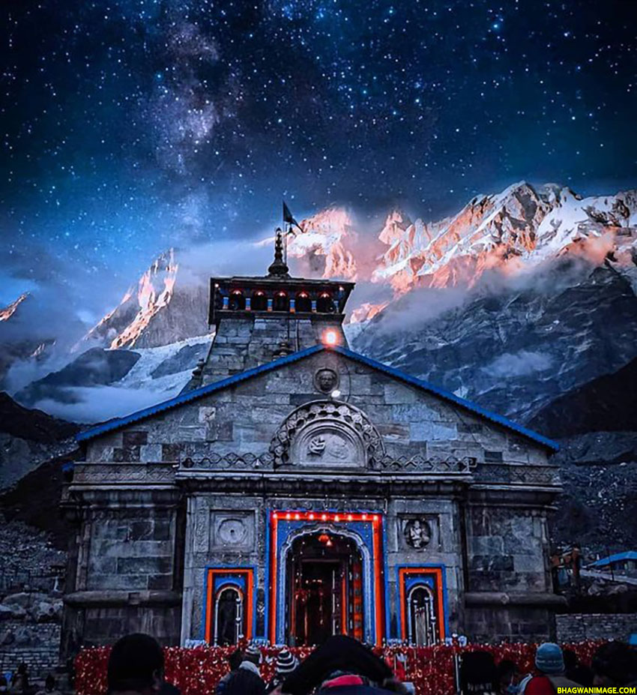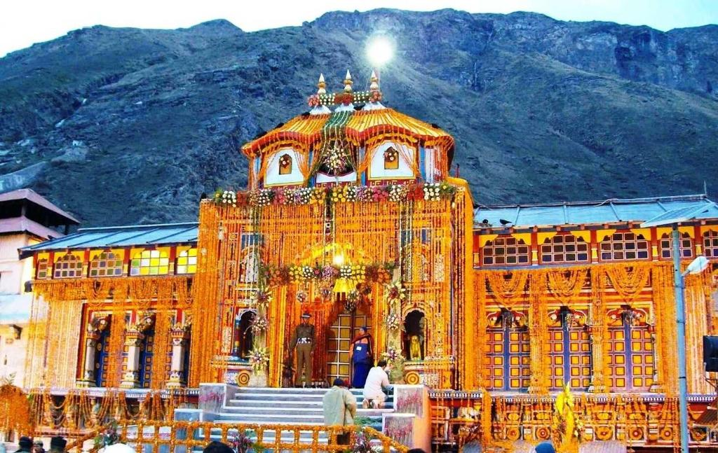

Do Dham Tour Details

Day Haridwar - Guptkashi (Drive220 km8 hrs)
Morning meet our representative at your Airport / Railway Station / Hotel. Drive towards Guptkashi. Enroute you can see the beautiful river Mandakini at Tilwara. The
Mandakini River comes from Kedarnath, drive alongside the river to reach Guptakashi, visit Ardh Narishwar Temple in Guptakashi. Check into the hotel arrival in Guptakashi. Overnight stay at Guptakashi.

- Day Gutkashi – Kedanath (Drive30 kmTrek14 kmAlt3384 m)

Morning after breakfast, today we will go to Kedarnath. To reach Kedarnath you will have two options. One if by trekking and other is by Air via Helicopter (at your own cost).
Important Information: Read Carefully
By Helicopter: Morning our driver will transfer you to your Helipad location
(Phata, Guptkashi, Sirsi etc) as per helicopter ticket time. Kindly inform the driver timings of helicopter mentioned on the ticket previous day. Different aviation has different location for their helicopter service. Our driver will provide you pick and drop to hotel. Kindly inform the driver timings of helicopter mentioned on the ticket. Advance booking is highly recommended for the helicopter.
Note: Helicopter Tickets are not included in this package.

By Trek: To reach Kedarnath by trekking route first you have to reach Gaurikund. We will drive to Sonprayag early in the morning after breakfast. Our car will drop to Sonprayag. From Sonprayag 5 kms drive to Gaurikund local jeep is available. This sharing basis jeep guests can book directly at own cost. Gaurikund to Kedarnath is further 14 Kms trek.

Day Kedanath-Trek14 kmDrive30 km
Gaurikund to Sonprayag local jeep at your own cost. Get packed breakfast from hotel to start early. At arrival check in to hotel in Guptkashi. Overnight stay at Guptkashi.

4Day Gupatkashi –Pipalkoti/Joshimath/Badrinath(Drive220 km)
Morning after breakfast, drive to Badrinath. Check in to the hotel arrival in Badrinath. Pilgrims after having a bath in the Taptkund have the Darshan of Badrivishal & Aarti in evening. Brahamakapal is significant for Pinddan - Shraddh of ancestors (Pitrus). There are other interesting sightseeing spots like Mana, Vyas Gufa, Maatamoorti, Charanpaduka,
Bhimkund and the "Mukh of the Saraswati River”. Just within the three km of Badrinath.

5 Day Badrianth - Haridwar/Dehradun/Rishikesh Drive320 km)

Morning after breakfast, drive for Haridwar / Dehradun / Rishikesh. Rishikesh 'Place of Yoga' is a celebrated spiritual town on the bank of Ganga. It is surrounded by Shivalik range of the Himalayas on three sides. Drop at Hotel / Airport / railway station

Place | Basic Hotel | Standard  Package Hotel | Deluxe Package  Hotel
GUPTKASHI/PHATA/SIRSI/SONPRAYAG | HOTELPANWAR HOTEL HANSDEEP HOTEL ANNPURNA HOTELSURYA SADAN  HOTELBHARAT HOTELHEERA HOTELBHARAT HOTELRAJ PALCE  HOTELVIDYA | HOTELNATRAJ HOTELKRISHNA RESORTS HOTELAIPAN RESORTS HOTELVISHNU PALACE  HOTELKEDAR KUNJ  HOTELSHINE RESORT HOTELSHIVA RESORTS HOTELWHITE  HOUSERESORTS HOTEL PUSHPWAN HOTELKEDAR GANGA | HOTELCHAR HOTELMACHAN HOTELNANDA HOTELRESORTS HOTELKEDAR HOTELVALLAY HOTELLAL RESORTS  HOTELHIMALIYAN ORCHID  HOTELSHIVALIK HOTELKEDAR GANGA  HOTELADADHAY VILLA
JOISIMATH/  PIPALKOTI | KRISHNAPALACE SIDDARTH KALPEAH KRISHNA TREVANI  SANIKHOME STAY BALARAMGUEST HOUSE  SRIKANT GUEST HOUSE PAWANHOME  STAY | BADRI KEDAR MAHALAXMI DIVINE RESEDENCY DHAULI GANGA SUNRISEINN PANCHVATI MADANMADHAV INDERPLACE | UDAY PLACE AULI D  INDERPALACE HOTEL DRONAGIRI SAPPHIRE MANIKRESORTS AULI  DEVINE RESIDENCY TATTVA HUMAALIYAECHO  LODGE

Excluding

- Entry rickets at monuments,Zoo,sightseeing places,National Park, boat ride.
- Guide charges
- Personal Expenses such as Laundry, telephone calls, tips & gratuity, mineral water, soft & hard drinks, rafting, rock climbing, paragliding, Porterage, Still / Video Camera fees etc
- Additional sightseeing or extra usage of vehicle, other than mentioned in the itinerary.
- Any cost arising due to natural calamities like, landslides, road blockage, political disturbances (strikes), etc. (to be borne by the client, which is directly payable on the spot).
- Any increase in taxes or fuel price, leading to increase in cost on surface transportation & land arrangements, which may come into effect prior to departure.
- Any additional meals / en route meals, sightseeing and activities other than those mentioned in the itinerary.
- Tour Guide Service.
- Helicopter Shuttle Charges

Pony Charges, Helicopter Charges & Palki Charges. It has to be directly borne by the tourist.Travel A Ease will have no role in this.

Cancellation Policy:

No. of days before commencement of Trip* | Total Deductions
21 days prior to the departure date | 30 % of the package cost
21 - 15 days prior to the departure date | 55 % of the package cost
14 - 08 days prior to the departure date | 80 % of the package cost
Less than 8 days/No Show | 100 % of the package cost

Health Advisory
- Senior citizen passenger must get their medical check-up before booking the tour.
- b. Passengers above age of 75 are required to accompany by an escort/family member of younger age.
- Hotel Check in time is 1200 noon.
- Being a group tour, personalized service is not viable. Hence, please converge with the group.
- Above rates are subject to availability.
- Cancellation charges as per company policy.
- Room categories in all packages are the base category rooms unless stated otherwise.
- Final confirmation in the proposed hotels is subject to the availability at the time of booking, else similar category hotel will be provided
- Please reach the airport 2 hours before the departure of the flight. SMTS will not responsible for missing of flights by the guest.
- In flight (Low Cost Carriers), the food and beverages are available on chargeable basis.
- Kindly reconfirm the departure terminal and the flight schedule from the airline before leaving for the airport.
- Web check in can’t be done for group tours.
- Transfers and sightseeing are on SIC (seat in coach) / shared basis by A/C vehicle.
- Arrival / departure transfers & sightseeing shall be provided as per schedule fixed by the hotel/Local SMTS Office.However, this may require you to wait at the airport for short duration until all the guests arriving at that time exit the airport.
- The request for an adjacent or adjoining rooms in case of two or more families from same acquaintance can considered by SMTS Tour Manager subject to availability.
- It is mandatory to carry the age proof of children (02 to 11 yrs) and infant (below 02yrs) along with other travel documents. Child above 11 yrs shall be considered for an adult cost.
- Airlines don’t offer seats to infants
- Room allocation (Twin bed / Double bed) is at the discretion of the hotel. The check in time at hotel is 1400 Hrs and check out time 1200 Hrs. Numbers of meals are always corresponding to the number of nights booked. Breakfast is not provided on the day of arrival.
- In hotels, for an extra Adult / Child, either Rollaway bed or mattress shall be provided.
For early check ins and late check outs the payment is to be settled directly by the guest.

Hotel has the right to claim the damages incurred by any of the guest.

The guests are requested to take care of their personal belongings carefully and avoid leaving
them unattended.

The airfares and taxes are calculated as on a mentioned date and any increase in the Taxes or
airfares will be borne by the customer.

For any change in Flight Timings/diversions, Flight cancellation from the airline SMTS will not be responsible and if it further affects the Sightseeing/Itinerary client need to accommodate accordingly.

Cost of additional services availed by the guest which are not part of our package inclusions are to be settled directly at the hotel.

To avail the arrival transfers please check the hotel representative holding the placard of your name / hotel name/ SMTS name.Buffet meal will be provided at fixed venue decided by the hotel.Timings: Breakfast: 0800 - 1000 hrs Dinner: 1930 - 2200 hrs.

These are the standard buffet timings observed by the hotels. Still, you are kindly requested to check the perfect buffet timings at the time of check in at the hotel. Once the buffet time is over the hotel might ask you to pay for your meals.

SMTS request you that before finalizing the tour with us kindly go through the
website of the hotels and read the reviews.
Package cost is calculated on lowest class Air Fare. Any increase in air fare or airport taxes has
to be borne by the client.

Any Itinerary posted on the website is only a proposed holiday outline.

SM TOUR AND SERVICES LLP Haridwar

S NO 10 KAPIL MARKET NEAR CHETAN DEV KUIYA MG ROAD KANKHAL HARIDWAR 249408

MOB. +91 9997680289,9927516565,6397734590



