SUMMARY
SCPASAR is based in York County, Pennsylvania…

South Central PA Search and Rescue is a 100% Volunteer, Non-Profit, 501c3, Search & Rescue Team that is available 24/7 - 365 Days a Year.
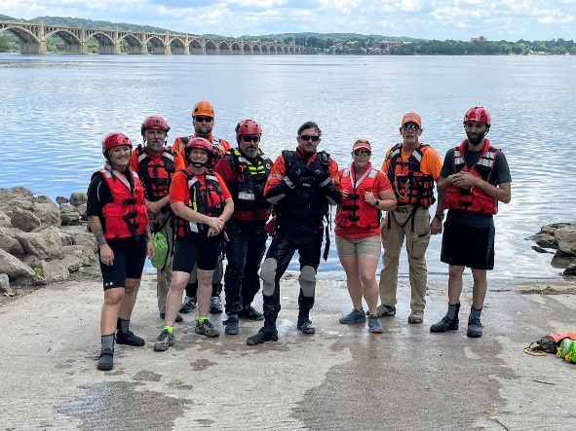

CAPABILITIES
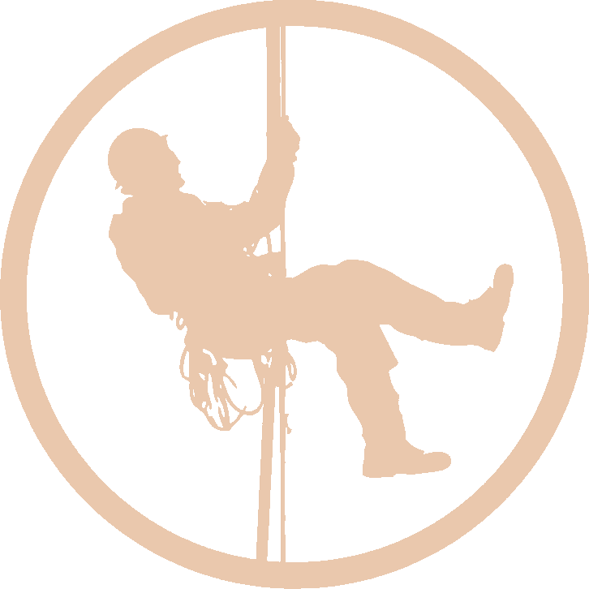
South Central PA SAR maintains a Team with a diverse set of skills and training in the following
areas…

- Ground Search
- K9 Search
- Water Rescue/Water Resource
- CERT
- EMS/Medical
- Rope Rescue
- Special Operations
- Incident Command
- Drone Operations

CONTACT INFO
For Emergencies Call 911
or for a Team Response
Contact a Team Duty Officer:
Chief - Kurtis Timmer: 717-927-1302
Dep Chief–Derek Bowersox 240-626-4287
Asst. Chief - Drew Harlacher: 717-804-6262

Mailing Address:

South Central PA Search and Rescue Station 93
P. O. Box 144 Wrightsville, PA 17368

Website:
Search93-SCPASAR.org
Facebook:
https://www.facebook.com/SCPASAR93/

SOUTH CENTRAL PA SEARCH AND RESCUE
- Station 93 -

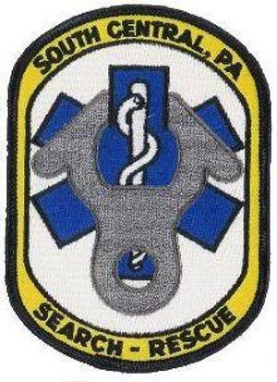

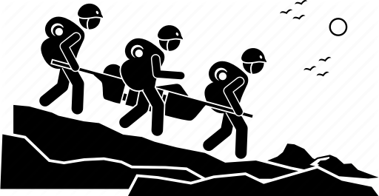
"Trained to Search... Able to Find...

Ready to Rescue... Determined to Care..."

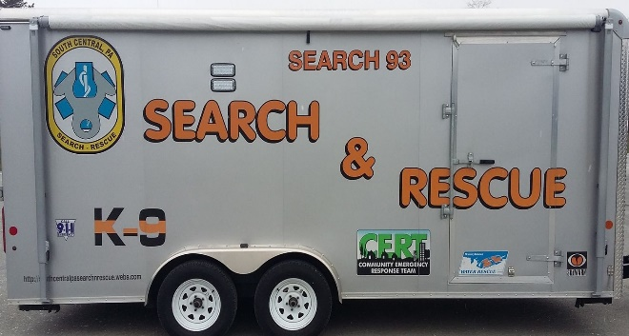
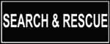
HOW WE CAN HELP…

As a deployable Search and Rescue Team we are able to respond and assist you with manpower and additional resources as well as certified responders… Many of our members are certified in Firefighting, EMS, Incident Command, NIMS, and Haz-Mat as well as our Search and Rescue Certifications so we are easy to implement and fit into your command or operations structure. We can assist in planning and organizing search operations as well as handling bystanders and family members. We can support your existing crews, provide relief, or back-fill your existing manpower. We can bring K9, Water, and Logistic Equipment to the table and implement them should it be beneficial and/or needed. We can assist your command staff with mitigating map work, task assignments, and logistics.

Above and Beyond…
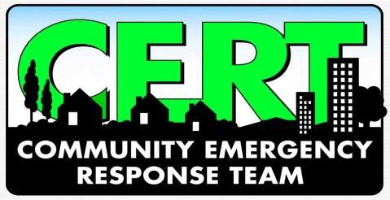
Above and beyond our SAR capabilities we are also a Certified CERT Team that can deploy and assist in times of Disaster. We can assist with evacuations, disaster relief, mitigating small hazards, providing manpower to affected areas to allow you to continue to respond to larger emergencies, staffing shelters or just providing supplemental emergency staffing wherever may be needed. We have a wide array of Medically Certified Responders who can triage and treat any potential patients. We are available to assist as a Medical Team should the need arise at a large scale incident or just to assist and help staff your existing Medical Operations.

The South Central PA Search and Rescue Team was developed to help local emergency services and communities deal with lost or missing persons no matter what the situation entails. We are a "Support" Team that local Fire, Rescue, EMS, Police, Water Rescue, and other emergency agencies can call upon to assist in mitigating any incident involving a lost or presumed missing person. All Team Members are very professional and certified in various aspects of Search and Rescue as well as EMS and Medical, Firefighting, Water Rescue, Hazardous Materials, NIMS, and many other certifications which support the overall team operations.
Once requested the Team will respond and function under the Incident Commander for the incident at hand. Our Team will operate as a support team to assist in the overall incident. We will not take over the incident nor assume responsibility of the incident as we are a mutual aid support team. The Team is able to assist with all aspects of the incident and is very "user friendly" in any application or need.
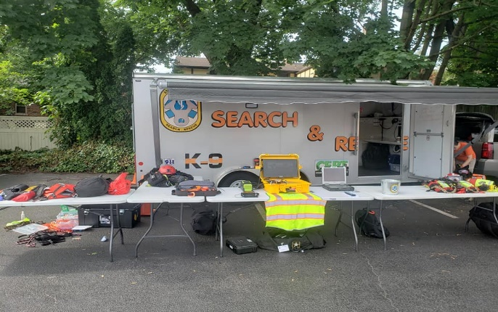
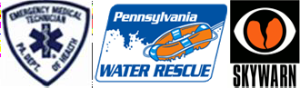
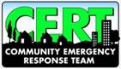

TEAM CREDENTIALS
Certified Search Managers
Certified NASAR SAR Tech I, II, III
Certified Wilderness SAR Search Responders
Certified Grid Search Responders
Certified Advanced Grid Search Responders
Certified Wilderness First Responders
PA Certified EMTs
PA Licensed Registered Nurse
Certified Pet First Aid Responders
PA Certified Water Rescue Techs.
PA Water Rescue Awareness Responders
PA Certified Water Rescue
Certified Haz-Mat Specialist
Certified Haz-Mat Ops. Responders
Haz-Mat Awareness Responders
Firefighters
Certified Fire-Police Responders
Certified SkyWarn Responders
Certified HAM Radio Operators
Certified CERT Responders
Part 107 Licensed Drone Operators

