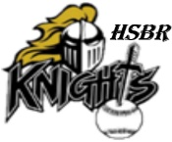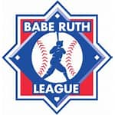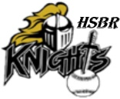

**Highland Springs Babe Ruth**

Good afternoon,

My name is Jeff Jackson and I am the President of Highland Springs Babe Ruth. We started this organization based on a continued need in Eastern Henrico and the Greater Richmond Region. I am the former founding Vice President of Highland Springs Little League, (2019), as well as current manager and coach of HSLL Majors (10-12 y/o) and Seniors(13-16 y/o). The boys that play for the Senior team, per Little League age charts, will be and are no longer eligible to continue playing baseball upon reaching the age of 16.

A dedicated group of athletes and parents requested that the senior coaches create an opportunity, for those who have aged out, to continue their playing careers. Now there are other avenues that may offer options however, those options oftentimes are cost prohibitive for families in the socio-economically challenged areas of Eastern Henrico and The Greater Richmond region. Out of that request Highland Springs Babe Ruth was created and charted in 2023. We are a 501c3 registered youth sports organization. We can be found on the IRS listings of non-profit organizations.

Attached you will find the Highland Springs Babe Ruth mission statement and sponsorship packet for 2024. We are also attaching our team registration and hole sponsorship flyer for our 1st Annual Protect the Hive Fundraising Golf Tournament scheduled for June 7, 2024, 1pm shotgun start @ Mill Quarter Golf Course in Powhatan, VA.

Thank you in advance for taking the time to read our introduction and looking over the above-mentioned attachments.

We look forward to partnering with you, with the intention of providing young men 16-18 y/o a positive, structured and organized alternative to being left to negative influences.

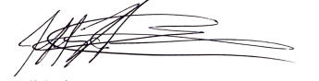With deepest appreciation,

Jeff Jackson

President Highland Springs Babe Ruth

804-502-8836

hsbaberuth@gmail.com