**Newsletter for Koa Lagoon Owners February 2018**

A copy of this newsletter can also be found at the Koa Lagoon Owner’ webpage by going to [koalagoon.org](http://koalagoon.org/) . The password for all owners is **lagoon800**

**TAT Increase Reminder**

The Hawaii Department of Taxation has advised that Senate Bill 4 has passed and **effective January 1, 2018**, the Transient Accommodation Tax **(TAT)** will increase from 9.25% to 10.25%. No change has occurred to the General Excise Tax (GET) at this time.

**Annual Owner’s Meeting**

This year we had 26 attendees representing 17 units and 74% proxy representation at our February 7, 2018 Owner’s Meeting. The minutes of that meeting, as well as those of the afternoon board meeting are in a separate attachment of this mailing. The next annual Koa Lagoon Owners meeting, followed by an evening potluck, will be held February 6, 2019.

**Vent Cleaning**

All of the vents at Koa Lagoon will be cleaned in the next several months as a part of routine maintenance.

**Concern over Aging tiles**

Several owners made mention of the aging tiles in both the pool shower area and the entry steps leading up to the mailboxes. The tiles are continuously cleaned but are aging and need replacement. For the entry area we are requesting quotes for tiles that will match or complement the current entry tiles outside of the elevator. The intent is to locate matching tiles and use those to retile the stairway and in front of the mailboxes. For the shower area in the pool there will be complimentary tile as well, but we are holding off on scheduling that work until we are more certain of what the repair to the pool coping and decking will involve. We want to complete all work for that area at one time. The board will keep you posted as they continue to gather information.

**Owner Directory**

Owners present at the AOAO Koa Lagoon Owner’s meeting were asked to update their information for the Owner Directory. Because of privacy concerns, the directory is **not** posted on the Koa Lagoon Owner’s Website. A copy of the current directory is sent annually to owners and this electronic mailing has your updated copy. If you discover errors in your own listing, please e-mail [board@koalagoon.org](mailto:board@koalagoon.org) to share changes.

**Book Exchange Area**

*Talk about a “facelift”!*

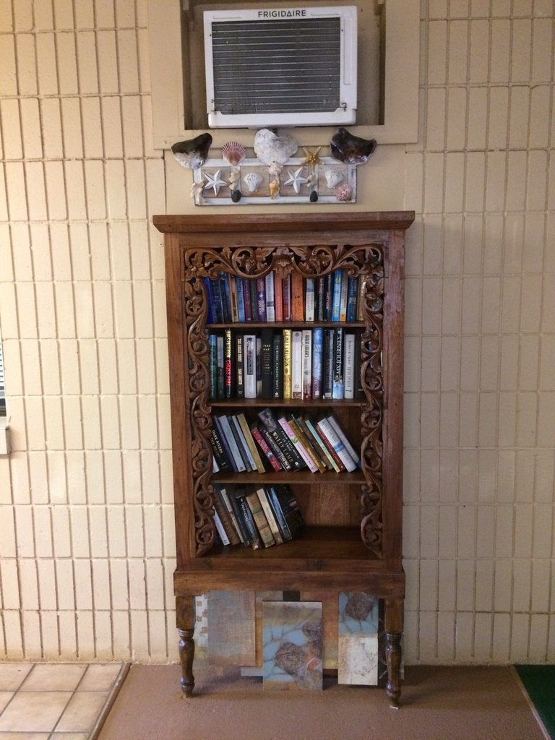

Valerie and Marie volunteered to spruce up the book exchange area, which had grown to include flyers, menus, leaflets, and spare phone books. It was looking a little “tired” and didn’t make a good first impression for our first floor owners and guests.

Marie and Valerie enlisted Edward to remove the existing wall mountings and he took the project further by painting and adding a “cover-up” to hide an air-conditioning tube….thank you Edward!

A new book case was purchased and Marie refinished it and sealed it for the elements. She and Edward added legs to accommodate a water collection pan …..and the end result is shown at the left. Well done!

**Repair of the Entry Trellis**

It was brought to the board’s attention that the front entry trellis is showing visible signs of rot in the wood when viewed from the upper floors. We currently have set aside funds to repair and/or replace the damaged beams and Larry Osborn has volunteered to assist the board in this project. Thank you Larry!

*Valerie Oliver*, Secretary AOAO Koa Lagoon