**Newsletter for Koa Lagoon Owners May 2018**

A copy of this newsletter can also be found at the Koa Lagoon Owner’ webpage by going to [koalagoon.org](http://koalagoon.org/) . The password for all owners is **lagoon800**

**Dryer Vent Cleaning**

All of the vents at Koa Lagoon have been cleaned as a part of routine maintenance over 3 days in early May. We have been advised that cleaning should occur every 3 years and will be inserting that new time frame into our maintenance schedule. We have changed our pest control and vent dryer cleaning vendors. This change was spearheaded by our Property Manager Edward, and will result in about a $1,200 a year savings.

**Repair of the Entry Trellis**

It was brought to the board’s attention that the front entry trellis is showing visible signs of rot in the wood when viewed from the upper floors. Over 3 days the trellis wood was entirely replaced and stained. Our entry is smiling again!

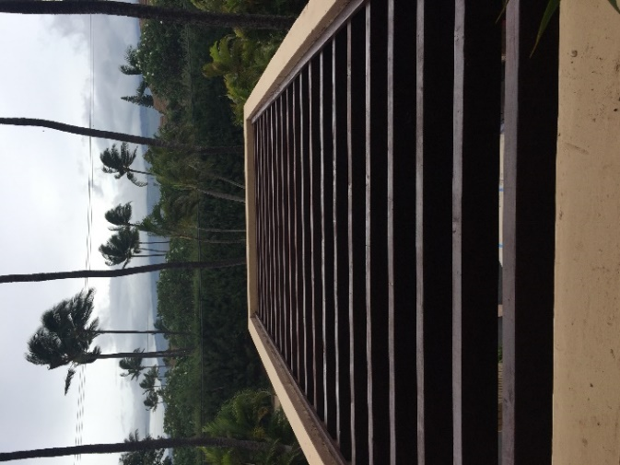 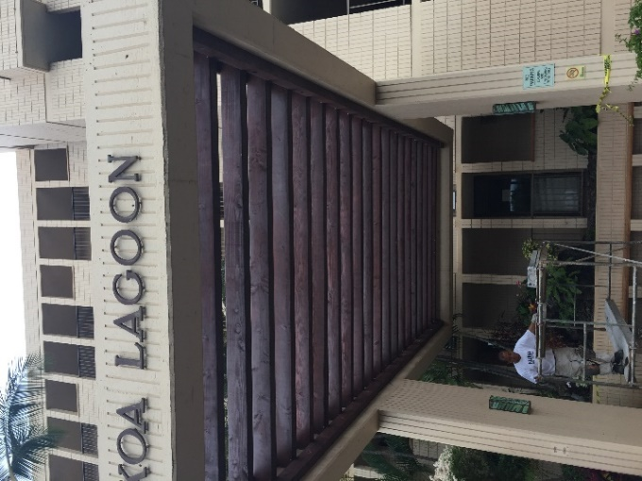

**Remodeling Projects set to commence in May, 2018**

There are 2 units at Koa Lagoon that have submitted the required paperwork to the Board President and received board approval for unit remodels. Those units are 406 and 201. While an application for remodel is not required for minor interior redecorating or replacement of carpet, it is required whenever any electrical, plumbing, wall or tile work is a part of the plan. You can find the AOAO remodeling application, as well as the Lanai Resurfacing policy on our Owner’s website.

**R-1 Project is nearing completion**

After 5 years, and involving much work done by L. A. Bannowsky, the R-1 water project is nearing its final completion. We anticipate that it will be done by the end of May and when that occurs we will have new markings on our property with purple heads that indicate the water emanating from them is R-1 (recycled) water. This water will be used for landscaping and will result in a savings of water costs over the long run. Thank you L.A. for sticking with us to see this project through!!

**Protecting our Reserve Funds**

We are pleased to say that, as reported by Treasurer Marie Bader during our February Owner’s Meeting, that we have in excess of $500,000 in reserves. At the time she informed owners that she would be looking into moving this total into several accounts so that all funds were protected under FDIC, and we would also earn substantial interest. We are happy to report that this action has been completed and we anticipate an additional $11,000 in interest on these 3 year CDs as a result of these changes. Thank you Marie!

**Reserve Plan Update**

The board has elected to once again hire HIG to prepare our 20 year reserve plan, which was determined to need significant attention. As treasurer, Marie Bader will be taking on this project and will be assisted by L.A. Bannowsky as the on-island board member. We anticipate that this activity will take several months and, as required by law, we will have the new reserve study ready to send to you all prior to the next annual owner’s meetings. This reserve plan will guide the current and future boards in identifying what common elements need to be addressed in order to maintain our current property features. While we are addressing an updated reserve plan the board will be temporarily halting work on future projects so that our most immediate needs may be assessed and addressed.

**Water leak**

There was a water leak in a 5th floor unit, caused by a 10 year old water heater, resulting in damaged to the units below. This is a good time to remind all owners that the board recommends replacing water heaters that are eight years old or older. The owner of failing equipment is liable for damage its failure may cause to any effected unit.

**Elevator Roof Room**

The Elevator roof room has been found to have a drainage problem, which caused water to temporarily leak into the elevator shaft. This leak has been sealed and the problem was resolved.

**Did you know??**

The composition of Koa Lagoon is as follows: Rental Units comprise 79% of Koa Lagoon ownership, followed by 14% Personal/non-rental secondary residence, and lastly 7% Primary Residence.

**On the Market**

Unit 107 recently went on the market. The listing has some wonderful photos of the property that might interest you. A link to the listing at this date is:

<http://www.thewaileagroup.com/PropertyDisplay.aspx?mls=378425>

**Proposed B&B**

Just south of Koa Lagoon (between K.L. and Village by the Sea) many of you have notices 2 lots, one of which has been under development for the past year or more. The developed lot is complete and has been for sale but has not sold at its asking price. The developer would now like to petition Maui to have this residential property issued a variance so that it can be rented as a B&B home. It is unclear whether the AOAO board or the entire membership received the “Neighbor Notice” from the Dept. of Planning on Maui. We are attaching the notice to this newsletter for those interested. The board of Koa Lagoon has taken this notice under consideration at this time and have not responded to date.

It is also worth noting that the County of Maui has recently purchased the undeveloped lot directly to the south of the B&B property and have actively started the process of turning this into a public parking lot for better beach access. This may have the benefit of reducing foot traffic along the southern property edge of our Koa Lagoon site.

**Questions? Concerns?**

We would love to hear from you! If you are on island and have compliments or concerns to share with the board, an accompanying picture is “worth a thousand words”

Mahalo!

Find us at: [board@koalagoon.org](mailto:board@koalagoon.org)

*Valerie Oliver*, Secretary AOAO Koa Lagoon