AOAO KOA LAGOON
NEWSLETTER—AUGUST 2015

DISTRIBUTION: To Koa Lagoon Owners

The Newsletter is to update owners on Board actions and the status of work at Koa Lagoon, as well as to review provisions of KL governing documents, Declaration and Bylaws, relevant to current issues. Board actions are designed to serve the common good. Board members are guided by HI law, Koa Lagoon’s governing documents, and advice of the Koa Lagoon attorney.

Some Koa Lagoon History with Property Management Companies: FROM THE 2002 MINUTES: “Management of Koa Lagoon by a property management company over the past two years has proven to be inefficient and expensive. Having an off-site property management company directing a qualified property manager is redundant, at times confusing, and has not resulted in cost savings promised by the two companies employed over the past two years. The cost of property management increased fifty percent for this past year, and the cost of projects planned increased about fifty percent over plan for a variety of reasons: management and control issues.”
Present Evaluation of A Property Management Company: Homeowners’ costs would increase every year. It would be more difficult and time-consuming for a Board to manage a property management company. We would lose our excellent bookkeeper. Our present excellent Property Manager would be asked to answer to and take direction from a management company, not the Board. We would still need to recruit five owners to be on the Board. Property management companies regularly raise their rates after they have become entrenched with a contract and their own personnel. Self-management by a dedicated Board brings a feeling of ownership and a sincere desire to do what is most economical and pleasing to the majority of owners. President Darrell Pierson is in almost daily communication with Edward for reports on Edward’s projects and challenges and for advice from Darrell, as was also true with previous President LA Bannowsky. The Koa Lagoon Board makes great effort to secure multiple bids and proposals, to research options, and to negotiate the best contract for owners. A professional management company has its own business goals and priorities, which would come FIRST for it. The current Board has only Koa Lagoon as its focus, not a number of properties. KL owners are fortunate to have had boards willing to devote time and effort to the self-management of KL, because they believe in the value of maintaining self-management status.
Revised Declaration and Bylaws: The Board has received a tentative final draft of the revised Declaration and Bylaws, which includes amendments added to the original Bylaws and changes to make Koa Lagoon’s governing documents compatible with HRS 514b. Added to the Declaration is this provision: “Smoking is prohibited in apartments, on lanais, all common and limited common elements and/or areas, and on the grounds.” The revision also includes provision for service animals. The Board has been reviewing this draft. Ultimately the KL attorney will make a final draft, which he will record with the State. At some time in the future, the secretary plans to provide owners with the final revision. KL owners are encouraged to acquaint themselves with the governing documents to insure accuracy of information.
FEMA Reclassification of Flood Zone Areas: In October FEMA will publish its new flood zone areas. In their preliminary report Koa Lagoon will no longer be considered as part of their new flood zone area and will not be required to pay flood insurance. This is not a final report and still subject to change. If the report is finalized and there is no change, we may want to consider termination of flood insurance. Image #1

2
An Assigned Parking Space for One Owner: The Declaration states ONLY that “all parking areas” are COMMON ELEMENTS (p. 8). Assigning a specific parking space to one owner would “amount to converting a common element to a limited common element for the exclusive use of a particular unit.” (letter from Attorney Robert Rowland, dated June 4, 2004) The Bylaws state (Page 17): “Changing Common Elements. Upon the approval of seventy-five percent (75%) of the common interests appurtenant to the Apartments, to change the use of the common elements.” Attorney Rowland’s letter states that changing a common element to a limited common element, “according to Hawaii Supreme Court, may only be done if 100% of the project owners approved.” A handicapped owner requesting an assigned parking space may ask the Board to place the request on the agenda for the annual meeting, at which time owners would vote on granting the request. Approval, then, according to the Bylaws, would require 75% of owners. Image #2
Rules at Koa Lagoon: The Bylaws (p. 32) state the following: “ THE VOTING OWNERS, BY THE VOTE OF A MAJORITY OF THEM PRESENT AT ANY MEETING FOR WHICH THE NOTICE OF MEETING SHALL HAVE STATED THAT THE ADOPTION OR AMENDMENT OF ADMINISTRATIVE RULES AND REGULATIONS WILL BE CONSIDERED, SHALL HAVE THE POWER TO ADOPT, AND FROM TIME TO TIME AMEND, ADMINISTRATIVE RULES AND REGULATIONS GOVERNING . . . THE DETAILS OF THE OPERATION AND USE OF THE COMMON ELEMENTS, AND SUCH RULES AND REGULATIONS WITH RESPECT TO THE USE OF THE APARTMENTS AS MAY BE DEEMED NECESSARY FOR THE COMMON WELFARE.” To comply with this provision, the Board will include the different sets of rules, submitted to owners prior to the annual meeting for their perusal, on the agenda for the 2016 Homeowners Annual Meeting. A motion to adopt the rules will be subject to the vote of owners and require majority vote by owners present at the meeting, as mandated by the Bylaws.
Enforcement of Rules: The Bylaws (p. 32, 33) state the following: “The Board of Directors shall have the power to fine any apartment owner an amount not to exceed …$250.00 for any willful violation of any of such rules and regulations.. . The Board shall impose such fines in its sound and sole discretion. The Board shall have the right to refuse to impose any such fine, even though such a violation be established, in its discretion, and for good cause.”
Recycled Water Comes to Koa Lagoon: The R-1 water recycled from the Maui sewer treatment plant pipeline has been completed from Kihei to Koa Lagoon. Past President LA Bannowsky secured favorable financial conditions for the R-1 project on behalf of Koa Lagoon owners and has been delegated by the AOAO Koa Lagoon Board to continue to manage the project to completion. Because of LA’s initiative to get Goodfellow Bros to pay for damage to KL landscaping during the waste water project, he secured a check for $1000, payable to KL, to replace a tree and other landscaping.
Maui County mandated the recycled water line be hooked up by property owners and condominiums. The irrigation water usage at KL was previously measured to be over 2/3 of the total County water purchased. The potential cost savings is over $5,000 per year.
The R-1 water hookup design, permits, water meter, and vault installation expenses will be reimbursed to Koa Lagoon through credits for future water bills by Maui County. These costs will be paid back within two to three years. After that, cost reduction will continue for years to come. Koa Lagoon will pay for improvements to the irrigation system, which are included in the present Reserve Plan for the irrigation system. Image #3
Wood Inserts and Wooden Benches Renewal: Edward has now completed the replacement and refinishing of all wood inserts in walkway railings on all six floors. He is installing the last two now and then will apply a second clear top coat to all wood inserts. Image #4 Edward has also completed refinishing of the wooden benches in front of the building. Image #5 An outside contractor would

3
have cost KL owners several thousand dollars for the refinishing of the wood inserts and the clear coated benches in front of Koa Lagoon.
Resealing of Elevator Pit: At the time of the elevator renovation, the Board hired a contractor from Honolulu to reseal the elevator pit, which developed accumulations of water because the water table is so high. However, after about a year, the elevator pit again showed water in the bottom. The Board learned that the Honolulu contractor would guarantee its work for only one year. In recent years Edward has had to pump out water with the help of an Otis technician to raise the elevator cab. In early August, Edward enlisted the help of the Otis technician to keep the cab raised while he waterproofed the elevator pit again, another example of Edward’s exceptional efforts as Property Manager. The first time the elevator pit was sealed by a contractor for $12,000. This time, the out-of-pocket cost for 2 buckets of sealer cost $400. There were no other charges. Image #6
High-Risk Components: During the past months, Kelly of Maui Sewer and Drain has been inspecting and replacing nipple connectors in the drain lines from the kitchen and bathroom sinks to the sewage drain lines. The Association paid for the inspection, but individual owners were billed for the nipple connector replacement work for their units, along with the invoice for quarterly maintenance dues. HRS 514-b calls these “high-risk components.” This HI Statute states: “The Board, after notice to all unit owners . . . may determine that certain portions of the units . . . pose a particular risk of damage to other units or the common elements if they are not properly inspected, maintained, repaired, or replaced by owners ...The Board may require . . . inspection . . . and replacement and repair . . .at the sole cost and expense of the unit owner.” Kelly found many nipple connectors in very bad condition, some close to failure. These replacements may have saved owners a future liability because of damage to units below from a leaking nipple connector. Image #7 All owners have readily paid their bill for this repair, excepting for one owner.
Improved Oceanic Time Warner Services: Koa Lagoon owners and guests now have the following: (1) Broadband Turbo Internet Service with Wireless; (2) Standard Digital Cable Service with over 200 channels, including Digital Variety Pak, HD Entertainment Pak, Music Choice, and Showtime; (3)Bulk Standard Telephone Service with unlimited local and nationwide calling to include Canada and select U. S. Territories. This telephone service does NOT include voice mail, operator-assisted call, directory assistance 411 information, and international calls. The Board again recognizes LA Bannowsky for negotiating this much improved contact with bulk rates at an increase of only $8.82/month over the old contract for owners who previously had all three services.
Hot Water Tank Leakage: A twelve-year-old hot water tank in #405 failed and flooded the floors. Edward was notified, and he immediately vacuumed up over 6 gallons of water to prevent further leakage down into unit #305. Edward promptly called the President to report the incident and the actions he had taken to prevent further water leak damage. Edward’s prompt action prevented more leakage into #405 and #305, and possibly into #205. Then he called Linda, who called the appropriate plumber to have the broken water heat replaced. Some water did seep down into #305. Owners are reminded of the need to replace water heaters that are past their warranty date and to have a flood alert device to detect leaks and emit a signal.
Report from Plumbing Administrator, Kerry Beasley: Hot Water Heaters—Image #8 Kelly Ford of Maui Sewer was able to identify warranty dates on only 19 of the 42 hot water heaters. Of those 19, 9 of the water heaters are beyond their warranty dates, ranging from 7 ½ years old to 17 years old. One of these hot water heaters is scheduled to be replaced in February 2016; this replacement needs some carpentry work done to gain access. Hopefully many of these hot water heaters beyond their warranty dates have been changed out by plumbers other than Kelly Ford. Owners are advised
4

to check the age of their water heaters, if it is not clearly identified on the heater. The Board would appreciate knowing if owners have had their water heaters replaced by a plumber other than Kelly Ford. Main Water Shutoff Valves—Unit #307 still has the old gate valve, which needs to be replaced with the newer type of shut-off valve. During Kelly Ford’s inspection, the shutoff valve in #407 was not accessible behind a locked closet door; Edward would not have access in case of an emergency. The location of main water shutoff values is not in the same location in each unit. Owners are asked to provide a detailed description of where their main shutoff valve is located, so that we can provide this information in a folder for Edward.
Sewer Re-piping Project—Progress Report by Darrell Pierson: Koa Lagoon is dealing with three companies to get proposals for Re-piping Sewer Lines. Image #9
- We have received a proposal from RVS Builders, a Maui-based company. The approach submitted is to do the re-piping in two phases. Phase I—Replace vertical stacks. Test and evaluate the vertical sewer vent pipes and the copper water pipes for present condition and laboratory analysis of “remaining life.” Phase II—Replace the ground floor, under-slab collector lines. The first step would be to add clean-outs and to clean out thoroughly the collector lines. This approach would disrupt two stacks per year (during low season) and the Reserve Plan spending would be on a pay-as-you-go basis.
- Michael Wright and Associates, a Maui-based company, is a consulting and project management company. They would handle getting preliminary engineering and permits and bring competing contractors’ bids to the BOD for approval. Michael Wright advocates doing the entire building one low season period; ie, June, July, August, September. Financing would require a bank loan.
- Sagewater (Honolulu-based company) would do the entire building re-piping during one shutdown of the entire building. Their shutdown would be for 2.5 months. However, they say they are busy on Oahu and would do Koa Lagoon on their schedule (one 2.5 month period) at a discounted price? Their representative said, “as soon as Koa Lagoon can ‘get in line,’ ngotiations may proceed and timing can be determined.” Financing would require a bank loan.
All three companies have access to skilled work teams to do what the Koa Lagoon Re-piping Project will require. The technical and economic evaluations of these options are underway.
Recent Break in County Water Line: Linda has reported that a break in a eighteen-inch water line occurred in the last couple of days, and Koa Lagoon, along with other nearby properties, had no water for about a 24-hour period. At Menehune people were dipping water out of the ocean to flush toilets. Regarding salt water as not prudent for pipes, Edward and Linda decided to open the pool for emergency use of pool water. The County brought in water trucks, which were soon depleted. The County also opened fire hydrants, apparently with a hose attached to the hydrant, which had a small lever. Only one guest threatened to check out but changed their mind when the water came back on.

Sincerely,

AOAO KOA LAGOON BOARD OF DIRECTORS
Darrell, Pierson, President; Maxine Johnson, Secretary; Leonard Cesene, Treasurer & Plumbing Administrator; Kerry Beasley, Plumbing Project Administrator; Valerie Oliver, Member-at-Large

AOAO KOA LAGOON
NEWSLETTER -- AUGUST 2015

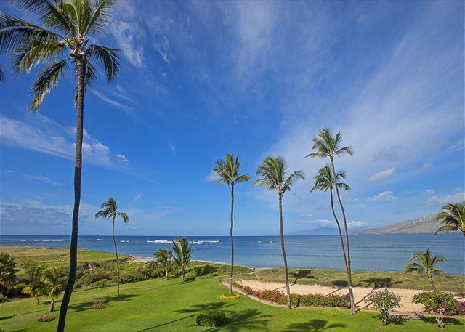 |  | 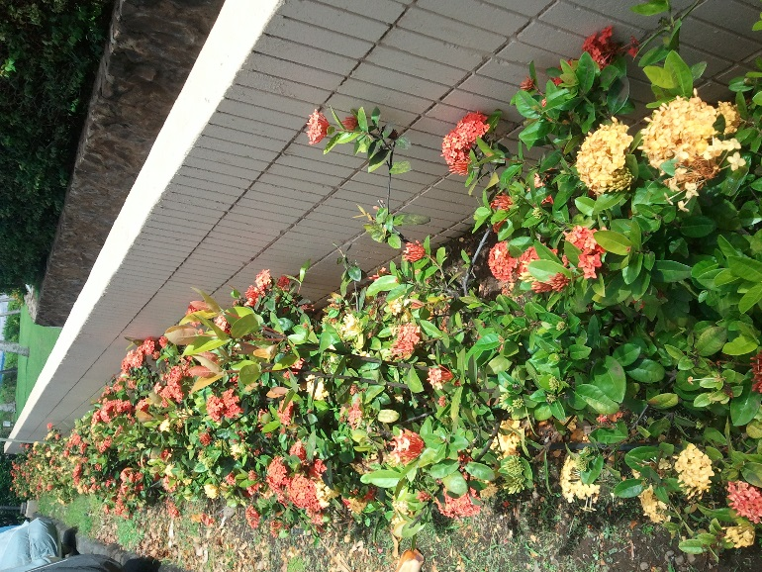
Image 1: Flood Zone Reclassification |  | Image 2: North Parking Flowers
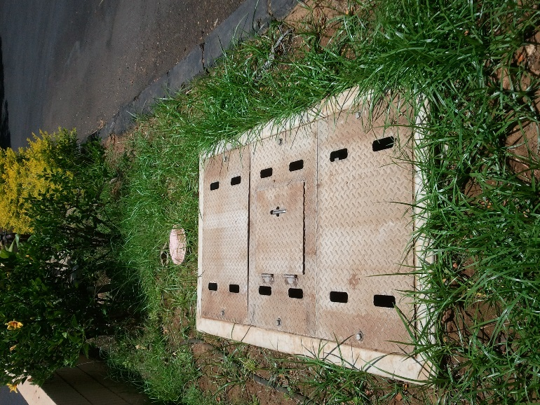 |  | 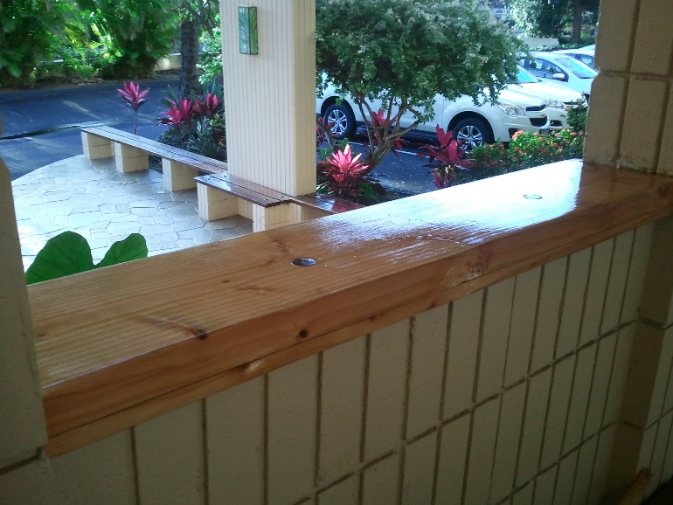
Image 3: R-1 Water Meter and Vault |  | Image 4: Wood Inserts
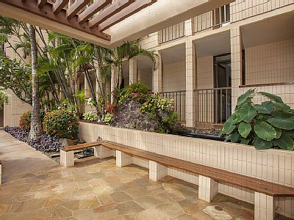
Image 5: Front Benches

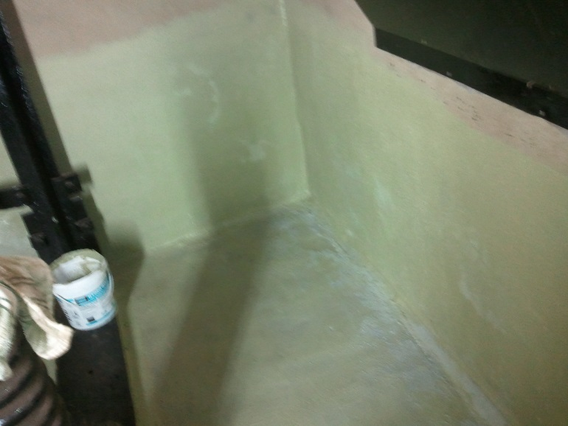 |  | 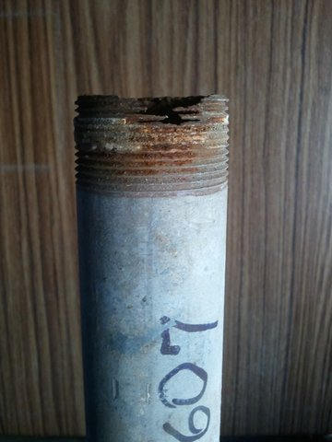
Image 6: Reseal Elevator Pit |  | Image 7: Galvanized Nipple Failure
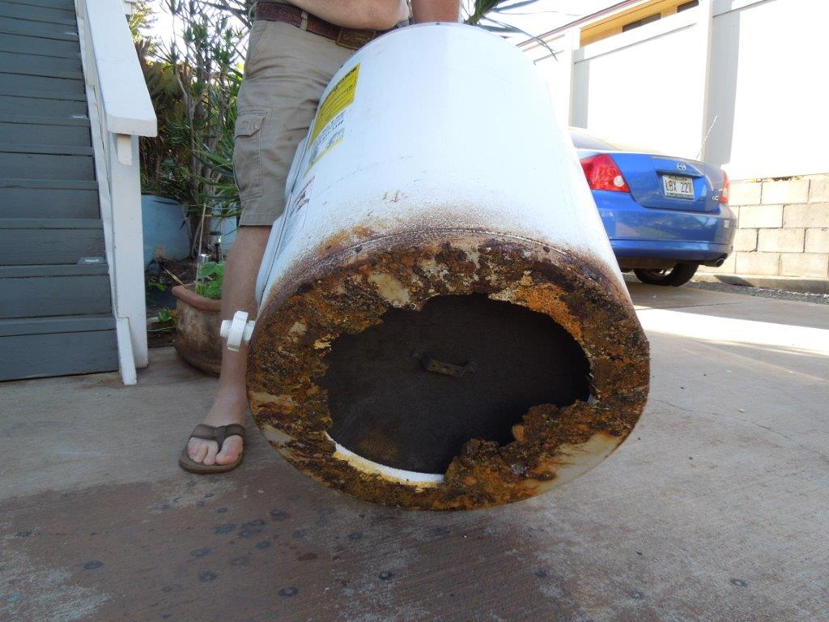 |  | 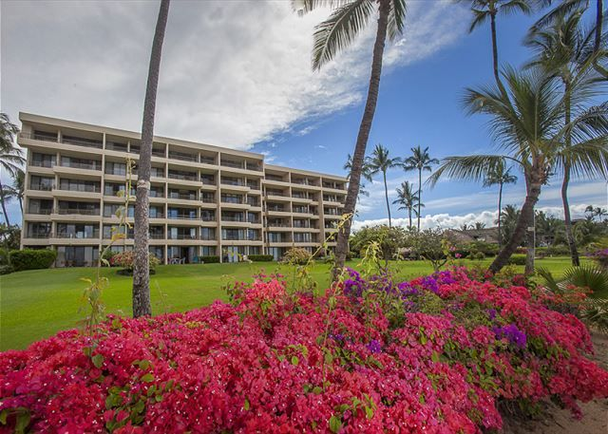
Image 8: Failed HWT |  | Image 9: Sewer Re-piping
AOAO KOA LAGOON
NEWSLETTER -- AUGUST 2015

