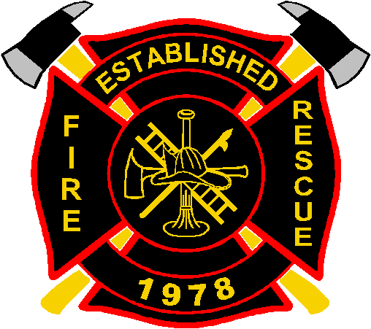
Jackson Trail Fire Rescue
3345 Jackson Trail Road ● Jefferson, GA 30549 ● 706-367-9557

Date: May 27, 2016
To: Insurance Agency, Inc.
From: Chief David J. Coholich
Re: ISO Protection Class Rating
Dear,
Please be advised that our ISO protection class was changed to a 3/3X – which went into effect 5/1/16.
If you or your underwriter should require further information, please do not hesitate to contact me at the number(s) provided below.
Sincerely,
Chief David Coholich
Jackson Trail Fire Rescue
Sta. #1 – 706-367-9557
Cell – 770-617-9205

