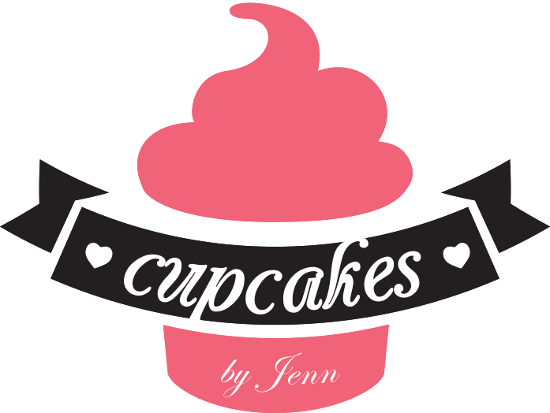
Cupcakes by Jenn
cupcakesbyjennshop@gmail.com

Cupcake/ Cake Flavors:
If you don’t see the flavor you want here just ask!
We offer allergy friendly options, just ask!
Base Cake Flavors: (For cake and cupcakes)
- Basic:
- Chocolate (GF)(V)
- Vanilla (GF) (V)
- Specialty:
  - Red Velvet
  - Funfetti (GF) (V)
  - Pink Champagne (GF)(V)
  - Devils Food (GF)(V)
  - Lemon (GF)(V)
  - Carrot
  - Chocolate Chip(GF)(v)
  - Strawberry (V)
  - Pistachio (GF)
  - Mint Chocolate (GF)(V)

Signature Cake/Cupcake Flavors: (highlighted indicates both cake and cupcake)
Boston Crème Pie: A soft yellow sponge cake filled with a sweet pastry cream topped with chocolate ganache.
Chocolate Crème Filled: Chocolate cake filled with a marshmallow crème filling.
Irish Car Bomb: A stout cupcake filled with Jameson ganache and topped with a bailey’s butter cream frosting.
Rainbow: Vanilla cake colored and layered to resemble that of the rainbow topped with whipped cream frosting. (Kids love these!)
Cuptails: Any of your favorite cocktails made into a cupcake! ( 21 and older only please.) Ask us for our Boozy menu.
Frosting Flavors: (for cupcakes only)
Most frostings can be customized to desired flavors
- Vanilla
- Chocolate
- Butter cream (any flavor)
- Swiss merengue buttercream (any flavor)
- Cream Cheese
- Ganache
- Chocolate chip cookie dough
- cookies and cream

Cake and Cupcake Fillings:
Don’t see yours here? Just ask! these also can be combined.
- Vanilla Custard
- Coconut Custard
- Fresh Fruit
- Fruit filling (like jelly)
- Chocolate, strawberry, raspberry, or vanilla Mouse
- Cannoli
- French crème
- butter cream (any flavor)
- fudge
- chocolate chip cookie dough
- cookies and cream
- pudding
- cream cheese

