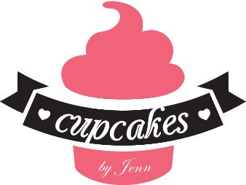
www.cupcakesbyjennshop.com
Price request form:
In order to give a price, we need to know a few things about your order…

- Are you looking to order a cake, cupcakes, or edible favor? (please list below)

- For cakes:
  - How many do you need to feed?

  - How many tiers would you like? (We may suggest a different size depending on amount of people, shape and design.)

  - What flavor cake and filling would you like? (you may choose a different flavor and filling for each tier)

  - Do you want fondant, butter cream, or a Swiss meringue butter cream (a less sweet butter cream) for the outside of your cake?

  - What design or theme would you like for your cake? (please feel free to send us pictures of cakes or anything that inspires your design, tell us what in those pictures you like best so we may design your cake.)

- For Cupcakes:
  - How Many do you need to feed? (minimum order of 1 dozen, 1 flavor per dozen)

  - What flavor?

  - What flavor frosting?

  - Would you like to fill your cupcakes? If so what would you like to fill them with?

  - What design or theme would you like? (please feel free to send us pictures of cupcakes you like or pictures that inspire your design)

- For edible favors:
  - What favor would you like? How many of each? (minimum order of 1 dozen each)
    - Cake pops/cake balls (please list flavors bellow)
    - Chocolate covered Oreos
    - Chocolate covered nutterbutters
    - Twice dipped Apples (Chocolate or Caramel)
    - Chocolate dipped strawberries
    - Chocolate covered pretzels (with caramel/ without caramel)
    - Chocolate dipped marshmallows
    - French Macarons (list flavor bellow)
    - Decorated sugar cookies
    - Brownie pops
    - Brigadero
    - Chocolate dipped rice crispy treats
    - Other (please list)

  - What design or theme would you like? (please feel free to send pictures)

  - Flavor or type/color chocolate?

