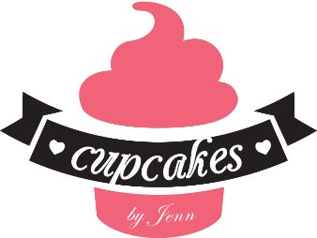
www.cupcakesbyjennshop.com
Dessert Table request form: In order to give a price, we need to know a few things about your request…
Please note included in your quote you will receive is design, set up, and breakdown as well as all other details quoted. We can always adjust to work within your budget your quote is just that any questions please ask.
Party Date:
Party theme/ colors (please give a description of what you would like this to look like and feel free to attached pictures):
Qty of guest:
Do you have a budget in mind?
Is this a favor that guests will be taking home in self-filled goodie bags or dessert served at the venue and you will be taking home leftovers, or both?
When at a party my family and friends: (this helps us suggest qty of treats needed)
a. leave empty handed.
b. will take home leftovers if offered.
c. brings their own Tupperware.
Which package interests you most?
Package #1 includes:
- Backdrop: this can be fabric drapes, custom designed poster, sequin wall, or arches
- Table linens for dessert table to match colors/theme
- Candy Jar and Dessert stand rental
- Signage for desserts, thank you note, and table opens when directed by sign.
- Design, set up before event, breakdown at end of event.
Package # 2 includes:
- Candy Jar and stand rental
- Signage for desserts, thank you note, and table opens when directed by sign.
- Design, set up before event, breakdown at end of event
Package # 3 includes:
- Disposable table linens, dessert trays and candy jars for self-set up. Delivery not included.
Design A la Cart Add-ons available: (Please check if you want any of these)
- Balloon garland (yours to take home)
- Neon sign (rental only)
- Props and decorations to enhance theme (rental only)
- Velvet ropes to keep guest from partaking before it is time (rental only)
- Goodie bags for take home; custom bags, boxes, basic white bags, bags with handles etc.
- Pilar cylinder stands instead of table to display your treats uniquely (rental only)
- All treats individually wrapped
What custom treats do you want on your table? Check all that apply, feel free to send images of designs you like. If you don’t see something you want just ask!
    - Custom cake
    - Cupcakes
    - Cake pops, cake balls or cake popsicles
    - Chocolate covered Oreos.
    - Chocolate covered pretzels (with caramel/ without caramel)
    - Chocolate or candy dipped marshmallows.
    - Chocolate dipped rice crispy treats.
    - Chocolate covered strawberries (seasonal)
    - French Macarons
    - Decorated sugar cookies
    - Gourmet Brownies (menu supplied if checked)
    - Gourmet cookies (menu supplied if checked)
    - Mini cookie cakes (bigger than your average cookie, single serving)
    - Dessert cups
    - Donuts
    - Apples caramel or candy covered
    - Other
Do you want candy to match your theme/colors? If yes please list what you would like, we will also send a list of what is available.

