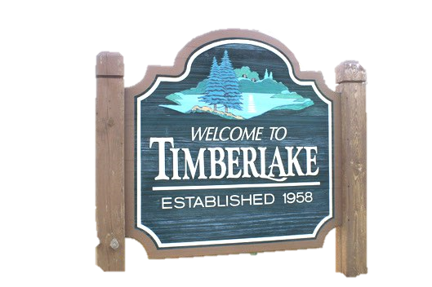
2026 Membership Form
Annual dues are $15.00 (optional additional contribution to the Timberlake scholarship_________)
Mail your check to: Timberlake Civic Association, P.O. Box 645, Westmont, IL 60559
OR – by PayPal
Complete the membership form and pay online via PayPal at www.timberlakecivicassociation.org
OR – by Zelle by completing the form online through our website www.timberlakecivicassociation.org and paying through your Zelle account to our email: treasurertimberlake@gmail.com
Method of payment ___Cash, ___Check, ___PayPal, ____Zelle

_____________________________ _____________________ __________________________________
Last Name First Name Spouse’s First Name (include last name if different)

__________________________________________________ ___________________________________
Address City

Phone Number: (_______) __________ - __________ **Email address necessary for newsletter and alerts

** Email Address: ________________________________________________________________________

** Second Email Address: ____________________________________________________________________

If you or a family member needs to be registered to vote, check here
Are you a new member? Yes ______ No ______

Were you in the last directory? Yes ______ No ______ Don’t Know ______

If yes, was the information correct? Yes ______ No ______

Telephone Directory Listing- Please select ONE

______ Include ALL information (Name, address and phone number)

______ Include ONLY Name and Address ______ Include NAME ONLY
Telephone directories will be available at the March Timberlake Meeting.

Preferred method of receiving your quarterly meeting notice?
______ By Email ______ By Postal Mail
2026 Vehicle Stickers (New sticker is good for 2026-2027)
If you would like to receive a vehicle sticker in the mail, please include a self-addressed stamped envelope with your dues. Otherwise, stickers will be available at monthly meetings or can be picked up from Linda Painter’s house (630) 209-5783. Indicate the number of stickers needed here (circle your choice): 0 1 2 3 4

Deadline to be in the Directory is January 15, 2026

