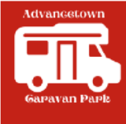
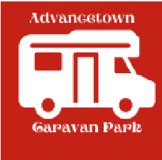
Advancetown Caravan Park Rules
To avoid conflict and to live in harmony, the following rules are set for strict adherence at all times.

- Only one vehicle per site. If you have a second vehicle/tralier please
park in the visitor’s car park

- Visitor’s cars are prohibited from entering the park without prior approval from management. This includes deliveries. Unregistered or un-roadworthy vehicles are strictly prohibited.

- The park road is one way clockwise. The speed limit is 10km/h must be abided by at all times.

- Vehicles are not to be parked on the grass.

- Vehicles are not to be parked in the restricted area this is reserved for main house residents.

- Pets must be kept on a leash at all times and their droppings MUST be picked up. Excessive barking and aggressive behaviour will not be tolerated.

- Smoking/Vaping is PROHIBITED in BBQ, laundry, clothesline and amenities areas.

- Two garbage compactors are located in the visitor’s car park – all rubbish to be bagged and boxes to be flattened. The compactors are emptied each Monday.

- Pool hours are from 7am – 9pm daily. Please see notice board in front of pool for rules.

- Laundry hours are from 7am – 7pm Daily.

- Clothes drying facilities are provided in laundry – Please ensure clothes lines are used discreetly, and refrain from hanging washing where it can be seen outside your space, as this keeps the park tidy for everyone.

- Dump Point is locked from 6pm to 7am daily.

- This caravan park operates solely on water tanks. Car washing requires approval from management.

- Excessive noise – (ie loud cars, loud music), illicit drugs & drunken behaviour will not be tolerated.

- If occupancy exceeds two tenants, an additional fee will be charged for each additional guest.

- Tenants are responsible for the area surrounding their site. It must be kept free of leaves, debris, and rubbish. Nothing to be stored around or under vans. Tenants must not install, attach, drill into, apply sealants or adhesives to, or otherwise alter any slab, site surface, structure or part of the site without prior approval from management.

CARING FOR ALL,
ADVANCETOWN CARAVAN PARK MANAGEMENT

