
Location: Greenville, S.C.

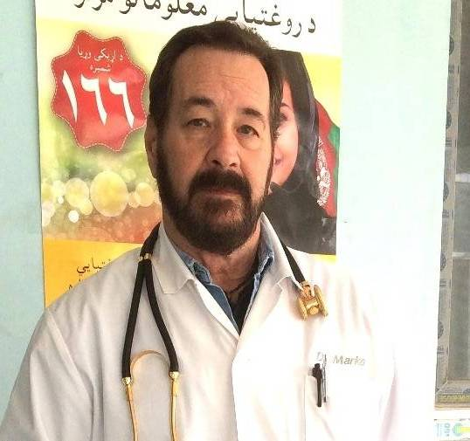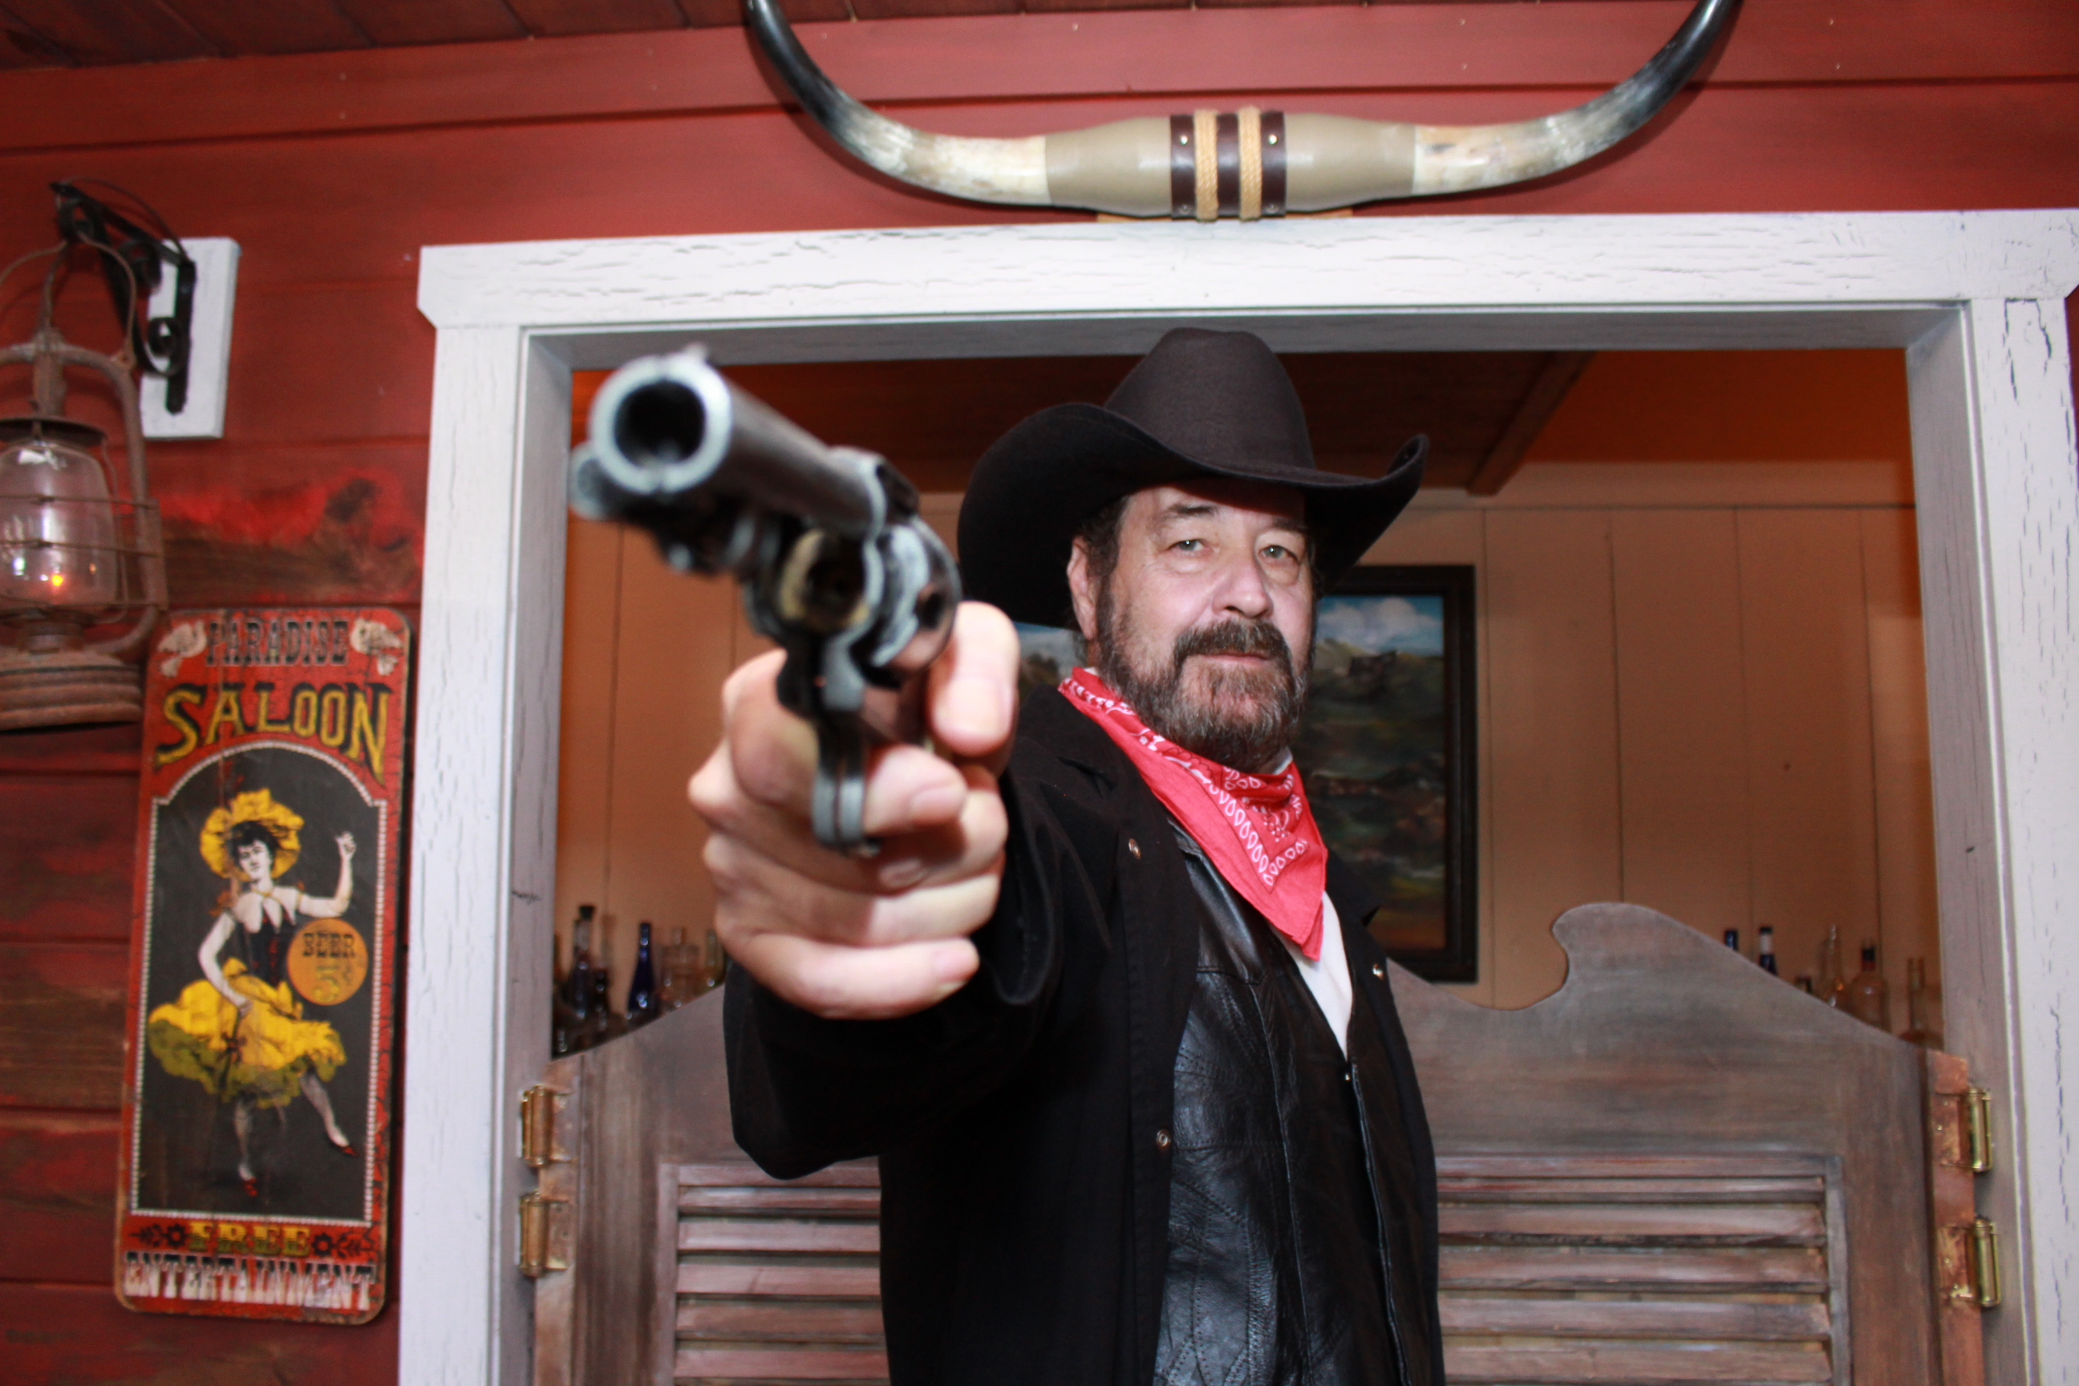

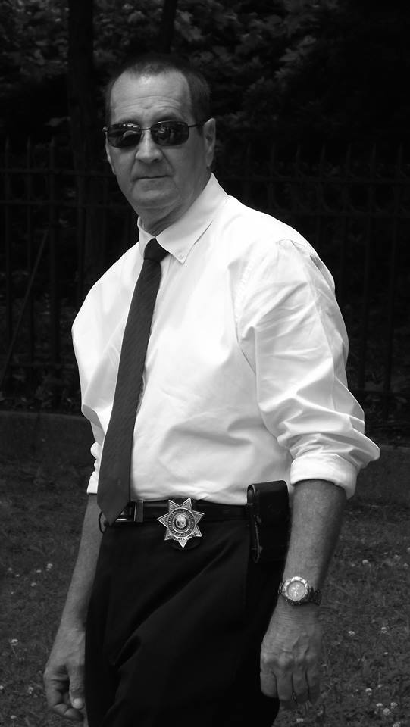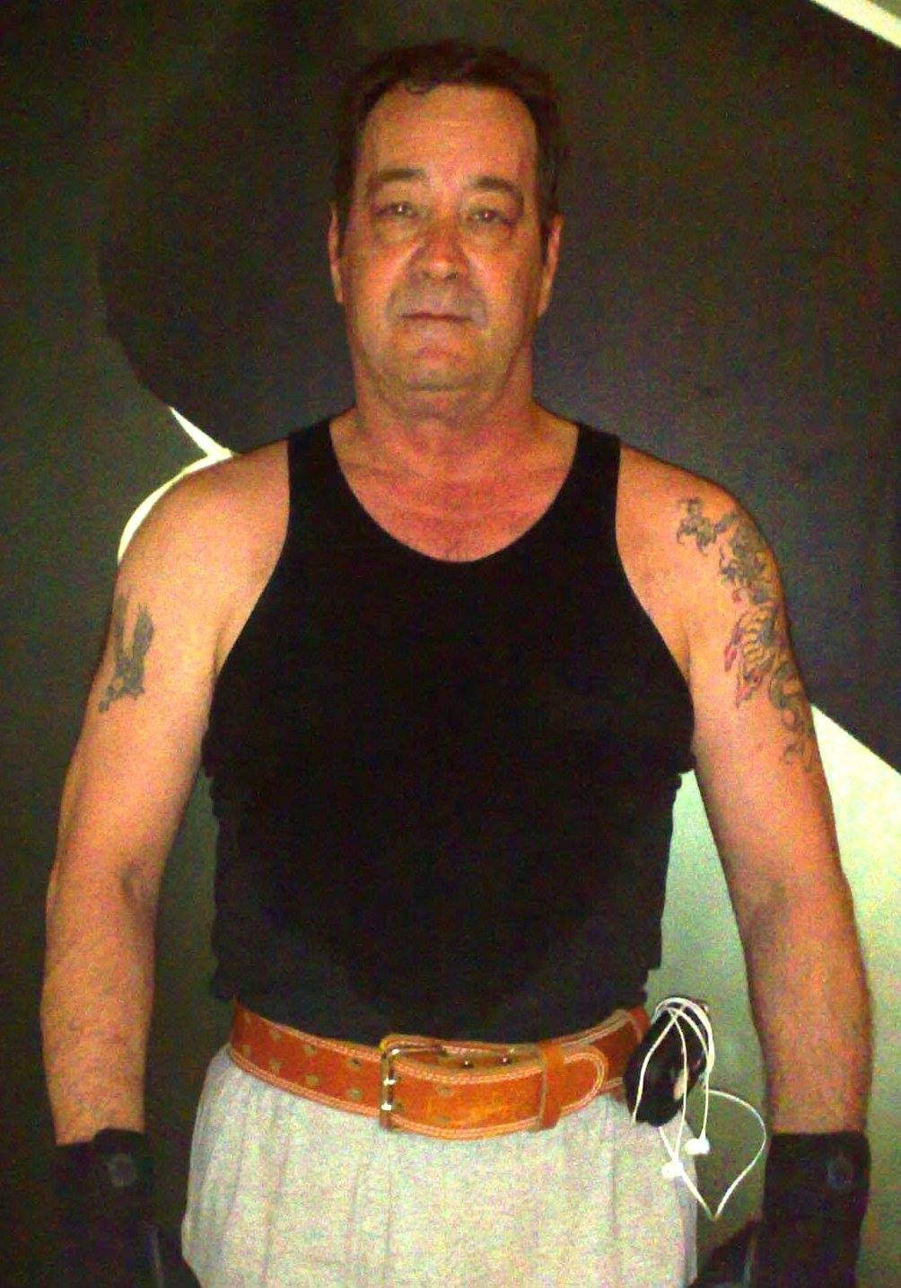

Have a Professional Home Studio for Recording
For Booking information, contact:
matt@mmarkoproductions.com
864-202-9546
Shirt – 15.5 Pants – 34x34 – Shoe – 11 / 6 ft, 185lbs.

Indie Movie Take: https://www.youtube.com/watch?v=nqE46qnFOow
FILM EXPERIENCE:
Shake Rattle & Roll Townsperson
Carrie 2 Paramedic
The Patriot Militia Fighter & More
Local Indie Film: That Guy –Lost Undercover - Police Captain
TELEVISION COMMERCIAL EXPERIENCE
Ten Local Commercials - Principal and Voice Over (both) Six television shows in China, One show in Ningbo, One movie in China
VOICE OVER: Documentary film narration for International NGO, Local Show “In The Stew”
SPECIAL SKILLS/INTERESTS
Psychiatrist/MD, Stunt Fighting, Sword Fighting, Archer, Expert Marksman, Hiking/Camping, Former Police Officer, Private Detective, Photographer, Paramedic, Military :USMC, Martial Arts

