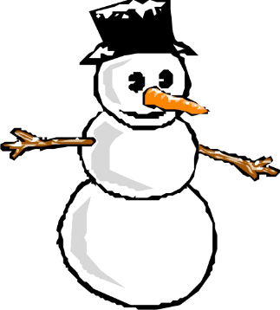
Salt Lake City
WINTER WINDUP SECTIONAL
AND
I/N PAIRS
SONS OF UTAH PIONEERS
(see map on www.utahbridge.com)
3301 East 2920 South
Salt Lake City, UT 84109

FRIDAY, JANUARY 17, 2020
Single Session Stratified Pairs 1:00 p.m. & 6:00 p.m.
Single Session Stratified 299 Pairs 1:00 p.m. & 6:00 p.m.

SATURDAY, JANUARY 18, 2020
Single Session Stratified Pairs 10:00 a.m. & 3:00 p.m.
Single Session Stratified 299 Pairs 10:00 a.m. & 3:00 p.m.

Max Aeschbacher “Bidding over Two Clubs” 2:00 p.m.

SUNDAY, JANUARY 19, 2020
Stratified Swiss Teams 10:00 a.m. & TBA
499er NLM Swiss Teams provided enough teams are available

STRATIFIED EVENTS
Pairs & Teams stratified by average MP per pair/team
299 Pairs Stratification 50/100/300
Swiss Teams scored on 20VP Scale
A 2000+, B 750-2000, C 0-750

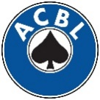
SPONSORED BY ACBL UNIT 386
SANCTION 2001332
ENTRY FEES
$10.00 per session for ACBL members
All players must have an ACBL number to participate.
A temporary membership is available from the Director for $4.00
(Unit 386 is subsidizing this fee regularly $7.99)
Lapsed members will be charged a $4.00 surcharge.
Members with 0-5 MP play free
Members with 6-20MP $10.00 1st session, $5.00 2nd session
Sunday
$120.00 per team for ACBL members
(Includes Continental Breakfast, Lunch and Snacks)
FREE COFFEE, DRINKS & SNACKS AT ALL SESSIONS
Players are invited to bring contributions for the snack table

ZERO TOLERANCE TOURNAMENT
No Scents – natural or artificial

NEARBY HOTELS
University Marriott 801-581-1000
Hampton Inn & Suites 801-583-3500
Extended Stay America 801-474-0771

TOURNAMENT DIRECTOR
John Gram

BOARD EVENT COORDINATOR
Cindy Zimmerman 971-886-1345 zczimm@gmail.com

UNIT TOURNAMENT COORDINATOR
Rosalee Gardner 801-440-7474
rosaleeg@comcast.net

PARTNERSHIPS

