CGPOA June 2021 eMinder

Letter from the President (Kathy Niemann): Hello Everyone, Hurray our sign is finally here. I know some of you thought it would never happen but thanks to the hard work of Mary Bell we have a new sign. One of the most frequently asked questions is “What took so long?”. We had to lease that little piece of land from the county. That meant that we had to have a contract with the county, it had to be approved by the county at a county commission meeting and then we had to get a permit. I think we need a permit to die in the Keys. After all of that was accomplished, the sign had to be ordered, created, and put in place. All of this took place during a pandemic. We have a great team of volunteers who have been working hard to landscape the sign and surrounding areas. If you see Nance Andrews, Bob Schoneck and BJ Deis, tell them thank you. They also installed solar lighting. The plants are designed to be drought tolerant and that is good since we do not have a way of watering in that area.
The board has more good news. Lisa Ferringo volunteered to be a director and Stacey Pillari volunteered to be our new social director. Mary Bell will move from director to our new Vice President. Speaking of social directors, more good news. The board has decided it is time to resume our social time together. If you are still hesitant because of COVID, we understand but believe with the new CDC guidance we can again safely socialize. The first get together will be June 18 at Jo Soha’s house on 1st Avenue West at 6 p.m. It will be a covered dish. Look for the signs as you enter the neighborhood.
Ken Kurdziel attended the last County Commission meeting. An additional 72 affordable housing units are proposed for Cudjoe. This proposal will increase traffic and certainly not increase our property values. The board will continue to monitor this proposal and object where possible.
If you live on Colson or Sawyer, we are trying to get signs for your streets. The current issue is getting somewhere to place the signs.
The next meeting will be held on June 8 at Ken Kurdziel house, 21072 6th Avenue E. at 7pm. All are welcome.

Join Cudjoe Garden Property Owners Association (CGPOA) (Kathy Niemann): It is not too late to join the CGPOA. We would love to have you be a part of the association. The dues are only $75 annually. Hopefully, you can tell we are working to improve the neighborhood and working for everyone. Come be a part of it. You can send the money to P O BOX 420121 Cudjoe Key, FL 33042 or see one of the board members for more information.

In the United States, Flag Day is celebrated on June 14. It commemorates the adoption of the flag of the United States on June 14, 1777, by resolution of the Second Continental Congress.

Hurricane reentry decal (Jo Socha): We are getting a lot of residents coming in for their stickers at the Sheriff's Office but we do not have them, please read below for distribution of the new sticker. The old sticker will not get you back in if the need arises to close the Keys. Changes in hurricane reentry decal system: Sheriff Rick Ramsay wants to remind residents that now is the time to prepare for hurricane season. “That means getting your evacuation plan in place, gathering important documents, stocking your shelves and cleaning up the yard among all the myriad other steps we take each year to stay safe,” said Sheriff Rick Ramsay. “There are some changes to the reentry sticker program this year and its important all residents are aware of those changes. Let’s make this storm season as safe as we can.” The important caveat this year: The Sheriff’s Office Substations are no longer distributing hurricane reentry vehicle stickers. As per Monroe County Emergency Management: Residents may now obtain one sticker for each registered vehicle by providing proof of residency at a Monroe County Tax Collector’s office. Proof of residency includes a Florida Driver’s License and vehicle registration, or a property bill with an out-of-county vehicle registration for out-of-county residents who own a home in Monroe County. These stickers make reentry easier if checkpoints are required to assure safe reentry into the Keys following a destructive storm that causes a public safety issue. Residents from Ocean Reef to Stock Island: Stickers are available at the Monroe County Tax Collector’s office locations from 8 a.m. to 4:45 p.m. Monday through Friday.
In Key West, residents can go to City Hall, 1300 White St.
Tax Collector’s Office locations:
• Marathon - 3015 Overseas Hwy
• Big Pine Key – 247 Key Deer Blvd (Tuesday through Thursday 9 a.m. to 2:45 p.m.)
• Plantation Key - 88800 Overseas Hwy
• Key Largo - 101487 Overseas Hwy
• Residents who live in Ocean Reef: Stickers are available at Ocean Reef Public Safety, 110 Anchor Dr., Key Largo.
For more information about the hurricane, sticker program go to www.monroecounty-fl.gov/916/Reentry-Vehicle-Windshield-Stickers
Please help us spread the word!

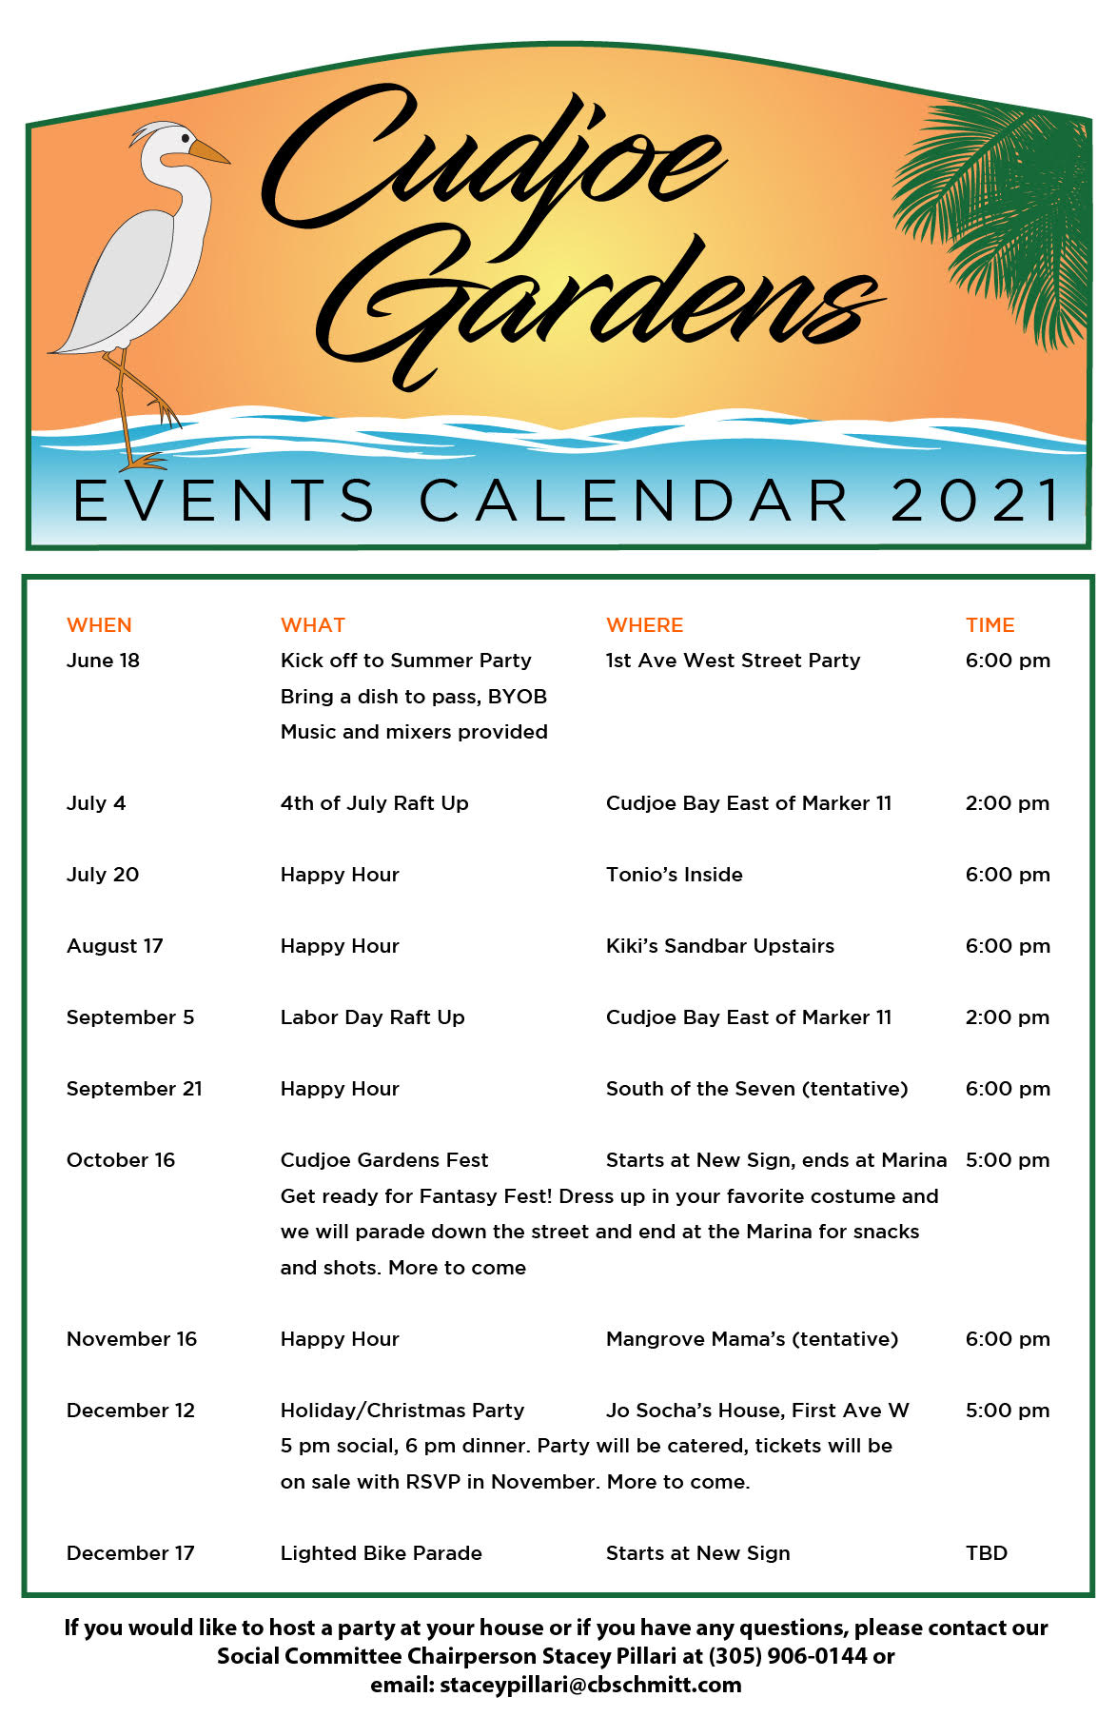

Vegetation Blocking County Right of Way (Cindy Dresow):
The Rainy Season has arrived, so all of our trees, and plantings are growing rapidly. The CGPOA Board has received complaints of dangerous situations at some driveways and stop signs because of vegetation extending into the right of way. Everyone needs to be able to clearly see other traffic, or bicyclists or pedestrians at intersections. One low branch can completely block a driver’s view of a person walking or running
It is the responsibility of the adjacent property owner to trim or remove vegetation blocking visibility. If the County takes action on this, they will send a crew to butcher every potential hazard in ALL of their right of ways. By keeping your vegetation properly trimmed, we will avoid “the butchers”. A tree, shrub, or other vegetation that blocks the view of signs, signals, and intersections is a potential hazard. If overhanging vegetation is blocking visibility on streets, sidewalks, alleys, and other public right-of-way areas, it is the responsibility of the adjacent property owner to trim or remove it.

“IF THESE WALLS COULD TALK” (Cindy Dresow): Have you ever wondered what stories you’d hear if walls could talk? In touring old houses, oftentimes the guide will say, “If these walls could talk”. In most cases, it’s best the walls remain silent, keeping details secret. Yet, it would be interesting to know all the history those walls have stood through. Perhaps the home’s owner had interesting hobbies, or served our country in ways we will never know.
Thus begins an idea brought to the CGPOA Board by a long-time member. She suggested that every house has a unique story. We’ll begin posting “IF THESE WALLS COULD TALK” in the July e-minder, and continue each month for as long as we have stories submitted. If you’d like to tell a story about your house, the reason you chose it, the history in the years it has been here, or the story of the house yours has replaced, please send that information to Cindy Dresow <cindy.dresow@gmail.com>. Photos of construction, or improvements you’ve made would be welcome. We look forward to learning the “How’s” and “Whys” and “Good Vibes” of your house.

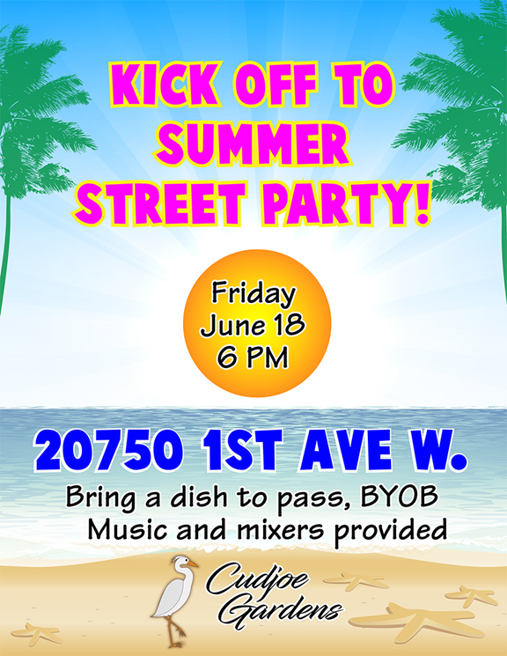

Rafting it up (Cindy Dresow and Randy McDonald): The first raft-up since the pandemic was a great success! Sunday, May 30th was a perfect day for the CGPOA Memorial Day Raft-up. At 1 PM, boats began arriving in Cudjoe Bay culminating with eight boats tied up together with 25 people and 2 dogs. Everyone brought delicious food to share as finger foods were passed from boat to boat. Most enjoyed swimming or floating with water toys behind the boats. Randy McDonald brought the combined ingredients for his famous mango ice-cream. Many took turns cranking the ice cream maker, as more ice and salt were added around the outside. The finished homemade Mango ice-cream was enjoyed and appreciated by everyone. The next raft-up will be July 4th. If you are unsure of rafting procedures (quite simple really) please read the article in last month’s eminder – available on our website: MONTHLY eMINDER | Cudjoe Gardens Property Owners Association. Come join the fun!
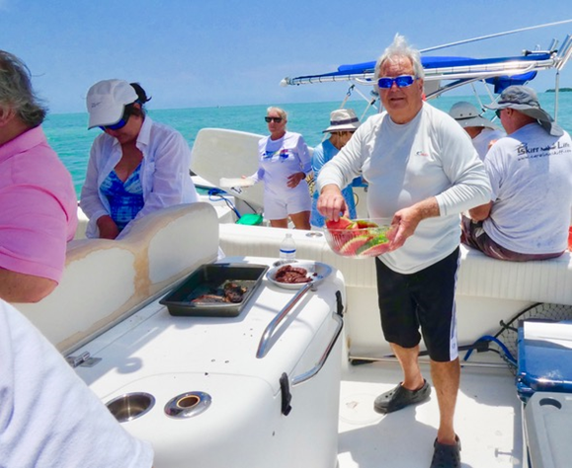

Rain Report (Randy McDonald): The rain total for May was 2.44”. To check rain more often visit https://www.cocorahs.org/ViewData/StationPrecipSummary.asp and enter my station: FL-MN-6

Property Owner’s Concerns: If a property owner has a specific concern, it must be mailed to the Cudjoe Gardens Property Owners Association (CGPOA) or given to a Board Member in writing. It will then be discussed at the following Board of Directors Meeting and kept on record. Please mail any correspondence to: CGPOA, PO Box 420121, Cudjoe Key, FL 33042
