Tee-Up 4 Kids Golf Classic

**SATURDAY, OCTOBER 20, 2018**

**[RAIN DATE OCTOBER 27, 2018]**

**Silver Wings Golf Course**

**Combat Road, BLDG 20067**

***Fort Rucker, AL***

**(334) 255-0089**

**HOSTED BY BOYS & GIRLS CLUB OF SOUTHEAST ALABAMA**

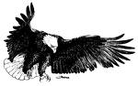

**~ FOUR PERSON SCRAMBLE ~**

$75 “Per Person” or $300 “Per Team”

ENTRY FEE INCLUDES GOLF, CART, PARTICIPANT GIFT & LUNCH BUFFET, ONE NON-ALCOHOLIC BEVERAGE, UNLIMITED DRIVING RANGE ONE HOUR PRIOR TO TEE TIME PLUS AN ADDITIONAL 18 HOLES OF GOLF AT SILVER WINGS GOLF COURSE.

6:30 A.M. REGISTRATION

6:45 A.M. BREAKFAST

8:15 A.M. SHOTGUN START

POST TOURNEY BUFFET LUNCH & PRESENTATIONS

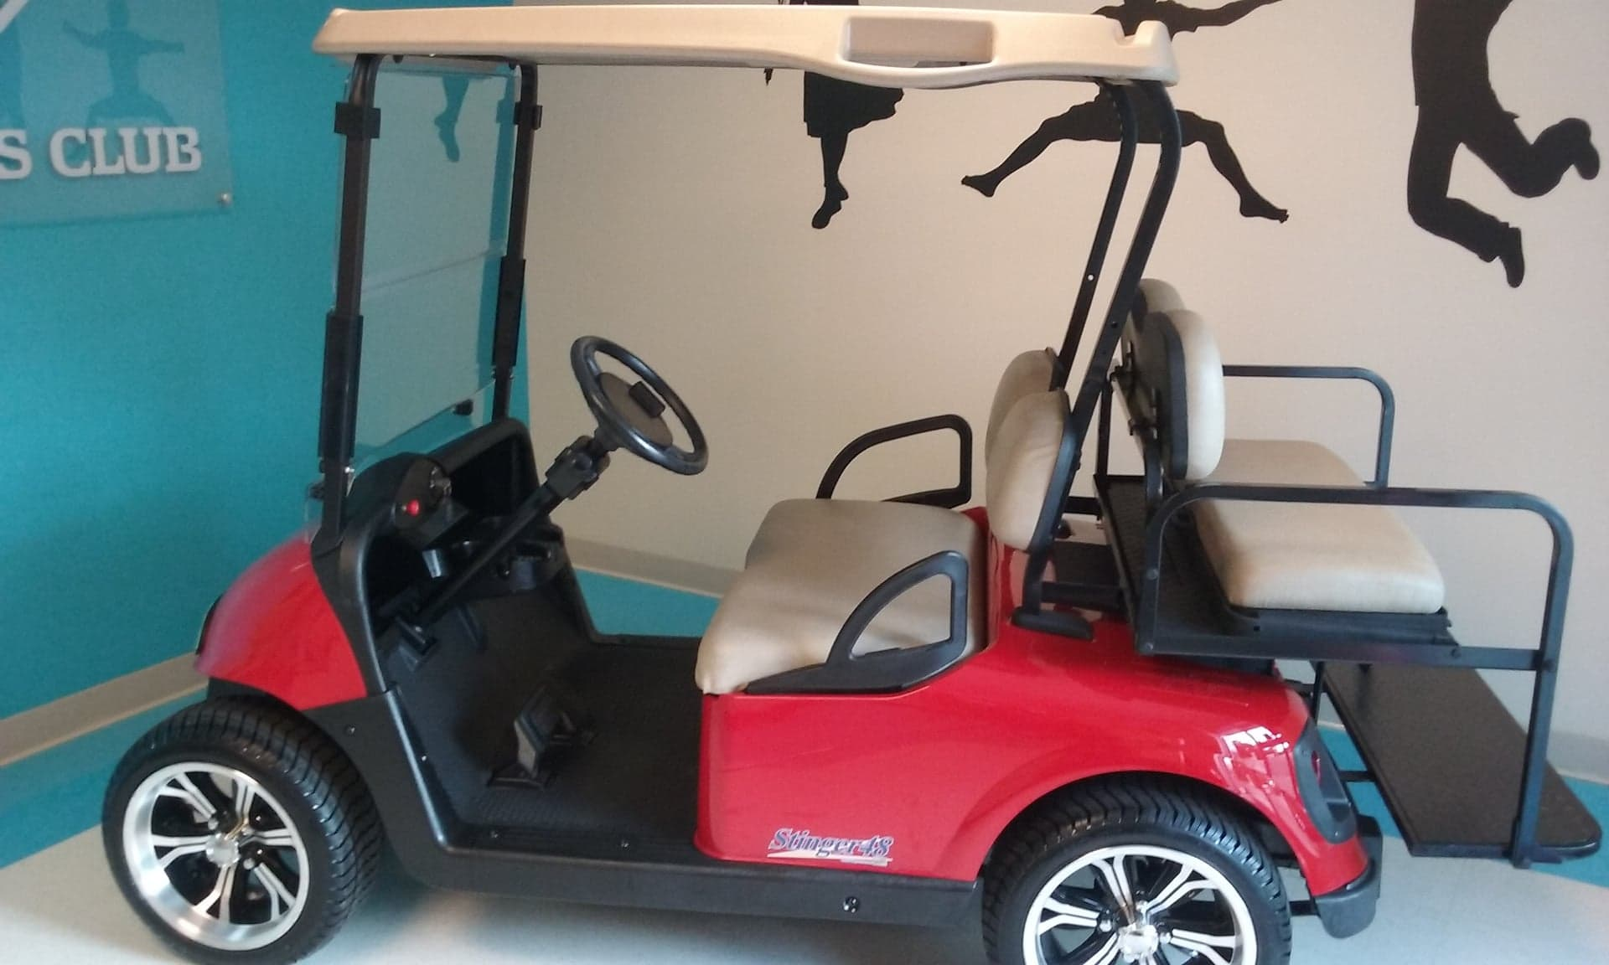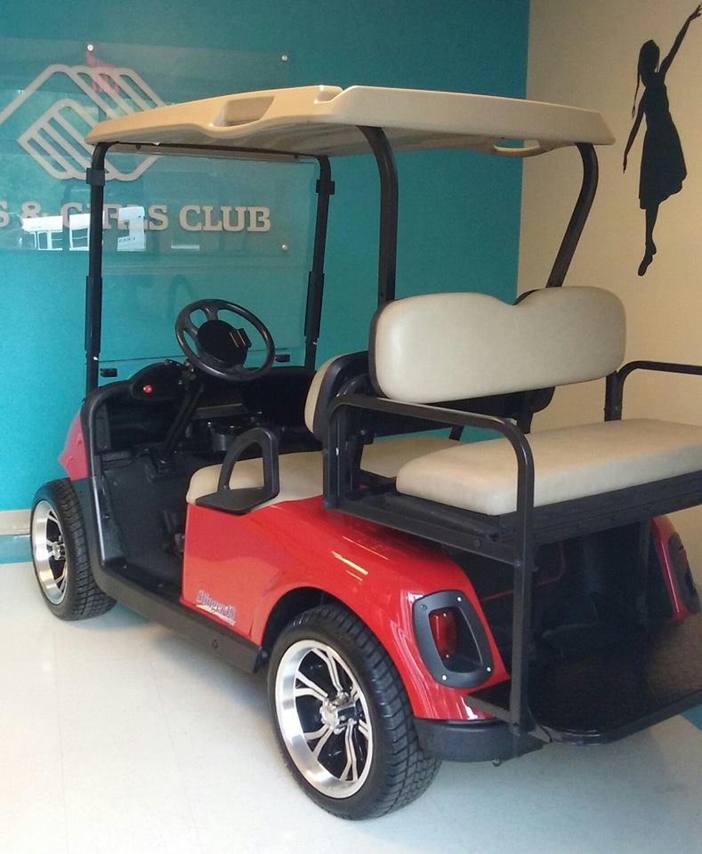

GOLF CART DRAWING

TICKETS $25.00 EACH

HOLE-IN-ONE WINS **$10,000**

**Cash Prizes and Gifts**

LONGEST DRIVE Prize CLOSEST TO THE PIN Prize

**TEAM GROSS 1ST thru 4TH PLACE**

**TEAM NET 1ST thru 4TH PLACE\*\***

***\*\*Computed on a basis of 15% of total team GHIN HC***

MULLIGAN’S (2 PER PERSON) AVAILABLE FOR $5.00 EACH

**SPONSORSHIP OPPORTUNITIES**

**Presidents Club ~ $2,000 (Signs & Team) Platinum Club ~ $1,500 (Signs & Team)**

**Gold Club ~ $1,000 (Signs & Team) Silver Club ~ $500 (Sign & Team)**

**Bronze Club ~ $250 Hole Sponsor ~ $100**

***ALL DONATIONS ARE TAX DEDUCTIBLE***

For more information, contact Lonnie Groomes or Amy Phillips at (334) 445-0512

**~ENTRY FORM ON FLIP SIDE~**

Tee-Up 4 Kids Golf Classic

**HOSTED BY BOYS & GIRLS CLUB OF SOUTHEAST ALABAMA**

**SATURDAY, OCTOBER 20, 2018**

**[RAIN DATE OCTOBER 27, 2018]**

**Silver Wings Golf Course**

**Combat Road, BLDG 20067**

***Fort Rucker, AL***

**(334) 255-0089**



Four Person Scramble

$75 “Per Person” or $300 “Per Team”

**(SILVER WINGS MEMBERS $65 “PER PERSON)**

ENTRY FEE INCLUDES GOLF, CART, PARTICIPANT GIFT & LUNCH BUFFET, ONE NON-ALCOHOLIC BEVERAGE, UNLIMITED DRIVING RANGE ONE HOUR PRIOR TO TEE TIME PLUS AN ADDITIONAL 18 HOLES OF GOLF AT SILVER WINGS GOLF COURSE.

6:30 A.M. REGISTRATION

6:45 A.M. BREAKFAST

8:15 A.M. SHOTGUN START

POST TOURNEY BUFFET LUNCH & PRESENTATIONS

*For more information, contact Lonnie Groomes or Amy Phillips at (334) 445-0512*

*If you wish to play but do not have a team, the tournament committee will pair you up!*

**Tee-Up 4 Kids Golf Classic “TEAM” Participation Form**

**\*PLAYERS NAMES SHALL BE EXACTLY AS ON DRIVERS LICENSE FOR RAPID ENTRY WITH RUCKER GATE GUARDS\***

_______________________________________________________ Silver Wings Member Y / N

Player’s Name Phone GHIN HC ________

_______________________________________________________ Silver Wings Member Y / N

Player’s Name Phone GHIN HC ________

_______________________________________________________ Silver Wings Member Y / N

Player’s Name Phone GHIN HC ________

_______________________________________________________ Silver Wings Member Y / N

Player’s Name Phone GHIN HC ________

Enclosed is my check payable to the Boys & Girls Club of SE Alabama for $_____________

Mailing Address

Boys & Girls Club of SE Alabama P. O. Box 219 Ozark, Alabama 36361

Contacted By___________________________________