**T-Shirt Order Form**

Navy Blue with White Lettering

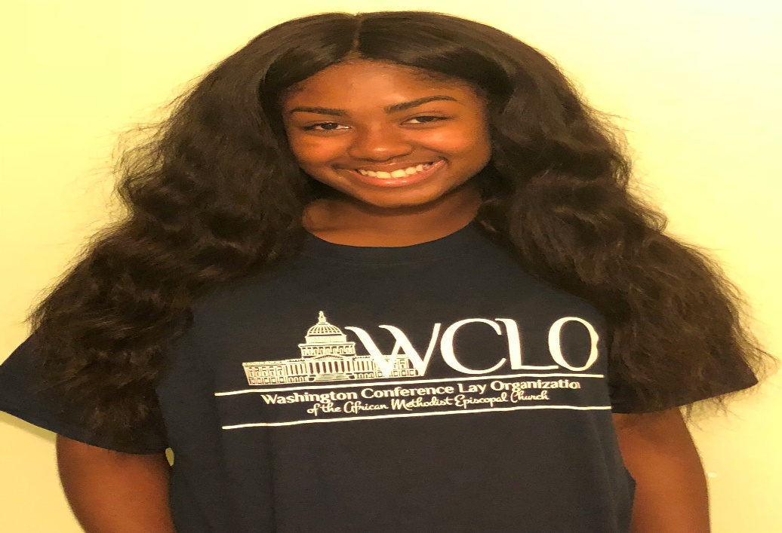

**$15.00**

**Make checks payable to the Washington Conference Lay Organization (WCLO)**

Name: ________________________________

Amount Paid: __________________________



**Please send orders to dola@wclo.org**