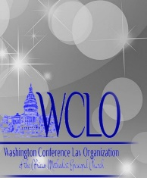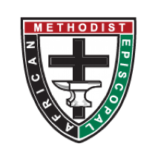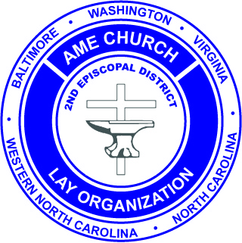
African Methodist Episcopal Church
Second Episcopal District

Washington Conference Lay Organization

“Laity walking humbly with God to do justice and to love kindness”
2020 OUTSTANDING LAY PERSON FORM
Categories- Outstanding Lay Person and Outstanding Young Adult Representative (YAR)

DATE:___________________ CATEGORY:_________________________
Nominee: ____________________________________________________________
Address:______________________________________________________________
_____________________________________________________________________
Phone:_______________________________________________________________
Email:________________________________________________________________
Education:____________________________________________________________
Occupation;___________________________________________________________
Local Church:__________________________________________________________
Local Church Lay:_______________________________________________________
Pastor:_______________________________________________________________
Local Lay President:_____________________________________________________
Due date for all documentation (to include a color 3x5 or 4x6 photograph) December 28, 2019.
Send to: Maria A. Wallace ~ 202-553-4049 mwallacedst@gmail.com
Please elaborate about the nominee’s specific experiences working and serving in the Lay Organization on all levels and include how s(he) have been enriched or enhanced and how being a member of the Lay Organization of the African Methodist Episcopal Church has impacted the lives of others. Use additional space if needed by adding another sheet(s) of paper.
Connectional Level: _______________________________________________________________________________________________________________________________________________________________________________________________________________________________________________________________________________________________________________________
District Level:
________________________________________________________________________________________________________________________________________________________________________________________________________________________________________________________________________________________________________________________
Conference Level:
________________________________________________________________________________________________________________________________________________________________________________________________________________________________________________________________________________________________________________________
Local Church Level:
______________________________________________________________________________________________________________________________________________________________________________________________________________________________________________________________________________________________________________________________________________________________________________________________________
Other Church Organizations/Boards/Auxiliaries/Ministries:
__________________________________________________________________________________________________________________________________________________________________________________________________________________________________________
Community Involvement/Significant Honors/Awards:
__________________________________________________________________________________________________________________________________________________________________________________________________________________________________________
______________________________________________________________________________

