[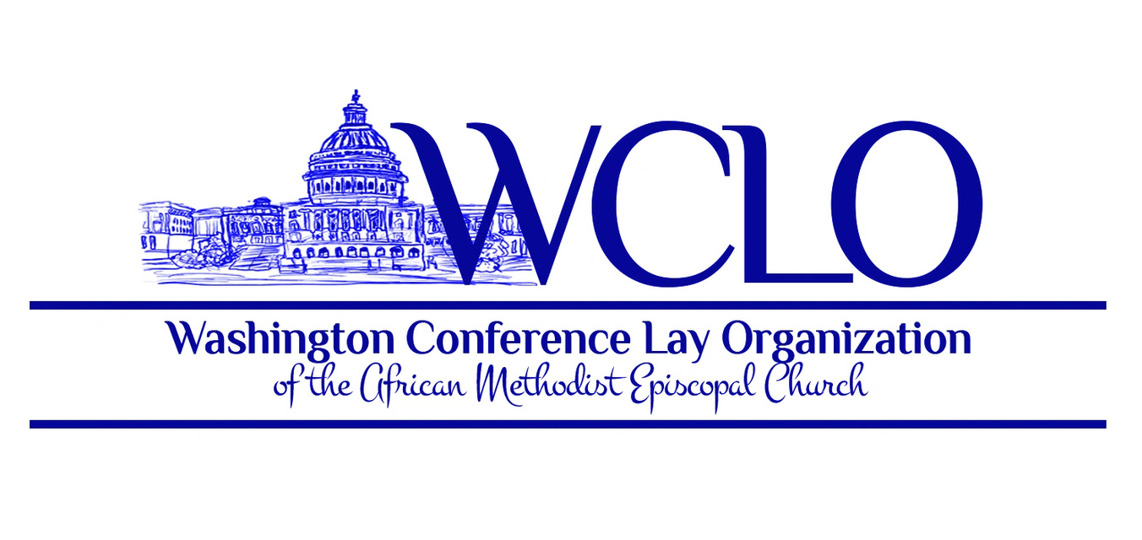](https://wclo.org/)

For Immediate Release

PRESS RELEASE

For Futher Information contact:

Bill Ayers - Director of Public Relations

billayers25@gmail.com

301-758-3776

Site: www.wclo.org

FB: https://www.facebook.com/wcloame/

**Washington Conference Lay Organization Mass Choir**

The Washington Conference Lay Organization is announcing the recruitment for people who love to sing and want to be a part of the WCLO Mass Choir. This group will perform a variety of music from various genres to include spirituals, gospel and hymns. The Director, Mr. Brian Glover, a music teacher with the PG County school system, is seeking two members from each church in the Washington Conference (both Capital and Potomac districts) to participate. A goal of the newly formed group is to sing at revivals, various church events, special WCLO events and for a once a year major WCLO concert. Please consider this opportunity to share your musical talent with the Mass Choir.

The Washington Conference Lay Organization of the African Methodist Episcopal Church is commissioned to teach, train and empower its members for lay ministry, global leadership and service following the tenents of Jesus Christ. The purpose of this organization shall be to organize and train the laity of the African Methodist Episcopal Church so that laypersons may maximally utilize their God given abilities and skills to improve and extend the kingdom, to create happiness, peace and harmony among its members. Help us improve and extend the kingdom of God by spreading the word for the need of musical talent for the WCLO Mass Choir.

Rehearsals are held on the 3rd Saturday of each month at Payne Memorial AME Church in Jessup. Maryland. The Church address is 7901 Brock Bridge Road. Rehearsal begins promptly at 2:00 p.m. and ends at 3:00 p.m. Please contact Brother Brian Glover at (571) 572-7450 or via email [chaplain@wclo.org](mailto:chaplain@wclo.org) for additional details. Your voice is needed.

###