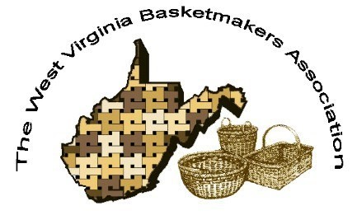

***WVBA REEDER***

***MARCH 2025***

**CONVENTION 2025**

**October 31-November 2, 2025**

**Battlers Knob LLC**

**(former Alderson Broaddus Campus)**

**Philippi, WV**

***2025 WVBA OFFICERS***

*Jan Hensley, President Lara Lawrence, Vice President*

*Sharon Scott, Treasurer Nancy Sealey, Secretary*

www.wvbasketmakersassociation.com

**WVBA NEWSLETTER**

Message from the President:

 Greetings!

I hope you and your loved ones have survived the winter snow and rain without too many difficulties! The WVBA Convention Co-Chairs are busy planning our 2025 convention (Oct. 31 – Nov. 2, 2025). I’m excited about the progress they are making and am looking forward to a great convention at Battlers Knob (formerly Alderson Broaddus College) in Philippi, WV. Watch your

email for updates!

As President of the WVBA, I want to help the local guilds build their membership—or help a group form a guild in their area! I am offering a basketweaving workshop (to be held in each guild’s local area) at a discount for people who join their local guild. The kit and guild membership fees combined will be less than the cost of the workshop for non-members. The basket kit will be available in a variety of team themes and measures approximately 9” long, 7” wide, and 7” tall. Please email me for details!

Best regards,

Jan Hensley

Jan.hensley@dragonflybaskets.com

304.389.2907

**Convention Update**

**Plans for our 2025 WVBA Convention are well underway! We wanted to share a little of what we have planned. We contacted some very talented instructors and invited them to teach at the convention. Those who accepted the invitation then submitted photos and information for the projects that they would like to teach. We have a selection committee made up of Nancy Sealey, Jan Hensley, Ruthie Crow, Carla Smith and Lara Lawrence. The committee reviewed all**

**submitted proposals and selected the ones that will be offered. Each proposal was evaluated for technique, overall appeal, size, pricing, skill level, etc. After selections are made, the event co-chairs have to fit the classes into the time slots. We try to have classes for all skill levels with a variety of techniques, colors, sizes and basket types offered during each class time. We have classes for baskets, gourds and wool projects lined up. Our 2025 WVBA Convention will be held**

**at Battlers Knob in Philippi, WV. This is the former AB University campus. We will have lots of space for our event. There will be some on-campus lodging available as well as local lodging choices, all at reasonable prices for attendees. All meals will be catered this year and you will have the option to purchase meals when you register. We will still have snacks and drinks out for everyone to enjoy so plan on bringing something yummy to share! We are now working with**

**Jan Hensley to get the brochure prepared and ready for the printer. Our goal is to have it completed and mailed to all current members in May. Classes are offered to our WVBA members first so make sure that your membership is current. Looking forward to seeing you all**

**at another Great Convention!**

**Lara Lawrence**

**Nancy Sealey**

**2025 Convention Co-Chairs**

|  |  |
| --- | --- |
|  | |
|  |  | |
|  |  | |
|  |  | |
|  |  | |
|  |  | |
|  |  | |
|  |  | |
|  |  | |

**PICTURES AND THOUGHTS FROM OUR 2025 CONVENTION**

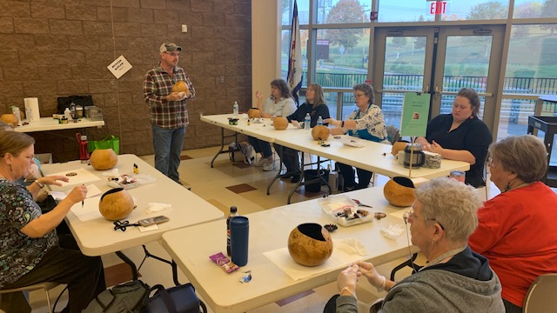

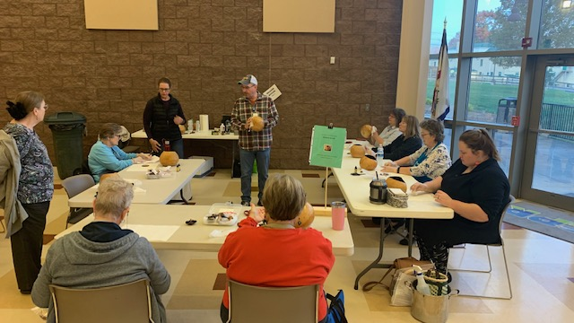

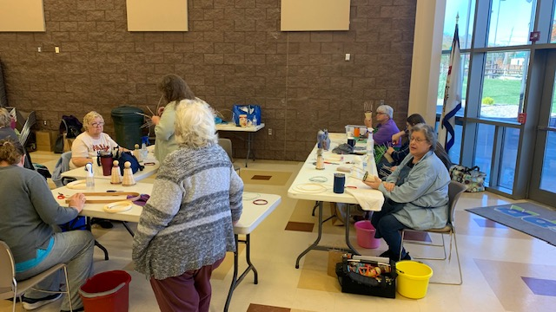

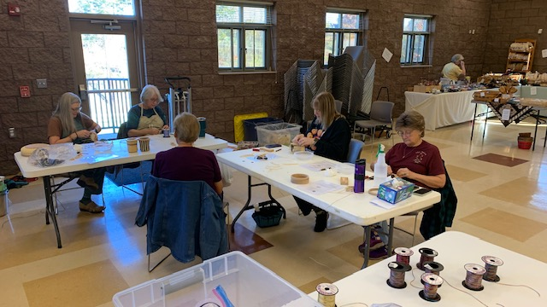

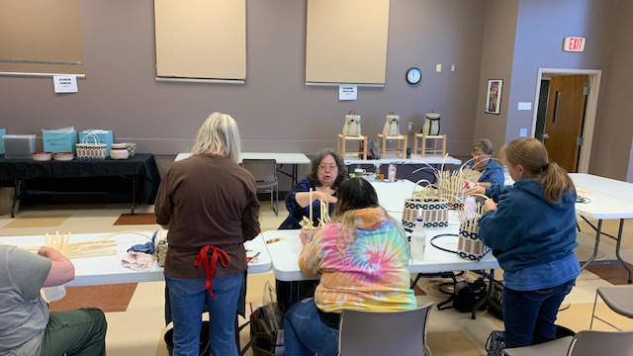

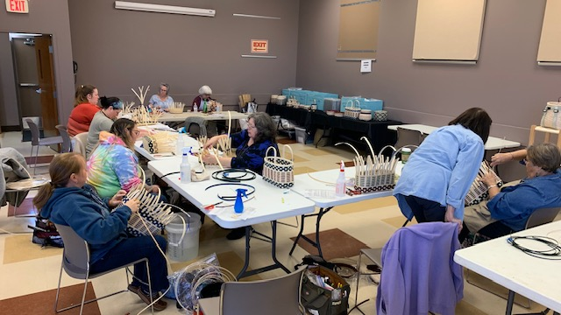

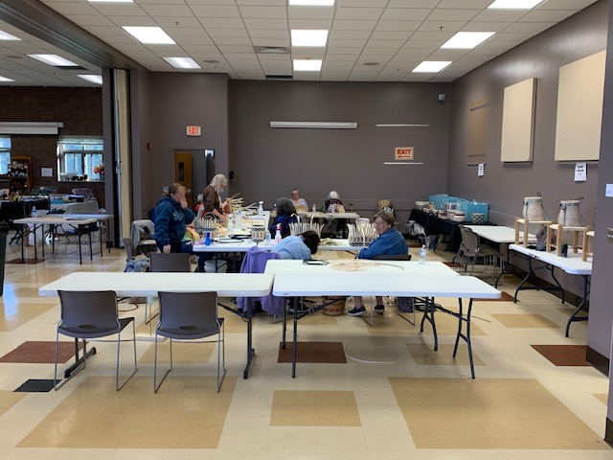

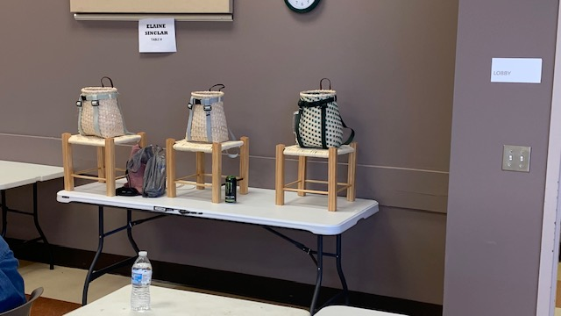

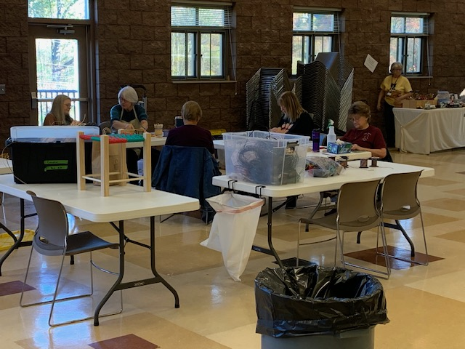

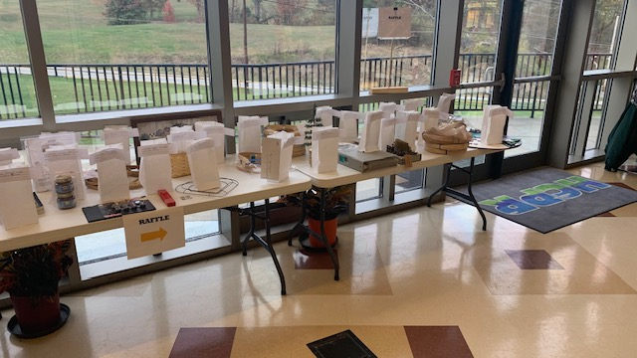

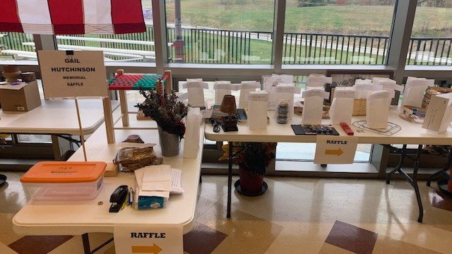

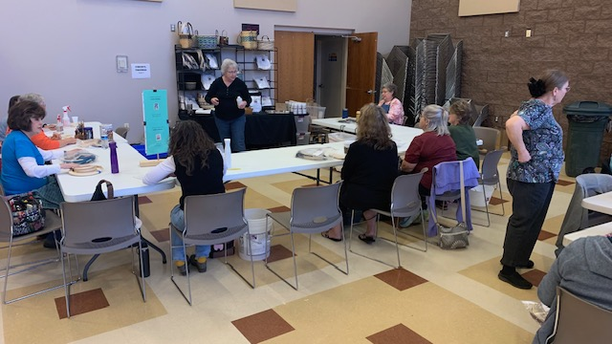

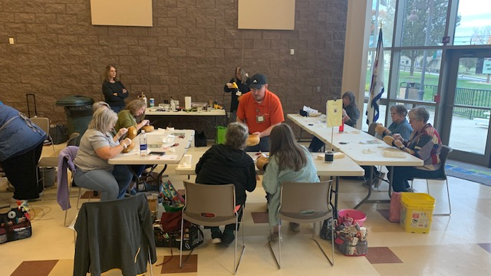



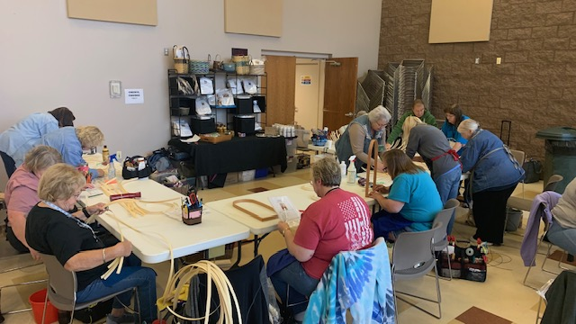

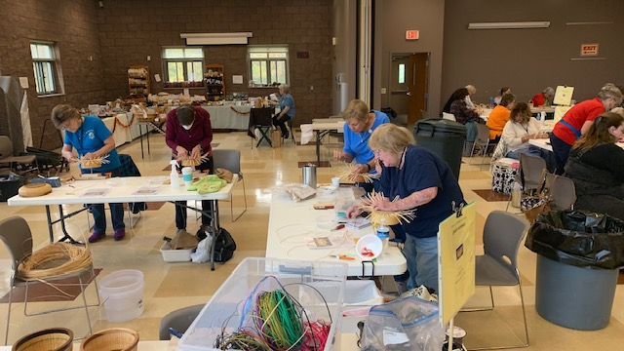

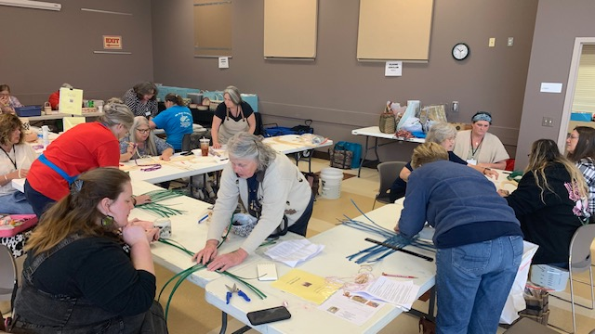

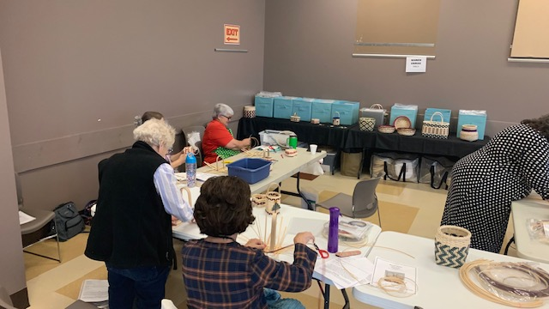

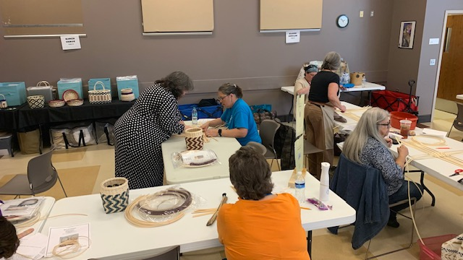

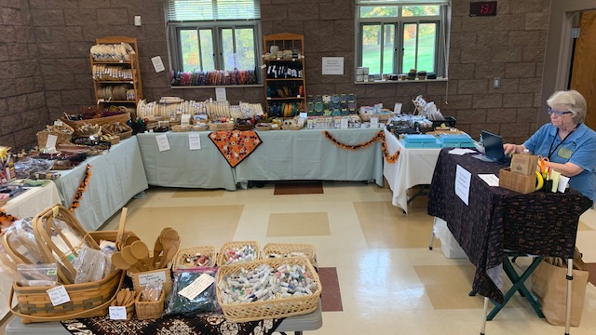

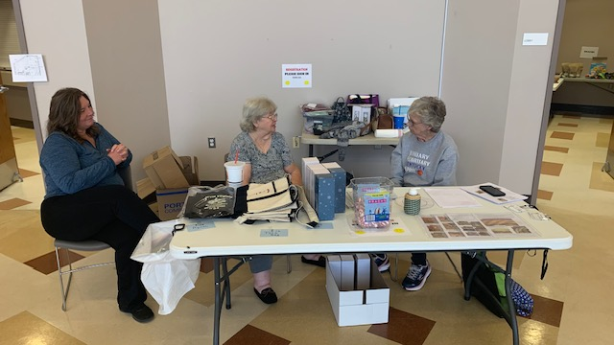







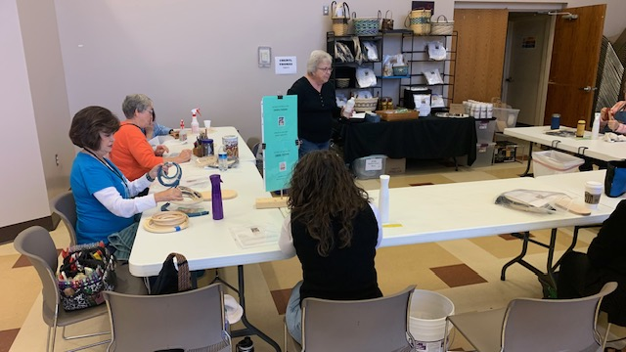

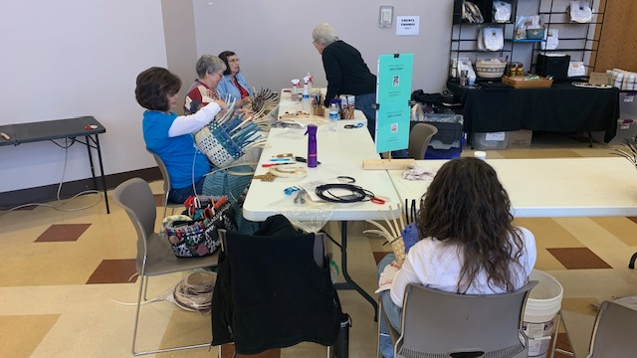

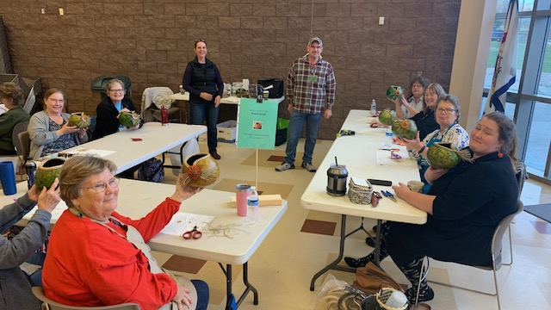

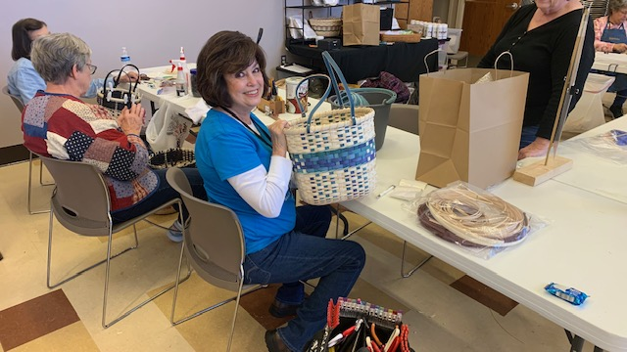

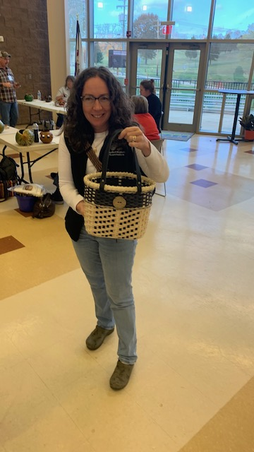

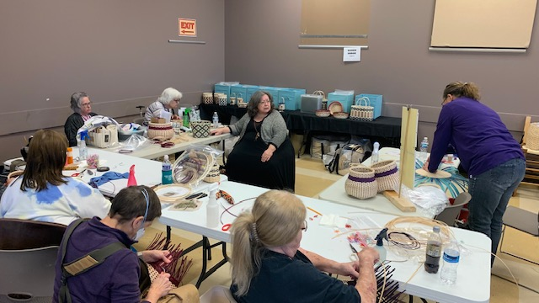

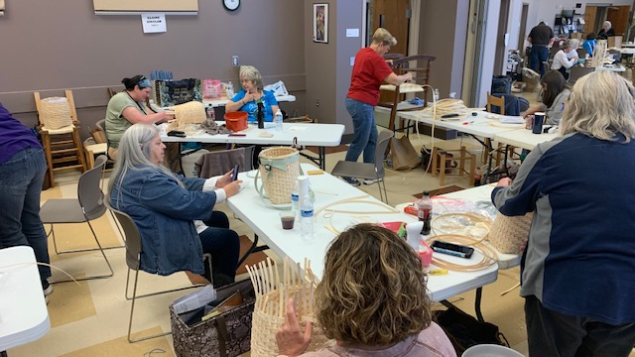

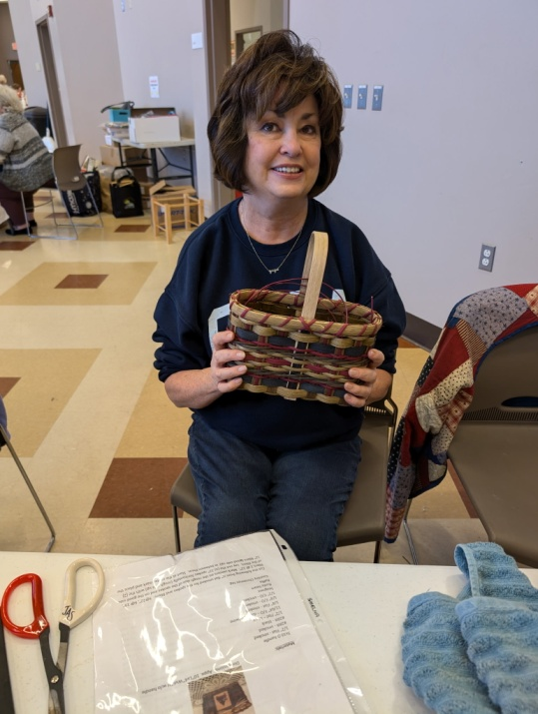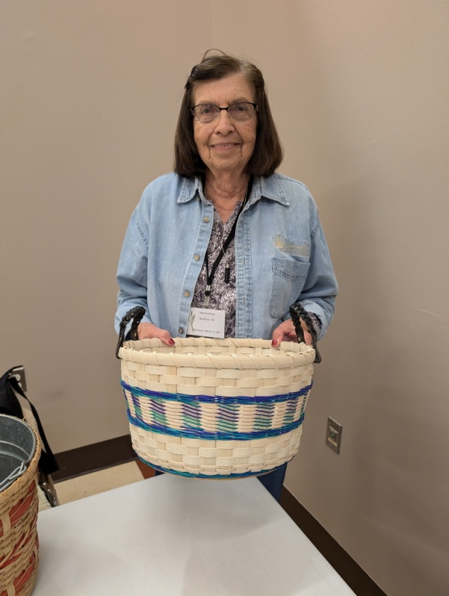

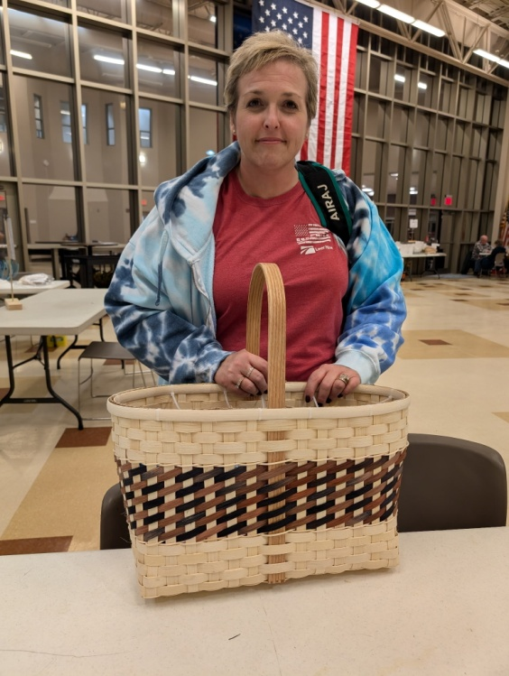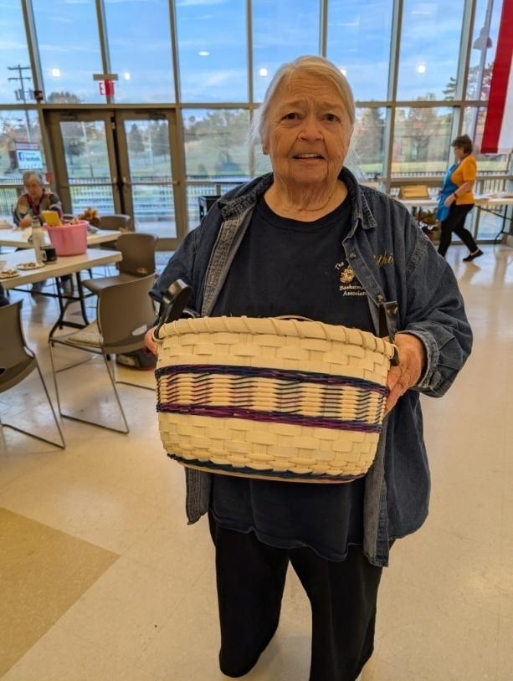

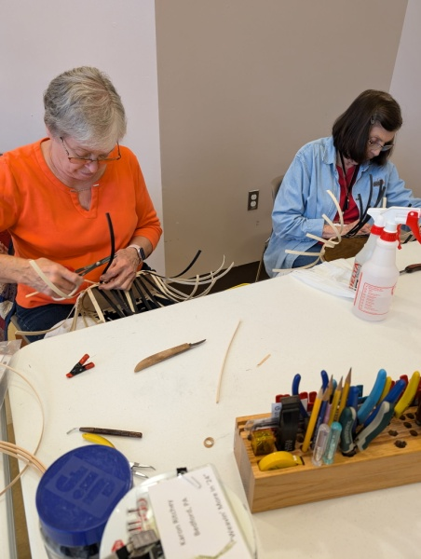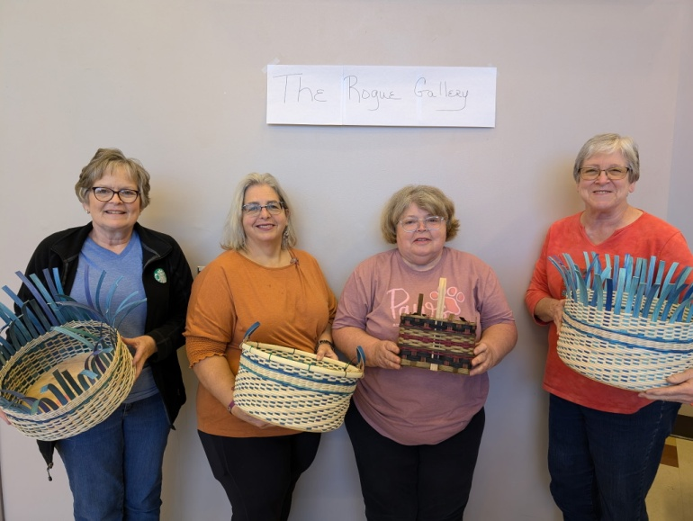

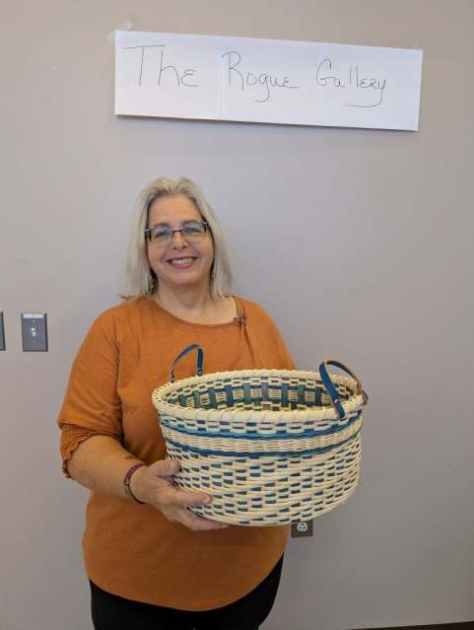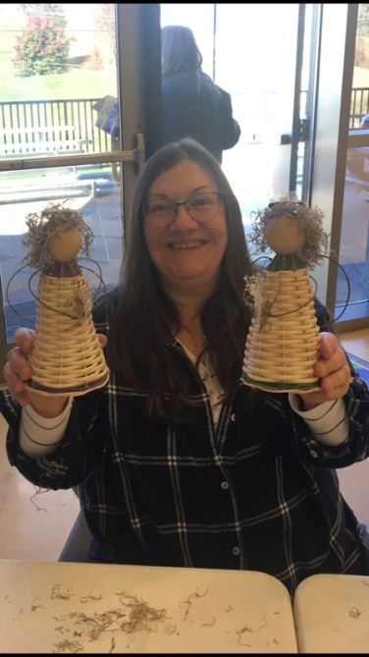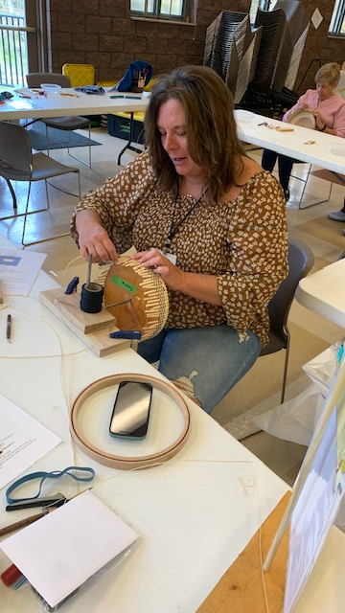

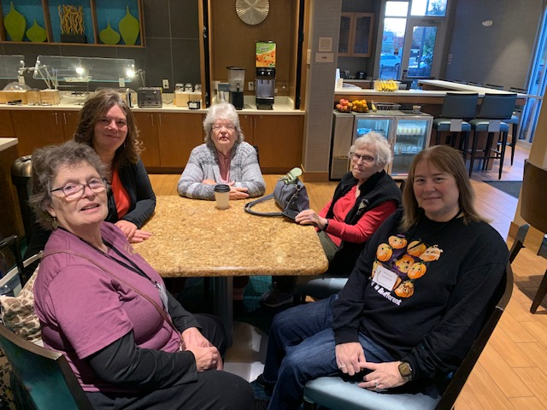

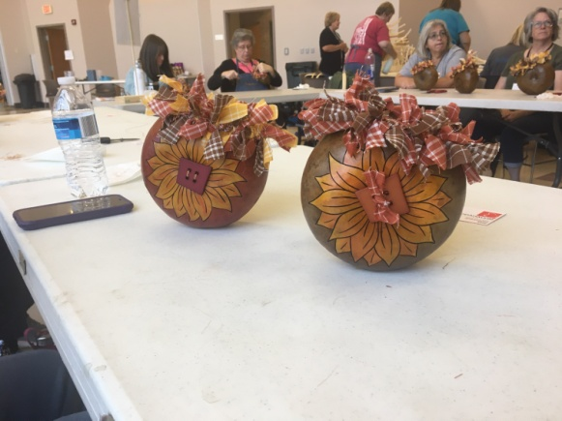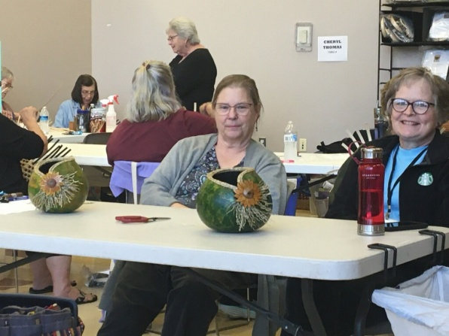

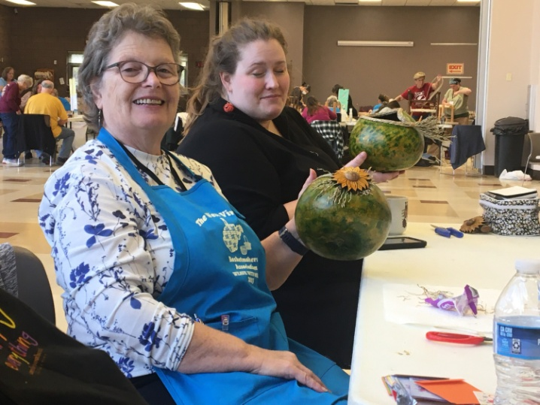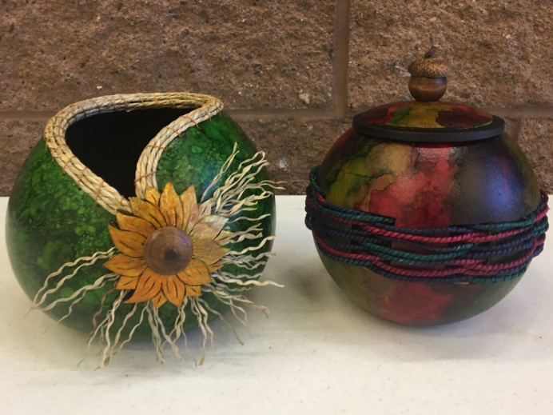

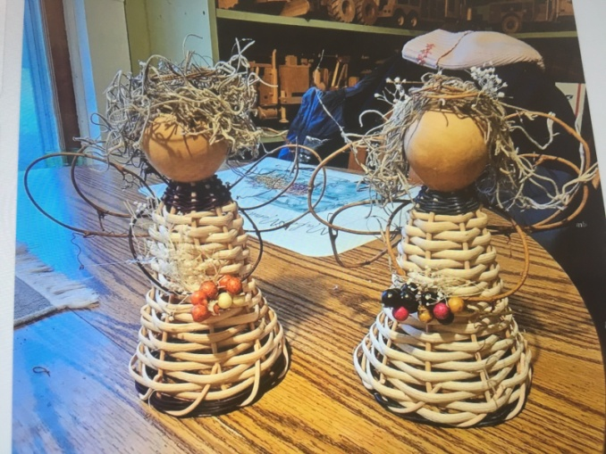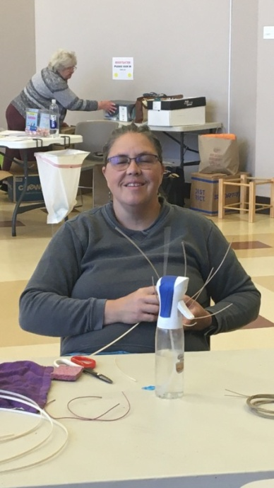

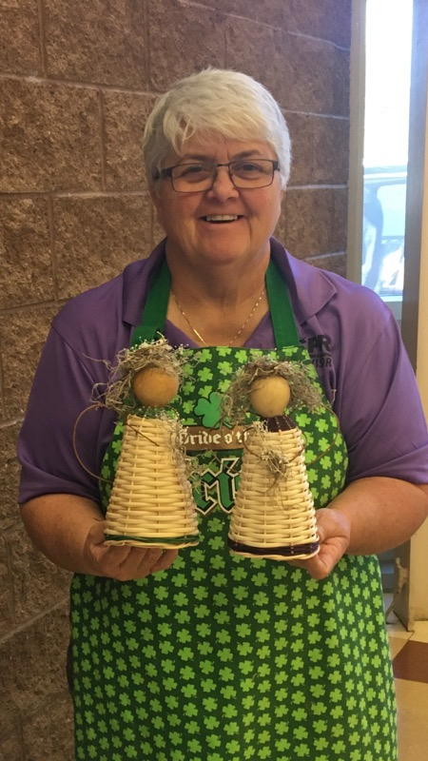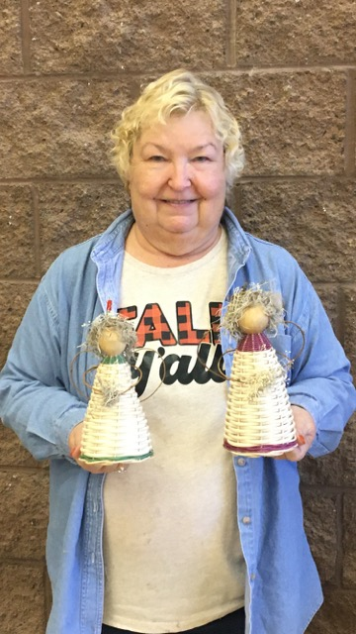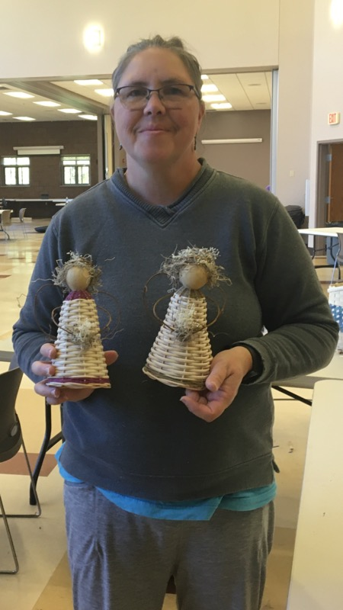

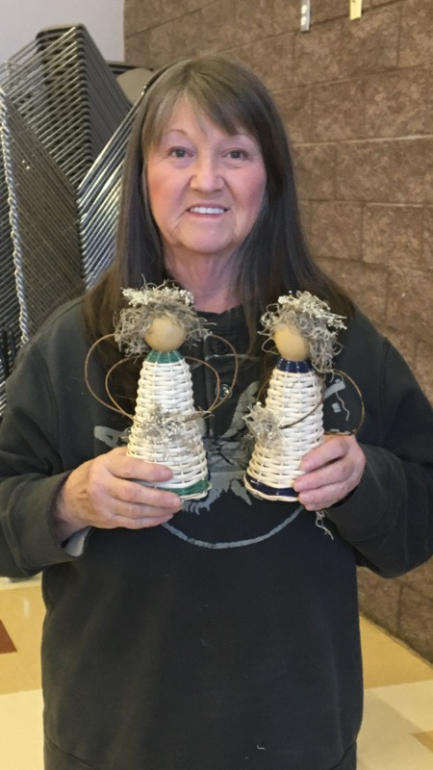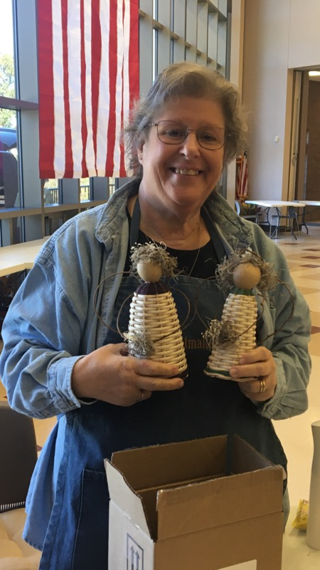

**SILENT AUCTION DONATIONS/WINNERS 2025 CONVENTION**

ITEM DONATED BY WINNER

HOMESPUN BASKET KIT AMY NESTOR MARCY MURPHY

CHINESE NEW YR KIT AMY NESTOR MARCY MURPHY

TWILL BREAD TRAY KIT ELAINE SINCLAIR MARCY MURPHY

BOOK OF TEACHER PATTERN CARLA SMITH

TAN. INDIAN BASKETS MARTHA CARTER SHARON SCOTT

MERRY LIL CHRISTMAS KIT KAREN UNROE LARA LAWRENCE

GARBAGE CAN LID ELAINE SINCLAIR SARAH FORBES

CANE COVERED CANISTERS LARA LAWRENCE J SHREWSBURY

2 FALL BUCKETS/GARLAND LARA LAWRENCE DEBRA WHEELER

WILMA’S STORAGE KIT ELAINE SINCLAIR MARTHA CARTER

CUTTING BOARD DAVE/CANDY BARNES KATHY STUMP

GOURDS BY L CROSSMAN ELAINE SINCLAIR KATHY STUMP

VAE W/LOTTERY TICKETS WESTERN WEAVERS KATHY HALTER

SUNFLOWER GOURD REAGAN BITLER KATHY HALTER

DECORATIVE BASES LARA LAWRENCE LITZ JARVIS

FISKAR PAPER SCISSORS PHYLLIS LYONS DEBRA WHEELER

CHRISTMAS CROSSES KITELAINE SINCLAIR MARCY MURPHY

EASTER BASKET KIT ELAINE SINCLAIR MARCY MURPHY

SYMBOL OF LOVE KIT KATHY STUMP MARCY MURPHY

CAT FANCY KIT KATHY STUMP MARCY MURPHY

**PROCEEDS FROM SILENT AUCTION $569.00**

***********************************************************************************

**RAFFLE DONATIONS/WINNERS 2025 CONVENTION**

ITEM DONATED BY WINNER

STOOL SANDY EISENHARD CANDY BARNES

5 PC HANDLES LARA LAWRENCE MELISSA HOWELL

BOOKS EVELYN MASSIE LARRIETTE SCOTT

2 WV JELLY DONNA STUART MARTHA CARTER

CHEESE BOARD JILL SCHIEFELBEIN LITZ JARVIS

WOOL FELT KITS SANDY EISENHARD

BASKET LAMP REBECCA MELCHER JOY EILLELAND

CHRISTMAS BUCKET MARY ANNUZIATO KATHY HALTER

HANDLES/BASES LARA LAWRENCE NANCY SEALEY

DOOR HANGER JILL SCHIEFELBEIN EVELYN MASSIE

PEG DOLL ANGEL KIT CHERYL THOMAS BETSY MULLINEAUX

BASKET NAREL HEBB LARRIETTE SCOTT

HEART FROM RUTH CROW E KEVILLE

SPOKE WEIGHTS JAN HENSLEY EVELYN MASSIE

PLATES ELAINE SINCLAIR AMY NESTOR

#4 ROUND REED EVELYN MASSIE MELISSA HOWELL

2 PICTURES KAREN BUSKIRK RUTH CROW

BOOKS EVELYN MASSIE KATHY STUMP

HANDLES LITZ JARVIS MARTHA CARTER

CANDLE TRAY JILL SCHIEFELBIEN JOY GILLELAND

4 BASES LARA LAWRENCE LARIETTE SCOTT

$50 GIFT CERTIFICATE ROYALWOOD PATSY FORTNEY

MISC CRAFT PCS KATHY STUMP BRENDA MUSE

TREE REBECCA MELCHER KATHY HALTER

BOOK OF PATTERNS REBECCA MELCHER E KEVILLE

EGG BASKET KIT LARA LAWRENCE CARLA SMITH

HANDLES/BASE/FEET LARA LAWRENCE DONNA HARTZOG

$50 GIFT CERTIFICATE ROYALWOOD MARCY MURPHY

BOOKS EVELYN MASSIE PATSY FORTNEY

MISC REED/PCS K RITCHEY/M SHAW/M MILLER E KEVILLE

**PROCEEDS FROM RAFFLE $594.00**

**GAIL HUTCHINSON MEMORIAL FUND**

At our 2024 Convention we had a 50/50 raffle for our Memorial Fund.

The total chances sold for the raffle was $170.00. Sharon Scott was the winner of $85.00 Cash.

Marth Carter won paid registration for next year’s convention.

**PROCEEDS FROM MGH MEMORIAL FUND $170.00**

***********************************************************************************

**IN MEMORY**

The members of WVBA would like to express their very deepest sympathy to the family and friends of Lou Ann Cunningham and Judy McCoy.

Both were members of WVBA who supported and attended and volunteered at conventions.

They will be missed.

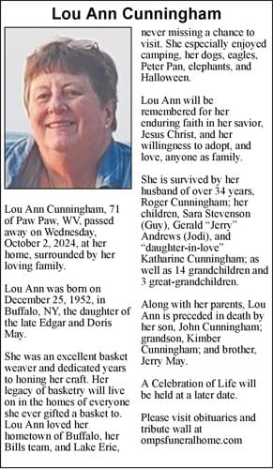

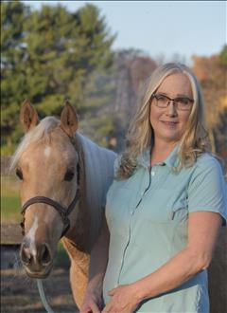

**Judith McCoy Obituary**

Judith Gay McCoy, 64, beloved wife, mother, grandmother, daughter, sister, and friend, passed away peacefully surrounded by her family. She was a cherished presence in the lives of those who knew her. Judy was born to her loving parents Shirley and Alfred Landers.  
She leaves behind a loving family to cherish her memory. Her devoted husband, Barry. Her daughters whom she always loved and supported Megan Mills (Nathan), Chloe Allen (Thomas), and Rachel Larimer (Josh), granddaughters Karma, Marlee, and Mckenna. Others left to cherish her memory include her mother Shirley, sisters Elizabeth Laws and Teresa Mason, nephew Justin Laws, several cousins and friends.  
Judy's love for her family was matched only by her deep passion for horses, which she dedicated much of her life to. She enjoyed sharing her love and knowledge with others, creating lasting memories with all of her loved ones. Her love for her family and horses was followed with a deep compassion for her job as a school bus driver. Driving for more than twenty five years she touched the lives of numerous children as well as serving as the voice of safety in her role with Buster the Bus. Left behind are many beloved co-workers.  
Her warmth, kindness, and gentle spirit will live on in the hearts of all who were fortunate enough to have known her. Judy's legacy of love and care will continue to inspire those who loved her. She will be deeply missed, but her memory will remain in the hearts of her family and all who were touched by her presence.  
A celebration of her life will be held at the Crab Orchard Baptist Church on Tuesday February 18th, with visitation from 4-5pm and service to immediately follow. Family and friends are invited to honor and remember her.  
Arrangements have been entrusted to Melton Mortuary and Cremation Center who are honored to serve the family during this difficult time. To offer words of comfort or condolences please visit Judy's virtual guestbook at www.meltonmortuary.com. In lieu of flowers, donations can be made to a scholarship for Southern District Horse Camp at the following link

********************************************************************************

NEWSLETTER/WEB SITE/MEMBERSHIP

Thanks to everyone who submitted info for this newsletter.

Without your input we cannot have a newsletter.

Please keep in touch in you have an address, phone number or email change so we can keep our membership/newsletter list current.

Membership dues are now due for 2025. Thanks to those who have sent theirs in.

Please check our web page for upcoming events. If your group sends that info to me, I will have it posted.

[www.wvbasketmakersassociation.com](http://www.wvbasketmakersassociation.com)

Thanks again for your info

Nancy Sealey

Nana276815@gmail.com

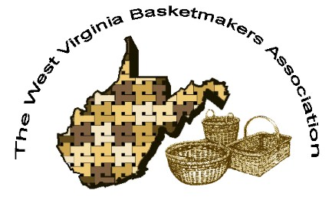**WVBA Membership**

**January 2, 2025 – December 31, 2025**

**(Please print)**

Name_______________________________________

Address _____________________________________

City ___________________________ State ____ Zip+4 __________

Phone _________________________ E-mail_____________________________________

____I am a member of a West Virginia guild.

(Name of Guild) _____________________________________________________________

____ I am NOT a member of a West Virginia guild.

**Basketry Business Name ______________________________________________________**

(A business that sells basket supplies, basketry related items, or baskets)

____ I have joined as a teacher/business member and I would like my basketry business listed in the annual membership booklet.

**Basketry Business Phone # _____________________________________________________**

**Basketry Business Web Site ____________________________________________________**

New Member ___ Renewal ____

Are you a basketry teacher? ___ yes ___ no

Are you a vendor? ___ yes ___ no

Membership is for: (Please check those that apply.)

__ **Individual membership** $20.00. for 2024 Dues.

Entitles you to Newsletter, and receive Convention booklet.

__ **Individual under 18** on Jan. 1 or 80+ years $15.00

__ **Teacher/Business Membership** $25.00. Entitles you to the same as individual membership, plus is mandatory to teach classes, vend, or participate in the Market Place at Convention.

**Paying by __ Cash __ Check # _____ Please make checks payable to WVBA**

**Send check and application to :**

**Nancy Sealey**

**2768 Emmons Ave.**

**Huntington, WV 25702**