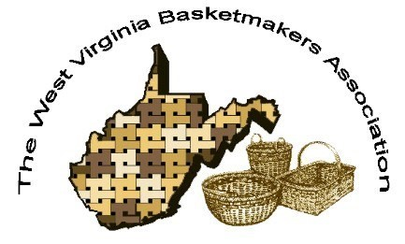

WVBA REEDER
JANUARY 2026

CONVENTION 2026
October 23-25, 2026
Battlers Knob LLC
(former Alderson Broaddus Campus)
Philippi, WV

2026 WVBA OFFICERS
Jan Hensley, President Vice President
Sharon Scott, Treasurer Nancy Sealey, Secretary

www.wvbasketmakersassociation.com

WVBA NEWSLETTER
Message from the President:
Greetings to all,
I have just recently finished summarizing the evaluation results of our 2025 convention:
Country Roads, Autumn Leaves, and Basket Weaves. Our overall average for the
Convention was 9.3 out of 10; the teachers' average was 9.9 out of 10. I truly appreciate
the efforts of Nancy Sealey and Lara Lawrence as Convention Co-Chairs; their dedication
and commitment to the WVBA are reflected in the great reviews we received.
I also genuinely appreciate the time everyone put into sharing their thoughts and
suggestions. While I am thrilled with the overall averages, I appreciate that there is always
room for improvement. We are taking your suggestions seriously and will consider them as
we plan our 2026 convention.
I am excited to share that we have reserved the same facility for our 2026 convention; I will
share the October 2026 dates very soon {October 23-25, ,2026}. One of the big changes will be the signage
pointing to where we will be weaving and where to park; this was the overwhelming
suggestion from our evaluations!
Requests for class proposals will be sent within a few days; please feel free to submit a
proposal if you are interested in teaching a class at our convention.
In the meantime, please do not hesitate to contact me if you have any questions or
suggestions for our upcoming convention. Remember—this is your association and our
success depends on each one of you!
I look forward to hearing from you!
Best regards,

Jan Hensley

West Virginia Basketmakers Association
2025 Convention Evaluation Summary

1. Survey Questions Evaluation Average
Was the date an appropriate time of year for the convention? 8.5
Was the location convenient? 8.9
Were you satisfied with the variety of classes offered? 9.4
Was the facility an appropriate place for the convention? 9.97
Did the brochure provide enough information? 9.2
Were the instructions in the brochure clear? 9.3
Were you satisfied with the vendors? 9.4
Were you satisfied with the variety and quantity of food? 8.8
How likely are you to attend the convention in the future? 9.6
How likely are you to recommend our events to a friend? 9.8
Was your teacher:
a. Prepared for class? 9.9
b. Proficient in the techniques being taught? 9.9
c. Able to take time to answer questions? 9.9
d. Able to provide enough one-to-one time, if needed? 9.9

2. What did you like most about the event?

• Everything!
• Laid back and relaxing.
• Facility was well-lit and there was room for weavers.
• Food was very good and the building was big and we were able to spread out.
• The community of weavers and the sharing of knowledge.
• I like being in different rooms and how spread out everything was.
• The space with the different rooms.
• Donuts in the kitchen of the alumni center were a nice touch.
• The quality of the projects—the materials, instruction, and length of
time.
• Great convention!
• Great location; interesting baskets; good instructors.

• Excellent facilities, good food, beautiful area!
• Like having vending available all the time instead of being crammed
into one night.
• Great space!
• Small group, good atmosphere; for institutional food, it was pretty good; stellar space: roomy space for walkers, canes, etc.), very good light.
• Venue was lovely (but hard to navigate campus); raffle/silent auction is always varies at your convention;
good blend of classes/vendors.
• Facilities and lodging
• Soups and cornbread were good.
• Reuniting with old friends and making new ones.
• The building was great—lots of light and space.
• Location, location, location—plenty of space, tables were not
Crowded together, and it was well lit!
• Having Reagan all weekend, the facility, and the food!
• Lots of room—wonderful facility!
• Decent food for meals; like the open vending; good facility—light, space—book for next year!
• The facility was great; wish we could have stayed on site but motel suggestion were good.
• The variety of classes available; the food was awesome!
• I enjoyed being able to take classes with two new teachers.
• Making baskets
• Lovely people! Excellent place to weave—great light and lots of room.
• Small group—“homey” feel; having vending open at all times.
• This is a fantastic location! And loved the menu!

3. What did you like the least about the event?

• Wednesday was bad.
• Needed signs to find the building; more teachers (if we get more participants)
• Nothing

• Campus was difficult to navigate.
• No signs outside
• No signs to tell us where to go
• The 2-hour drive to get here (but if I were to take additional classes and stay over, it becomes less affordable).
• No signs to direct you to where you were to be.
• Dinner on Saturday was too salty; I would pay more for better food.
• Distance. Directions.
• Alumni rooms were shabby but clean and functional—given the convenience factor—ok. Unclear on check-out time, etc.
• Hard to navigate campus (more detailed map should be provided); nothing else, really.
• Signage would have been helpful for those not familiar with the area/campus.
• The food was good, but I would have appreciated a veggie or fruit tray or salad for Saturday’s lunch. Signs pointing to the parking and building would have been appreciated. Spent a lot of time driving around campus trying to find you.
• Maybe not getting to pass out treats for Trick-or-Treat. ☹ haha
• It was cold in the room by “subconnection”.
• Need signs to facilities. Not marked at all. Better directions to site.
• No directions at event site (signage).
• Getting lost on campus.
• Students complained about hard chairs. You should tell people to bring cushions.
• Alumni rooms kinda shabby; kitchen sketchy. But for $79—good, worth
inconvenience. H/c shower had bars but no moveable shower head, no
phones but for price—accommodations are reasonable.
• No signs to the building.

4. What is the one thing you would like to tell us that isn’t covered by the questions above?

• Location was great, teacher was very good, vendors were great. Thank
You all very much! ☺
• I like getting the brochure mailed to me. I do not like to pay online.

• Maybe more room for bigger baskets.
• Thank you! ☺
• Everything was awesome!
• A virtual option might be nice—one instructor, one complex basket, materials ahead of time and a zoom link.
• Chairs were hard; suggest bringing cushions in the brochure.
• Noise was not a problem. Easy to hear teacher.
• Places to eat when food is not catered (breakfast). Odyssey has hadgood luck with a
newbie registration for /& day class. Might be worth a try to recruit new
Weavers.Maybe a “bring a 1st time buddy”?
• I love y’all (this isn’t Elin); nantuckets maybe?
• I appreciate everyone’s efforts in making this a wonderful event!
• I think the facility is great—I just wish it were closer to motels and
Restaurants in Bridgeport/Clarksburg area. Thanks for all you efforts to
make this convention possible!
• Put class time on participant’s name tag.
• Rule change on teachers being prohibited from teaching 2 years in a row.
• Thank you!
• List of eating places if people come in early/late. Check out time? Assuming it’s “whenever”?
• May be nice to have a popular teacher more than twice in a row.
• At the meeting last night when the subject of the convention was broached, an officer immediately interjected that “the convention was great, the food was fantastic” etc. That effectively stopped all communication. Those that had suggestions for improvement understood they would be commenting on “perfection”. Everything can be made a little better if only we are open to ideas.

GAIL HUTCHINSON MEMORIAL FUND
At our 2025 Convention we had a 50/50 raffle for our Memorial Fund.
The total chances sold for the raffle was $90.00. Lara Lawrence was the winner of $45.00 Cash.
Nancy Sealey won paid registration for next year’s convention.
PROCEEDS FROM MGH MEMORIAL FUND $90.00
************************************************************************************************************************

SILENT AUCTION DONATIONS/WINNERS 2025 CONVENTION
ITEM DONATED BY WINNER
WOOL TREE/VASE BETSY MULLINEAUX RACHEL WEBER
PINE NEEDLE BASKET PAM WILSON CAROL LAROY
LOTTERY TICKET ARRANGMT WESTERN WEAV LARA LAWRENCE
BOOKS MOLDS PINE NEEDLE PAM WILSON REBECCA MELCHER
COOKIE BECCI MELCHER LISA WEESE
PINE NEEDLE TRAYS PAM WILSON LINDA ELSCHLAGER
BLANKET YARN PHYLLIS LYONS KATHY STUMP
BEADED GOURD BECCI MELCHER KATHY STUMP
2 WASTEBASKET KITS SHARON KLUSMANN STACIE DEUTSCH
SMITTEN KIT BONNIE RIDEOUT STACIE DEUTSCH
BIRCH/CEDAR POCKET PAM WILSON MARTHA CARTER
CALENDAR MARTHA CARTER MARTHA CARTER
TEAPOT/CUPS LITZ JARVIS NANCY SEALEY
CANDLE/LEAF DESIGN BEXLER BETSY MULLINEAUX
DENIM SHIRT PHYLLIS LYONS ROSE MAR PROFILI
HONEY BUN MARKET KIT KATHY STUMP REGINA COLE
CRADLE LARA LAWRENCE AMY BERTSCH
LONGEBERGER JACKET PHYLLIS LYONS DEB GERBER
CONVENTION PATTERNS 2025 TEACHERS AMY BERTSCH
SW CACTI DISH PAT MERCER NANCY SEALEY

PROCEEDS FROM SILENT AUCTION $472.00
***********************************************************************************

RAFFLE DONATIONS/WINNERS 2025 CONVENTION
ITEM DONATED BY WINNER
KNITTED HAT CARRIE REED KATHY STUMP
WALNUT,MAPLE STRIPS REBECCA MELCHER
HEAD BAND, TOWEL, CLOTHS MINDY MONTELEONE KATHY STUMP
BASKETS PAM WILSON KATHY STUMP
TUPPER/GLASS WARE GEORGIA MILLER SHARON SCOTT
PLAQUE JILL SCHIEFELBEIN RITA WARREN
WOLFE CREEK CALENDAR MARTHA CARTER SARAH FORBES
HEART WIRE FRAME JILL SCHIEFELBEIN SUZANNE WILLIAMSON
LIGHTHOUSE PICT FRAMES GEORGIA MILLER SHARON SCOTT
BASE BUNDLE/ROCK HORSE BLANK PHYLLIS LYONS REGINA COLE
BOOKS AND HANDBAG PHYLLIS LYONS NANCY SEALEY
MIS CANDLE,EARRING.ETC MINDY MONTELEONE LISA JOHNSON
BEADS/TURTLE CHARM PAM WILSON MARY ANNUNIZATO
OUI JARS LITZ JARVIS ROSE MARY PROFILI
FARM PLAQUE JILL SCHIEFELBEIN LETTY WALKER
RD REED BASKET PAM WILSON PATSY FORTNEY
CELEBRATE KIT CHERYL THOMAS JENNY SHREWSBURY
CHRISTMAS PLATE JILL SCHIEFELBEIN SHARON SCOTT
WIRE FRAMES JILL SCHIEFELBEIN CARLA SMITH
AUTUMN BASKET ACC LARA LAWRENCE PHYLLIS LYONS
WVU BASKET KATHY STUMP
BASKET /FAN PAM WILSON SHARON SCOTT
JELLY (4) MINDY MONTELEONE MARY ANNUNAZIATO
ASHFORD KIT KATHY STUMP JENNY SHREWSBURY
WIRE FRAMES JILL SCHIEFELBEIN SUZANNE WILLIAMSON
PATTERNS DEE JOHNSON JILL SCHIEFELBIN (2)A
REGINA COLE (2)
LETTY WALKER (2)
CARLA SMITH (3)
REBECCA MELCHER (2)
KATHY STUMP (9)
CAROL WOLFE (4)
PROCEEDS FROM RAFFLE $592.00

IN MEMORY
The members of WVBA would like to express their very deepest sympathy to the family and friends of Nadine Memel and Lee Eisenhard.
Nadine was a member of WVBA and Lee was a volunteer at our conventions for many years.
They will be missed.
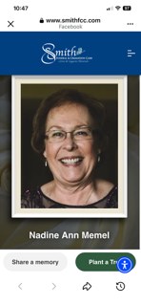
Nadine Ann Memel, 74, passed away at her home in Morgantown WV on October 22, 2025 after a well-fought and often arduous 7 year battle with multiple myeloma. Born on April 15, 1591, in Parkersburg, Nadine fostered the life of a committed worker, devoted friend and always prioritizing family. She married the love of her life at 35, Jay Memel, and started her journey of being a dedicated wife and loving mother to their one daughter, Julie Memel.

Upon first impression, Nadine was shy and quiet but once you got to know her she blossomed into a witty, creative and loving lady. She would tell many stories from her years at DuPont and what fun she had with her coworkers, many of whom became life-long friends. Nadine spent her life nuturing may creative outlets with her greatest love being basket weaving of 30 + years. Countless hours were spent creating special baskets for friends, family, baby showers and her dedicated medical team. She also found time to be a voracious reading, joining a book club at the age of 18 and remaining in it for 50+ years.
Beyond her personal attributes, Nadine was an exceptional wife, sister, mother, mother-in-law and grandmother. Words could never describe how hardworking and selfless she was for her family. She cherished the time spent with her husband and cared for him until his death in 2012. She had an inseparable bond with her daughter and they never went a day without talking. Her son-in-law, Daniel lit up her day while traveling to her weekly doctor visits. She and her sister spent countless hours on the phone talking recipes and meeting for lunch. During her battle with multiple myeloma, she was able to dive into a new role as grandmother to Finn 7, and Dax 1. Her love for them radiated to everyone around her and helped fuel her strength for so long.

Nadine is survived by her daughter, Julie Memel, son-in-law, Daniel Davis, grandchildren, Finn and Dax Davis, niece Lisa Johnson and daughter Stormy, sister-in-law, Nancy Cochran and daughter Jenny. In addition to her parents, she is preceded in death by her sisters Angie Cinton and Terry Craynon, husband Jay Memel, and brother-in-law Dwight Cochran.

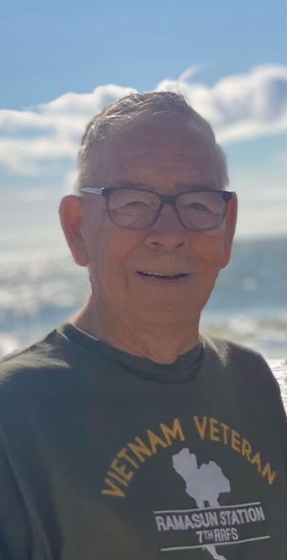

Lee R. Eisenhard November 09, 1952 - November 03, 2025
Mr. Lee. R. Eisenhard, 72, of Mont Alto, PA, passed away Monday, November 3, 2025, in Chambersburg hospital. Born November 9, 1952, in North Hampton, PA, he was the son of the late Eugene M. and Winnifred R. (Locher) Eisenhard.
He graduated Woodmore High School, Ohio
with the class of 1969.
Mr. Eisenhard served his country honorably in the United States Army serving from1969 until his formal retirement in 1989.
He and his wife, Sandra G. “Sandy” (Smith) Eisenhard were married September 14, 1974, in Higginsport,OH.
Mr. Eisenhard was a business owner, having owned Sunrise Computers, Chambersburg, PA. He was a faithful member of the Waynesboro Lions Club, Waynesboro, PA often helping out with their train shows. He was also a member of the Army Security Agency Union.
A faithful man by heart, he attended church services at Grace Baptist Church, Waynesboro.
A jack of all trades, Mr. Eisenhard enjoyed wood working where he made different pieces, including those to help his wife with her hobby of weaving. He also enjoyed old cars and model trains. In addition to his beloved wife of 51 years, he is survived by his two daughters, Becky Bryant of Mont Alto, and Kristina Snider and her husband Michael of Chambersburg; five grandchildren, Randy, Brandon, Virginia, Braxton, and Brody; three great-grandchildren,Jaxon, Myah, and Willow; and one sister, Tina Luebbers of CO; as well as an extended host of family and friends.

Just A Note: As Lee was being admitted to the hospital for the final time the week that our convention was being held, he was concerned that he would not be at our convention to make coffee, sell raffle tickets, take pictures and be our “go-ffer”.
He enjoyed the time he spent with “the girls”. We will miss him.

NOTES FROM OUR MEMBERS

I really enjoyed the Convention this year. Loved the facility and food was great! The room on campus was very nice. I am looking forward to this years convention.

Sharon Scott

- It's not what you look at that matters, it's what you see.

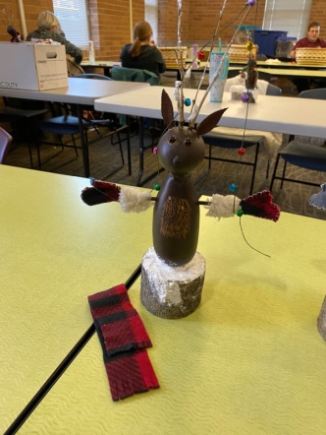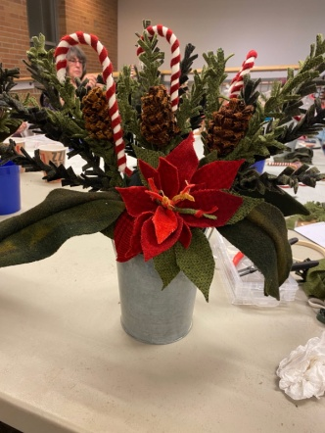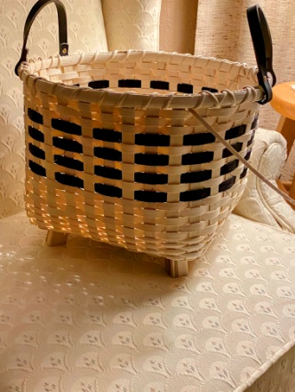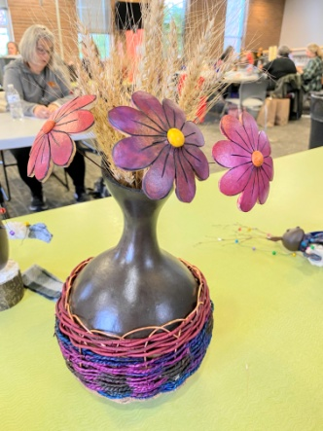

This was from a local competition at the library .

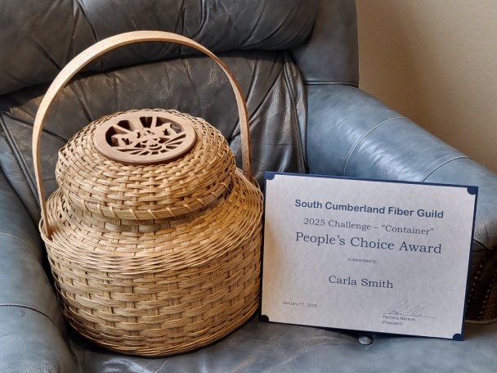

Carla Smith

******************************************************************

Beginner and intermediate basketry classes are held each month at the Greater Wheeling Soup Kitchen in downtown Wheeling. Whether you opt to make the basket, taught by Pat Mercer, or work on your own project, all are welcome to join. For information, contact Pat through Facebook, Messenger or email at WVBaskets@yahoo.com

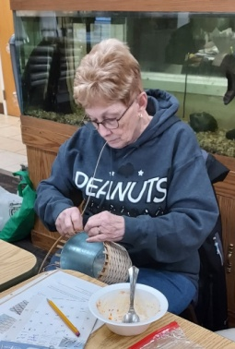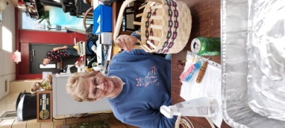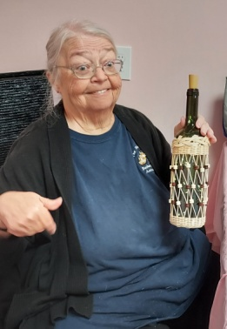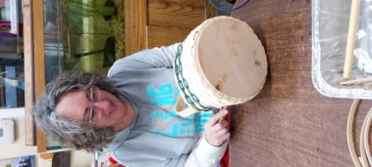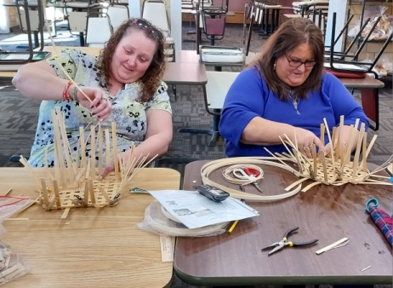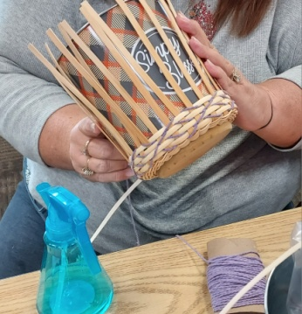
*****

Pat Mercer will be teaching March 5-8 at Weaving Together in Western Kentucky (WTWKY). Although she has taught at 3 other events in Kentucky, this is her first time going to Rough River State Park to teach at this event.

*****

March 19-21. Pat Mercer will be teaching at the Inaugural West Virginia River Valley Weavers Retreat at Grand Vue Park in Moundsville, WV. It promises to be a great time staying and teaching in the park's cabins.

Submitted by Pat Mercer

******************************************************************

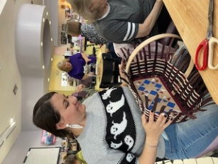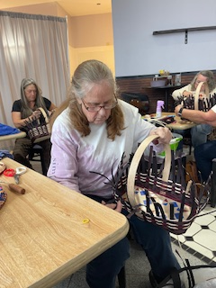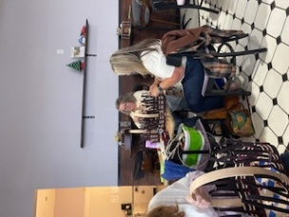

Linda Elschlager has been holding a basket class every month at The Wv Artisan Market in Fairplains, WV since it's opening in 2020.A great group of ladies meet every month to enjoy making a new basket, fellowship and have a great lunch. If interested in attending or getting on the group messenger page contact Linda. All class are posted ahead of time on this page.Message Linda or give her a call 304-482-9905 for details.

Submitted by Linda Elschlager

Whether you are looking for a challenge or an easy weave at the
Weaving Your Cares Behind Retreat on May 1, 2, and 3, 2026 in
Bedford, PA 15522. Instructors are Candy and Da e Barnes, Linda
Elschlager, Bonnie Rideout, Cheryl Thomas, and Pamela Wilson. For
more information check us out on Facebook at Basketweavers Guild of
Bedford County contact beverly1geller@gmail.com.
Thank you for the opportunity to put our information out in your email.
I thought the venue of last year's retreat at Battlers Run was a 100%
improvement over other years. It was very comfortable and roomy.
Good job!
Thank you,
Karon Ritchey

\********************************************************************************

NEWSLETTER/WEB SITE/MEMBERSHIP
Thanks to everyone who submitted info for this newsletter.
Without your input we cannot have a newsletter.
Our next newsletter will come out in July 2026. If you have input prior to that, please email to me at any time but make sure to mark WVBA Newsletter in the subject line.
Please keep in touch in you have an address, phone number or email change so we can keep our membership/newsletter list current.
Membership dues are now due for 2026. Thanks to those who have sent theirs in.
Please check our web page for upcoming events. If your group sends that info to me, I will have it posted.
www.wvbasketmakersassociation.com
Thanks again for your info
Nancy Sealey
Nana276815@gmail.com

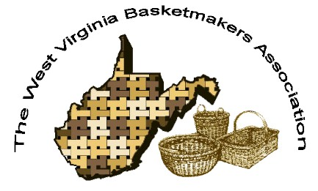
WVBA Membership
January 2, 2026 – December 31, 2026
(Please print)
Name_______________________________________
Address _____________________________________
City ___________________________ State ____ Zip+4 __________
Phone _________________________ E-mail_____________________________________
____I am a member of a West Virginia guild.
(Name of Guild) _____________________________________________________________
____ I am NOT a member of a West Virginia guild.
Basketry Business Name ______________________________________________________
(A business that sells basket supplies, basketry related items, or baskets)
____ I have joined as a teacher/business member and I would like my basketry business listed in the annual membership booklet.
Basketry Business Phone # _____________________________________________________
Basketry Business Web Site ____________________________________________________
New Member ___ Renewal ____
Are you a basketry teacher? ___ yes ___ no
Are you a vendor? ___ yes ___ no
Membership is for: (Please check those that apply.)
__ Individual membership $20.00. for 2026 Dues.
Entitles you to Newsletter, and receive Convention booklet.
__ Teacher/Business Membership $25.00. Entitles you to the same as individual membership, plus is mandatory to teach classes, vend, or participate in the Market Place at Convention.

Paying by __ Cash __ Check # _____ Please make checks payable to WVBA
Send check and application to :
Nancy Sealey
2768 Emmons Ave.
Huntington, WV 25702

