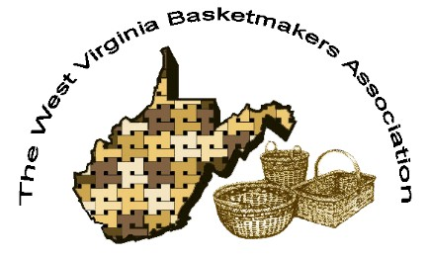
WVBA Membership
December 31, 2022 – December 31, 2023
(Please print)
Name_______________________________________
Address _____________________________________
City ___________________________ State ____ Zip+4 __________
Phone _________________________ E-mail_____________________________________
____I am a member of a West Virginia guild.
(Name of Guild) _____________________________________________________________
____ I am NOT a member of a West Virginia guild.
Basketry Business Name ______________________________________________________
(A business that sells basket supplies, basketry related items, or baskets)
____ I have joined as a teacher/business member and I would like my basketry business listed in the annual membership booklet.
Basketry Business Phone # _____________________________________________________
Basketry Business Web Site ____________________________________________________
New Member ___ Renewal ____
Are you a basketry teacher? ___ yes ___ no
Are you a vendor? ___ yes ___ no
Membership is for: (Please check those that apply.)
__ Individual membership. $15.00 Entitles you to Newsletter, and receive Convention booklet.
__ Individual under 18 on Jan. 1 or 80+ years $10.00
__ Teacher/Business Membership $20.00. Entitles you to the same as individual membership, plus is mandatory to teach classes, vend, or participate in the Market Place at Convention.

Paying by __ Cash __ Check # _____ Please make checks payable to WVBA
Send check and application to :
Nancy Sealey
2768 Emmons Ave.
Huntington, WV 25702

