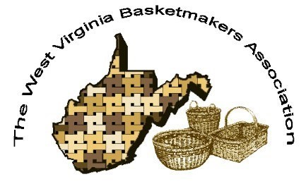

WVBA REEDER
APRIL 2023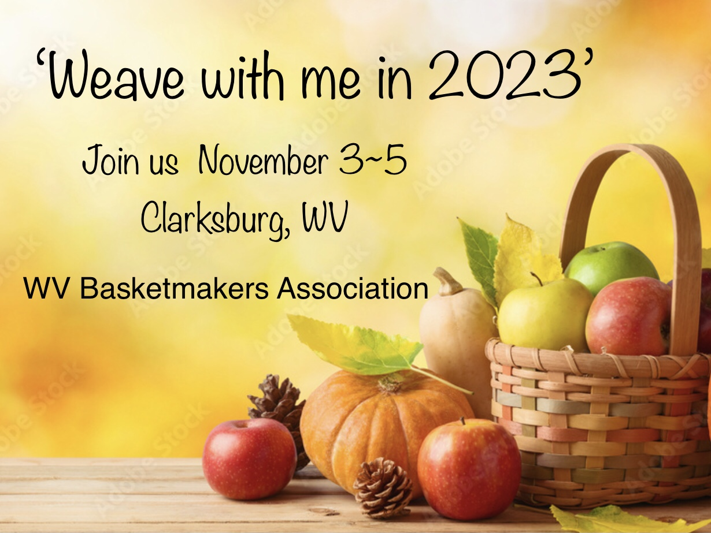
2023 WVBA OFFICERS
Sandra Carney, President Sherri Williams, Vice President
Ed Carney, Treasurer Nancy Sealey, Secretary

www.wvbasketmakersassociation.com

WVBA NEWSLETTER
Spring has sprung in our neck of the woods!

We set out one of our hummingbird feeders and have two males and a female already. Soon we’ll have three feeders and hummingbirds EVERYWHERE!

Ed and I (the BLUEHOLE company) are busy with basket making for our five consignment locations. Whew! What started as a hobby as quickly turned into a business. We love creating useful and decorative baskets, and thankful that people like to buy them!

I’m sure everyone is as excited as we are that the convention brochures will be in our mailboxes soon. The classes are diverse and for every skill level. Congratulations to our teacher liaison, Lara Lawrence, for finding these wonderful talented teachers. It’s going to be an exciting time at the “Come weave with me in 2023” convention.

Classes will fill up quickly, so get your registration and class choices in as soon as possible.

It’s been to long since the West Virginia Basketmakers Association have gathered to fellowship, share our skills and learn new techniques!

See you soon!
Sandra Carney, President
Edward Carney, Treasurer

Convention update:
Convention plans are moving right along. The brochures are finished and have been mailed. If you would like to volunteer to help with the convention, let us know please. We can always use volunteers at the raffle tables, kitchen and other areas so think about what you can do .

Lara Lawrence/Convention /Co-Chair

WARRIORS IN THE FIELD VETERANS BASKET
LARA LAWRENCE for WV BASKETMAKERS ASSOCIATION
A basket project of WV Basketmakers Association to be donated to Warriors In The Field Organization to benefit our Veterans. Warriors In The Field will fill each basket with gifts and donate them to the Veterans at the Louis A. Johnson VA Nursing Home in Clarksburg, WV at Christmas time. The baskets can be used by the Veterans for storage as well as decoration in their rooms. Thank you so much for your participation!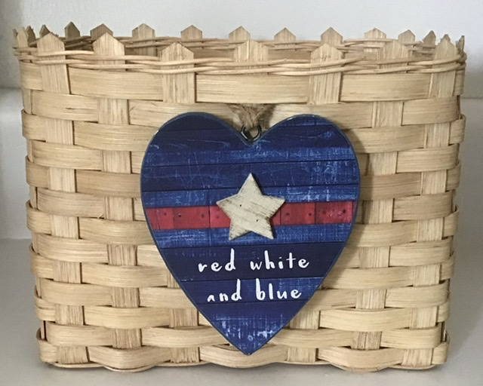
SUPPLIES NEEDED
1⁄2” Flat reed cut 5 at 21” for Horizontal stakes
1⁄2” Flat reed cut 7 at 18” for Vertical stakes
3⁄8” Flat reed cut 13 at 29” for weavers
#2 or #3 Round reed 1 at 50” for base twining
2 at 50” for top twining or 1 long piece
WEAVING INSTRUCTIONS
Mark centers and wet the (5) 1⁄2” Flat horizontal and (7) 1⁄2” Flat Vertical stakes. Weave your base with good side of reed up. Base should measure 7” across by 4 1⁄2” This is open weave base with no fillers Even up your base, twine one row around to secure it with #2 or #3 Round reed Turn your base over and upset the stakes Weave the 13 rows of 3⁄8 Flat reed being very careful to keep the sides straight and corners slightly squared. Pack down your rows Twine 2 rows around the top with #2 or #3 round reed After making sure that all sides are packed down evenly, cut the top of the stakes to a point. You can use a cut off piece of reed to make a guide to use on every stake. Add a very small drop of weavers glue or super glue on the back side of the stakes at the twining if you want to make sure the twining stays down against weaving. Trim your basket then stain. Make sure the basket sits evenly, if not, place a couple of cans of veggies in the base to help it dry level.
WVBA will have the decorative tie ons at convention to add to each basket.

NEWSLETTER/WEB SITE

Thanks to everyone who submitted info for this newsletter.
Without your input we cannot have a newsletter.
Please keep in touch in you have an address, phone number or email change so we can keep our membership/newsletter list current.

Please check our web page for upcoming events. If your group sends that info to me, I will have it posted.
www.wvbasketmakersassociation.com
Thanks again for your info
Nancy Sealey
Membership/Web Contact

NORTH CENTRAL BASKET GUILD
https://facebook.com/events/s/north-central-basket-makers-an/1232142207409578/
Here is the link to our weave day May 6th. NORTH Central. I sent some pics of the classes, but our Facebook page has them in the link above. You can still register.
Thanks! Sherri Moran
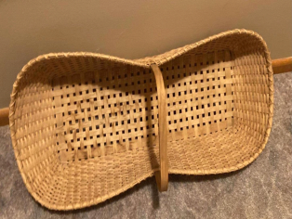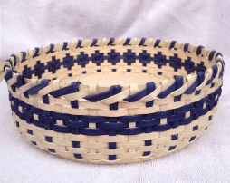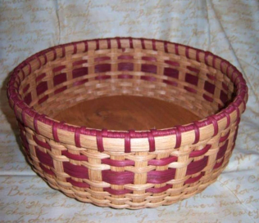

Note these are also on our Web Page.

WESTERN WEAVERS
The Western Weavers are meeting occasionally. We still have not recuperated from COVID. We have several recovering from illness and involved in remodeling projects. Hoping warmer weather will get us back together.
We will meet on the second and fourth Tuesday of each month at 1 PM at Highlawn Church of Christ in Huntington.
Come and join us.
Nancy Sealey

4 Square Basket Guild
We had a good weekend at Camp Virgil Tate! We are looking forward to February 2024 for our next Basket Weekend. We are excited to have Kathy Talley and Ashleigh Smithson as our featured instructors. Please plan to come weave with us next February!
(27 in attendance)

Judy McCoy

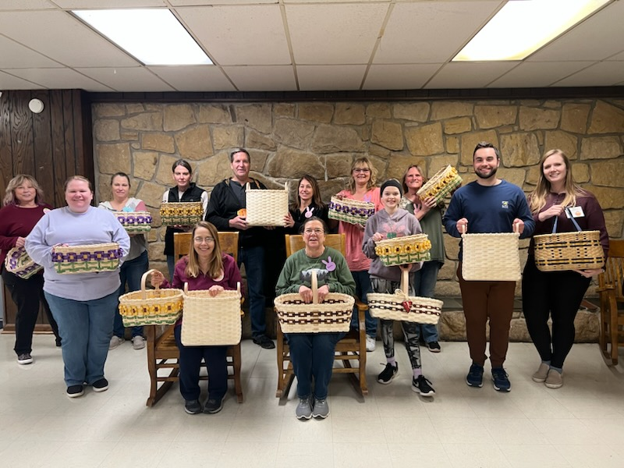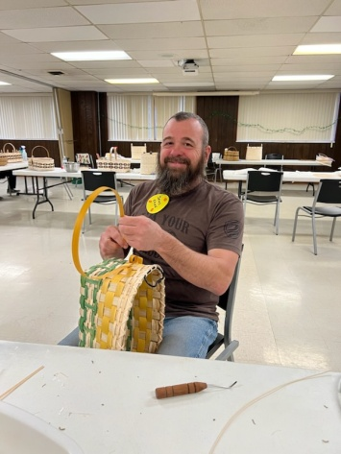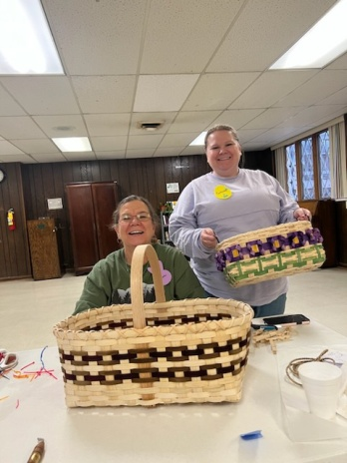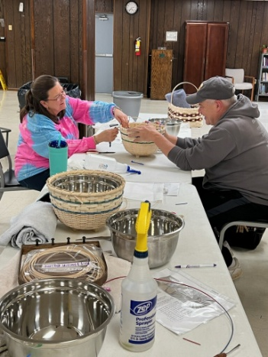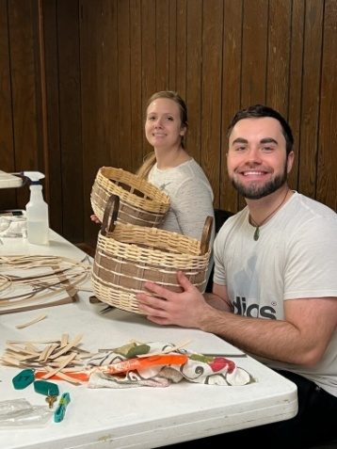

Mountain Heritage
Dee Johnson and myself just returned from a great weekend at Stateline Friends weaving retreat in Indiana. Dee taught one day and I taught three days. We had a vending booth also so it was a busy but enjoyable time. We are making plans for some local classes in Barbour County and will post when plans are finalized.
We are planning a class on June 10th at Crim Church in Philippi. For more information, email or message Lara Lawrence.j
Lara Lawrence

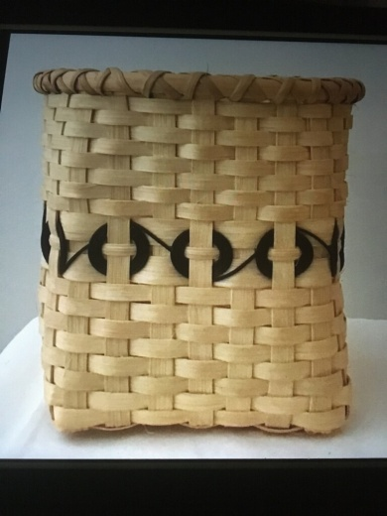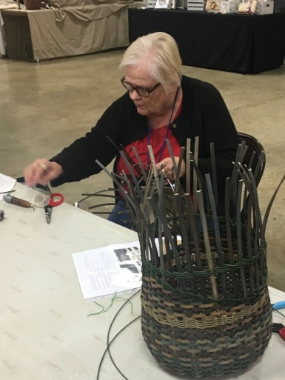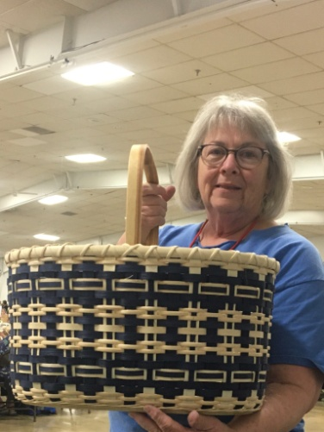
Dee Johnson’s Sue Jett Cheryl Thomas
Corner Basket

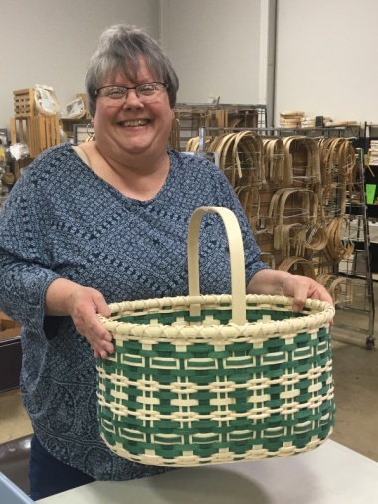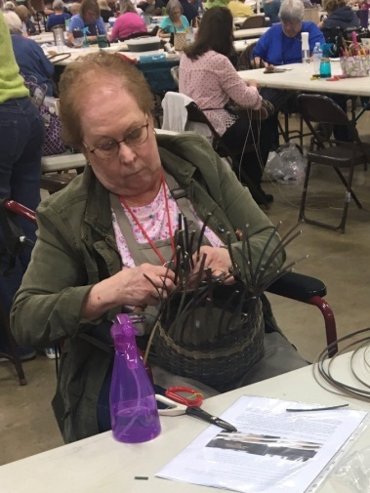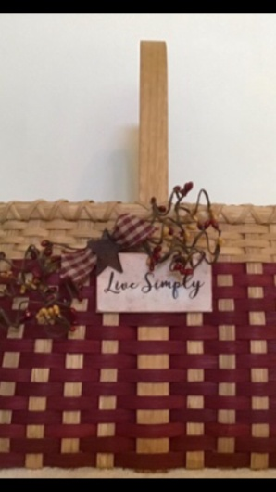

Diane Begeman Nadine Memel Lara Lawrence’s
Country Charm Basket

Weekend Weaving in North Carolina

What a wonderful March weekend weaving!!! A few West
Virginia BasketWeavers traveled to enjoy weaving at the
North Carolina Basket Makers Convention!! Many old
friends, and time to make new ones as well. There were
over 300+ weavers and 29 wonderful teachers.
The classes were challenging but filled with new ideas
and tips. It is always amazing to see “a bag of reed stuff”
become a beautiful creation!

WVBA November, come enjoy some of this same fun,
friends, and “weaving wonder” in Clarksburg!!

Mark your calendars!!

(submitted by: Sandy Eisenhard, PA)

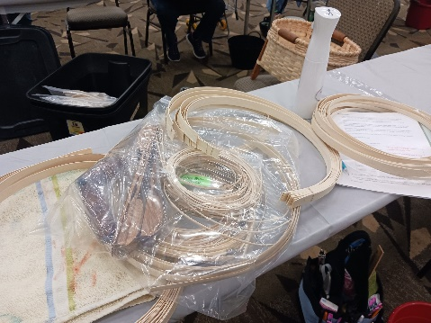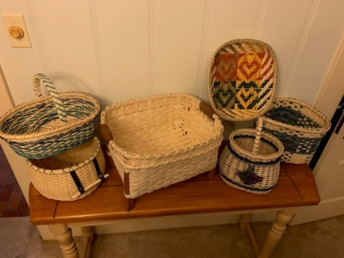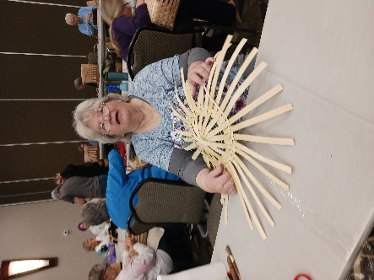

WVBA Membership
December 31, 2022– December 31, 2023
(Please print)
Name___________________________________
Address _____________________________________
City ___________________________ State ____ Zip+4 __________
Phone _________________________
E-mail_____________________________________
____I am a member of a West Virginia guild.
(Name of Guild) _____________________________________________________________
____ I am NOT a member of a West Virginia guild.
Basketry Business Name ______________________________________________________
(A business that sells basket supplies, basketry related items, or baskets)
____ I have joined as a teacher/business member and I would like my basketry business listed in the annual membership booklet.
Basketry Business Phone # _____________________________________________________
Basketry Business Web Site ____________________________________________________
New Member ___ Renewal ____
Are you a basketry teacher? ___ yes ___ no
Are you a vendor? ___ yes ___ no
Membership is for: (Please check those that apply.)
__ Individual membership $15.00
Entitles you to Newsletter, and receive Convention booklet.
__ Individual under 18 on Jan. 1 or 80+ years $10.00
__ Teacher/Business Membership $20.00. Entitles you to the same as individual membership plus is mandatory to teach classes, vend, or participate in the Market Place at Convention.
Paying by __ Cash __ Check # _____ Please make checks payable to WVBA
Send check and application to :
Nancy Sealey
2768 Emmons Ave.
Huntington, WV 25702

