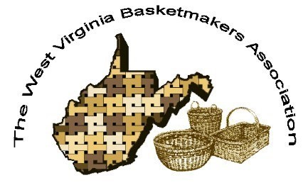

***WVBA REEDER***

***JANUARY 2023***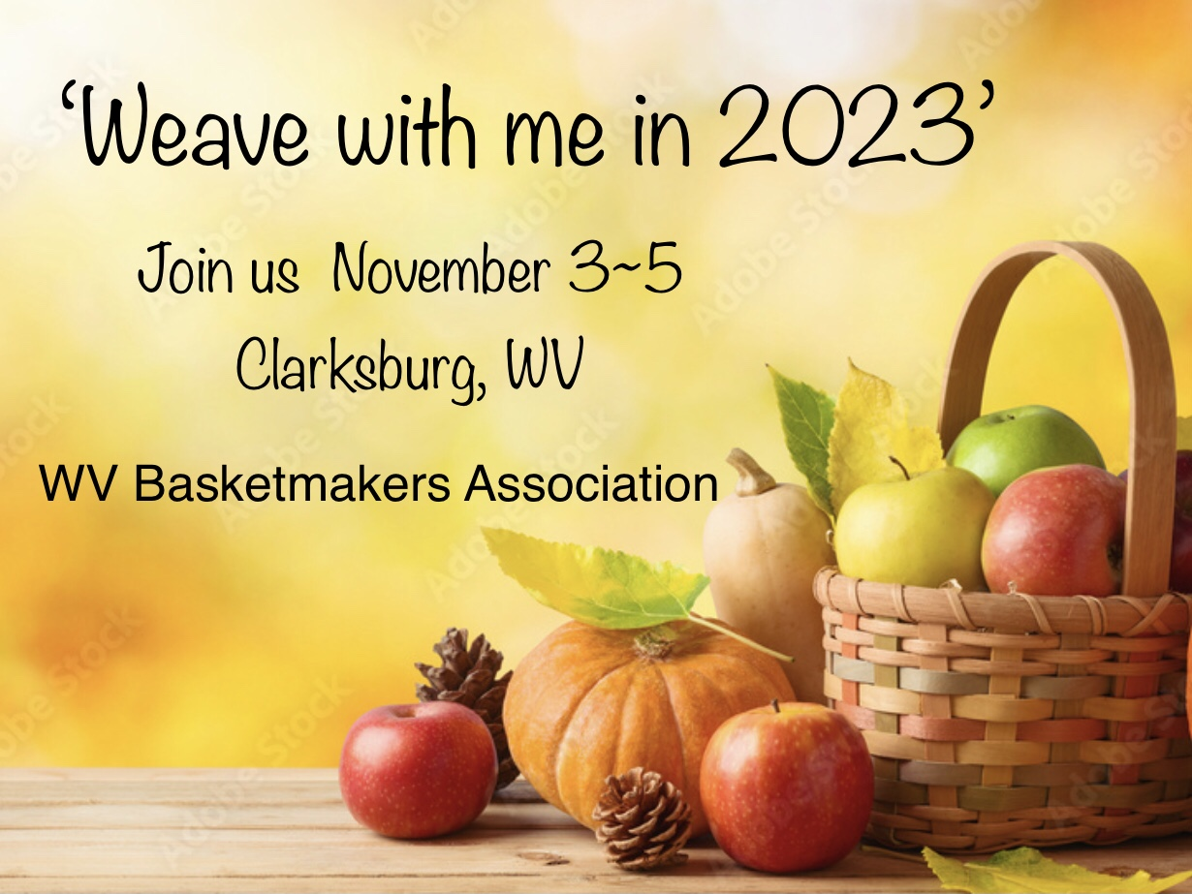

***2023 WVBA OFFICERS***

*Sandra Carney, President Sherri Williams, Vice President*

*Ed Carney, Treasurer Angie White, Secretary*

www.wvbasketmakersassociation.com

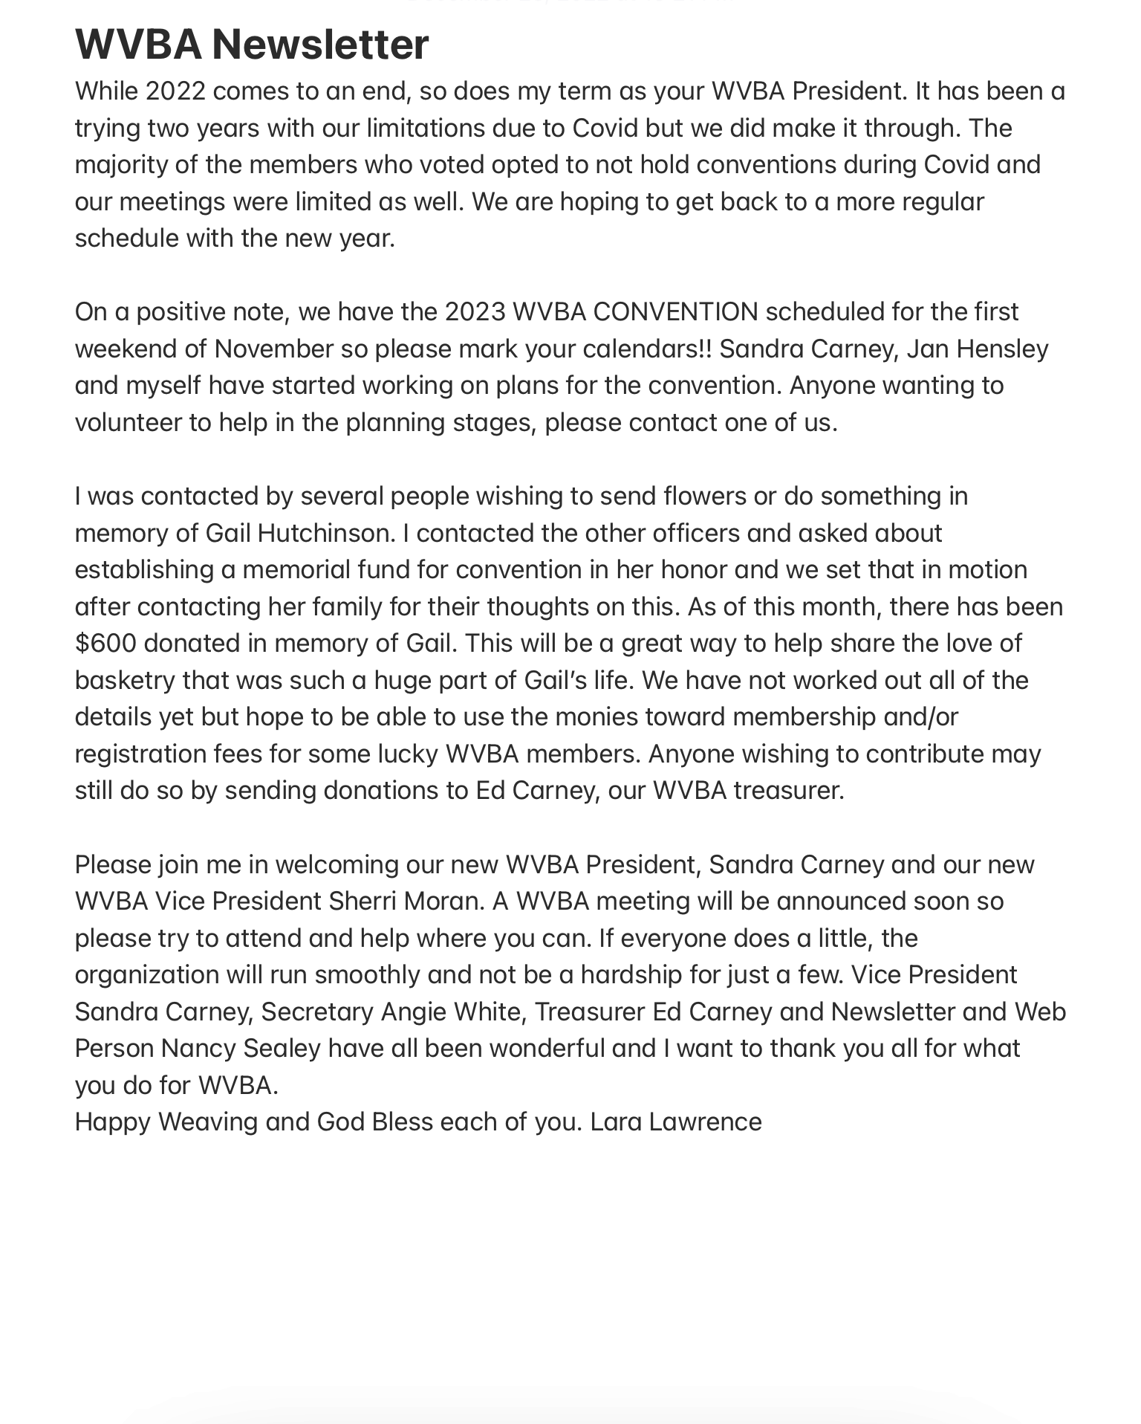

************************************************************************************************************************

**THERE WILL BE A BOARD MEETING AND CONVENTION PLANNING MEETING ON FEBRUARY 18, 2023 AT OLIVE GARDEN IN CLARKSBURG AT 1 PM.**

Ed & I are busy weaving and trying to keep all of our clients well stocked with various baskets. We stock the Craft Connection in Fairmont, Fish Hawk Acres (The Coop) in Buckhannon and Swiss Roots in Helvetia.  
It’s always a guessing game as to what types of baskets people want or need and what we enjoy weaving. Attached are a few examples of our work and a our picture to let everyone know who we are.  
  
We are anxiously excited about the upcoming 2023, and can hardly wait to start the theme and planning. It’s truly been to long since we gathered together.  
  
Sandra Carney, Vice President/President  
  
  
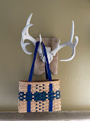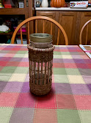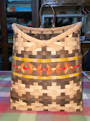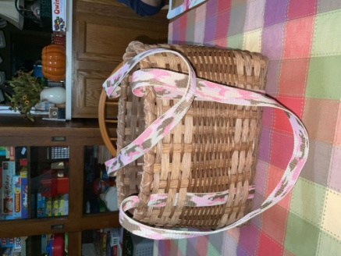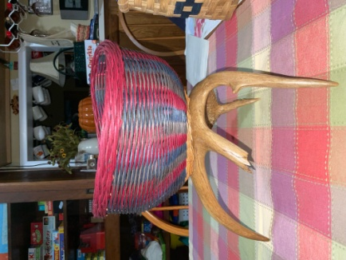  
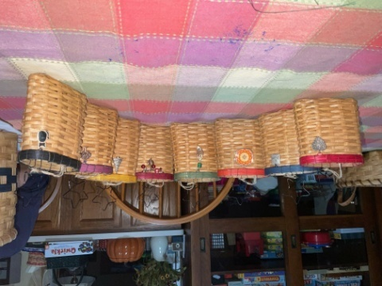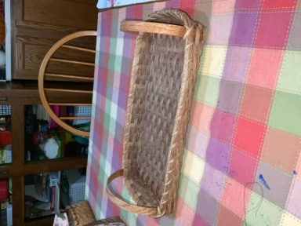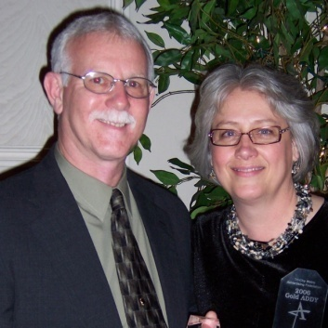

|  |  |
| --- | --- |
|  | |
|  |  |
|  |  |
|  |  |
|  |  |
|  |  |
|  |  |
|  |  |
|  |  |

*************************************************************************************************************

**WARRIORS IN THE FIELD VETERANS BASKET**

**LARA LAWRENCE for WV BASKETMAKERS ASSOCIATION**

A basket project of WV Basketmakers Association to be donated to Warriors In The Field Organization to benefit our Veterans. Warriors In The Field will fill each basket with gifts and donate them to the Veterans at the Louis A. Johnson VA Nursing Home in Clarksburg, WV at Christmas time. The baskets can be used by the Veterans for storage as well as decoration in their rooms. Thank you so much for your participation!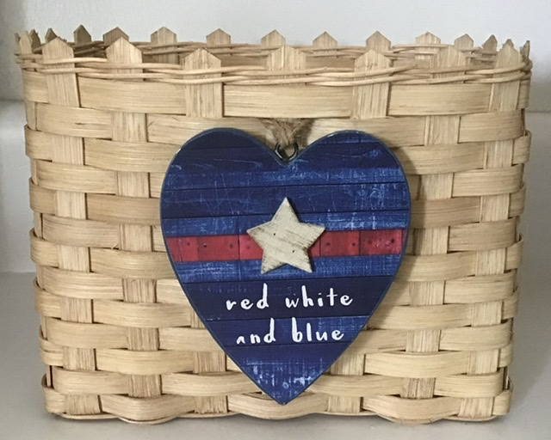

SUPPLIES NEEDED

1⁄2” Flat reed cut 5 at 21” for Horizontal stakes

1⁄2” Flat reed cut 7 at 18” for Vertical stakes

3⁄8” Flat reed cut 13 at 29” for weavers

#2 or #3 Round reed 1 at 50” for base twining

2 at 50” for top twining or 1 long piece

WEAVING INSTRUCTIONS

Mark centers and wet the (5) 1⁄2” Flat horizontal and (7) 1⁄2” Flat Vertical stakes. Weave your base with good side of reed up. Base should measure 7” across by 4 1⁄2” This is open weave base with no fillers Even up your base, twine one row around to secure it with #2 or #3 Round reed Turn your base over and upset the stakes Weave the 13 rows of 3⁄8 Flat reed being very careful to keep the sides straight and corners slightly squared. Pack down your rows Twine 2 rows around the top with #2 or #3 round reed After making sure that all sides are packed down evenly, cut the top of the stakes to a point. You can use a cut off piece of reed to make a guide to use on every stake. Add a very small drop of weavers glue or super glue on the back side of the stakes at the twining if you want to make sure the twining stays down against weaving. Trim your basket then stain. Make sure the basket sits evenly, if not, place a couple of cans of veggies in the base to help it dry level.

WVBA will have the decorative tie ons at convention to add to each basket.

NEWSLETTER/WEB SITE

Thanks to everyone who submitted info for this newsletter.

Without your input we cannot have a newsletter.

Please keep in touch in you have an address, phone number or email change so we can keep our membership/newsletter list current.

Our web page is up and running. Please contact me if you or your group is having an upcoming event and we will have it put on our site.

[www.wvbasketmakersassociation.com](http://www.wvbasketmakersassociation.com)

Thanks again for your info

Nancy Sealey

Membership/Web Contact

NORTH CENTRAL BASKET GUILD

Happy New Year!

North Central guild had a fun Christmas party. We played a sock game where we filled a sock with goodies them did Chinese auction.  We had lots of food and fun.  We made a beautiful peppermint basket for Christmas also. Jill Schiefelbein taught. We are doing a heart basket for Valentine's day. For all you weaving sweethearts have a good year !

Sherri Williams/North Central Guild

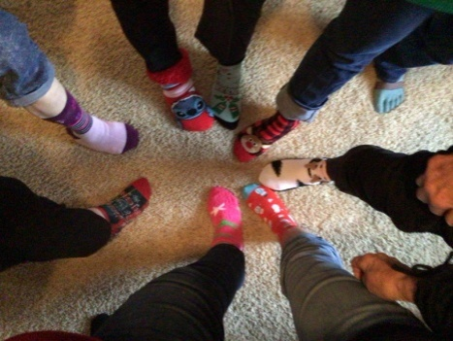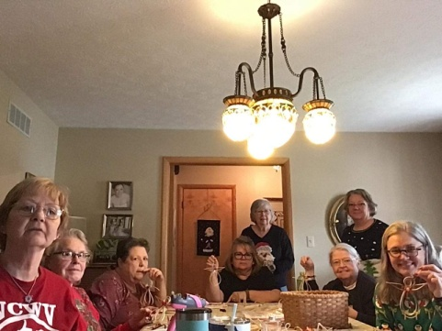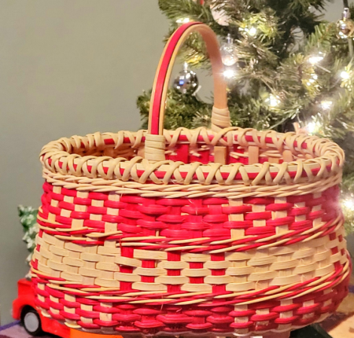

WESTERN WEAVERS

The Western Weavers are meeting occasionally. Some of us are still working on our egg baskets and a few are ready to move on to a new project. Lots of sickness, travel, remodeling lately so it has been harder to get together,

We did put up our basket tree again this year at the Huntington Museum of Art..

We will meet on the second and fourth Tuesday of each month at 1 PM at Highlawn Church of Christ in Huntington.

Come and join us.

Nancy Sealey

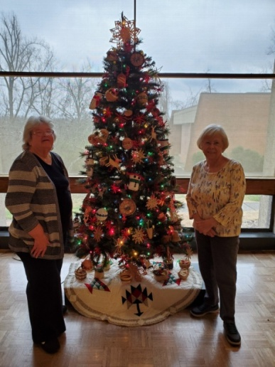

4 Square Basket Guild has been working hard to have our Second Annual Camp Virgil Tate Weave Weekend.  This is a fundraiser for Southern District Horse Camp.  Date will be Feb 18 and 19, 2023.  Please see our WVBA website ([www.wvbasketmakersassociation.com](http://www.wvbasketmakersassociation.com/)) for more information.  Following are pictures of baskets being taught that weekend.

Judy McCoy/4 Square

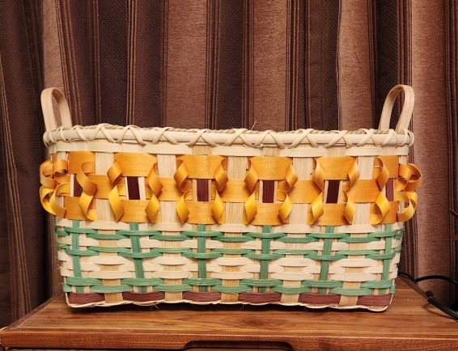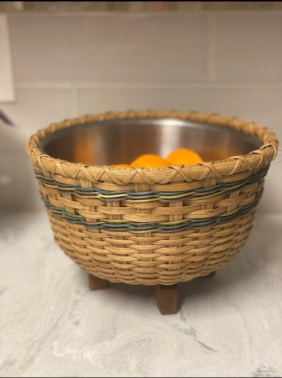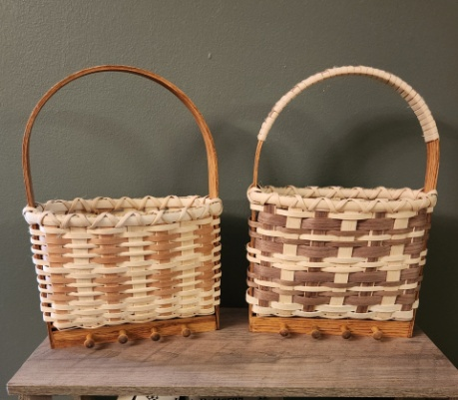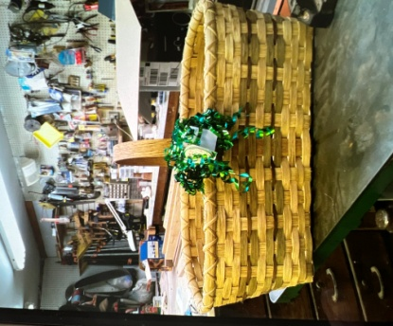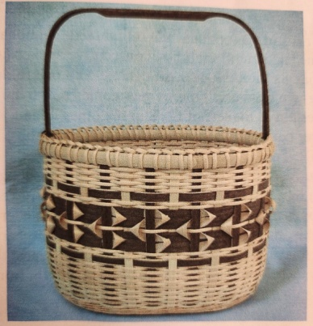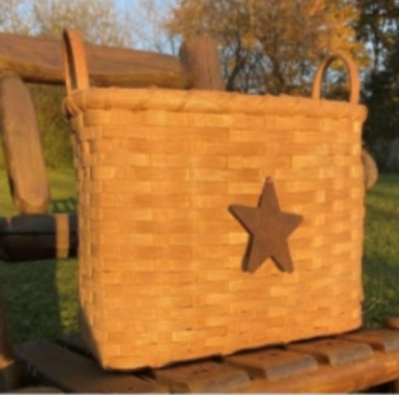

**WVBA Membership**

**December 31, 2022– December 31, 2023**

**(Please print)**

Name___________________________________

Address _____________________________________

City ___________________________ State ____ Zip+4 __________

Phone _________________________

E-mail_____________________________________

____I am a member of a West Virginia guild.

(Name of Guild) _____________________________________________________________

____ I am NOT a member of a West Virginia guild.

**Basketry Business Name ______________________________________________________**

(A business that sells basket supplies, basketry related items, or baskets)

____ I have joined as a teacher/business member and I would like my basketry business listed in the annual membership booklet.

**Basketry Business Phone # _____________________________________________________**

**Basketry Business Web Site ____________________________________________________**

New Member ___ Renewal ____

Are you a basketry teacher? ___ yes ___ no

Are you a vendor? ___ yes ___ no

Membership is for: (Please check those that apply.)

__ **Individual membership** $15.00

Entitles you to Newsletter, and receive Convention booklet.

__ **Individual under 18** on Jan. 1 or 80+ years $10.00

__ **Teacher/Business Membership** $20.00. Entitles you to the same as individual membership plus is mandatory to teach classes, vend, or participate in the Market Place at Convention.

**Paying by __ Cash __ Check # _____ Please make checks payable to WVBA**

**Send check and application to :**

**Nancy Sealey**

**2768 Emmons Ave.**

**Huntington, WV 25702**