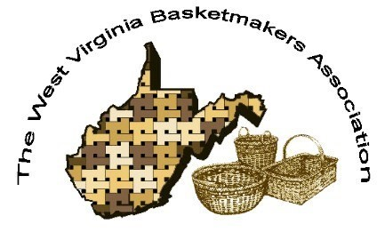

***WVBA REEDER***

***SEPTEMBER 2022***

***2022 WVBA OFFICERS***

*Lara Lawrence, President Sandra Carney, Vice President*

*Ed Carney, Treasurer Angie White, Secretary*

www.wvbasketmakersassociation.com

We were finally able to have an in person meeting! Unfortunately, 2 of those planning to attend

ended up with Covid so they had to miss the meeting. Apparently, Covid plans to stick around

so we are just trying to find a new ‘normal’. Thank you to those members who did attend. We

enjoyed a nice meal at Olive Garden and everyone enjoyed visiting and catching up.

We have a lot of news to report. We are working on the 2023 convention and need every guild

to step up and volunteer to do your part when contacted by one of the convention coordinators

please! A convention requires a LOT of work before, during and after so it is important that

everyone help in some way. It would be nice if everyone could just show up, weave and go

home but it does not work that way. If you want conventions to continue, do your part.

Our website is operational again!! The website can be accessed at

www.wvbasketmakersassociation.com . It will be so nice to get information online once again.

Thank you to Nancy Sealey for overseeing this!!

There are a couple of weaving events being held in the southern part of the state this fall. If your

guild is hosting regular meetings or an event, please contact Nancy Sealey so she can share

the information with all of our members.

We are going to try to follow through with the Baskets for the VA Nursing Home for 2023. More

information will be in this newsletter.

If you would like to share a recipe, a favorite quote or scripture, puzzle, a good joke or perhaps

one of your own basket patterns, please send it to Nancy Sealey and she will get it on the

website.

Be kind always and Happy Weaving.

LARA LAWRENCE

WVBA PRESIENT

CONVENTION UPDATE SEPT 12, 2022

Angie just talked to them at the 4H Center and they do not have the calendar open for reservations yet. She is to call back in a couple of weeks.

**WARRIORS IN THE FIELD VETERANS BASKET**

**LARA LAWRENCE for WV BASKETMAKERS ASSOCIATION**

A basket project of WV Basketmakers Association to be donated to Warriors In The Field Organization to benefit our Veterans. Warriors In The Field will fill each basket with gifts and donate them to the Veterans at the Louis A. Johnson VA Nursing Home in Clarksburg, WV at Christmas time. The baskets can be used by the Veterans for storage as well as decoration in their rooms. Thank you so much for your participation!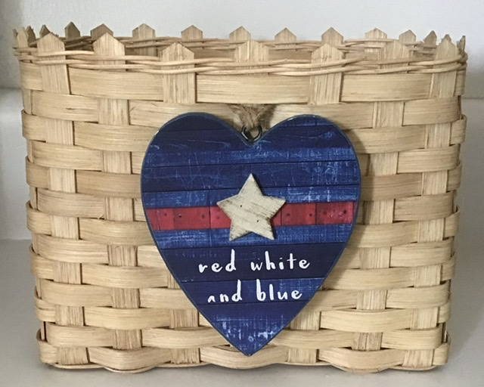

SUPPLIES NEEDED

1⁄2” Flat reed cut 5 at 21” for Horizontal stakes

1⁄2” Flat reed cut 7 at 18” for Vertical stakes

3⁄8” Flat reed cut 13 at 29” for weavers

#2 or #3 Round reed 1 at 50” for base twining

2 at 50” for top twining or 1 long piece

WEAVING INSTRUCTIONS

Mark centers and wet the (5) 1⁄2” Flat horizontal and (7) 1⁄2” Flat Vertical stakes. Weave your base with good side of reed up. Base should measure 7” across by 4 1⁄2” This is open weave base with no fillers Even up your base, twine one row around to secure it with #2 or #3 Round reed Turn your base over and upset the stakes Weave the 13 rows of 3⁄8 Flat reed being very careful to keep the sides straight and corners slightly squared. Pack down your rows Twine 2 rows around the top with #2 or #3 round reed After making sure that all sides are packed down evenly, cut the top of the stakes to a point. You can use a cut off piece of reed to make a guide to use on every stake. Add a very small drop of weavers glue or super glue on the back side of the stakes at the twining if you want to make sure the twining stays down against weaving. Trim your basket then stain. Make sure the basket sits evenly, if not, place a couple of cans of veggies in the base to help it dry level.

WVBA will have the decorative tie ons at convention to add to each basket.

NEWSLETTER/WEB SITE

Thanks to everyone who submitted info for this newsletter.

Without your input we cannot have a newsletter.

Please keep in touch in you have an address, phone number or email change so we can keep our membership/newsletter list current.

Our web page is up and running. Please contact me if you or your group is having an upcoming event and we will have it put on our site.

There are currently two upcoming weaves in WV in October.

Please see our site for info about these.

[www.wvbasketmakersassociation.com](http://www.wvbasketmakersassociation.com)

Thanks again for your info

Nancy Sealey

Membership/Web Contact

NORTH CENTRAL BASKET GUILD

We have been a busy guild this summer. Had a successful Weave day in May. We have had a few new members join our guild. Currently our guild is enjoying the annual fall trip to Balli Mountain.  Good fellowship and weaving with beautiful scenery to boot.  We will have a special guest teacher next month..Yes, we are

 planning our Christmas party too believe it or not! It will be here before we know it!  Sending some photos of baskets we have made. The porch pic is at Balli Mountain near Helvetia, WV.  God bless and happy weaving !

All the best,

Sherri Moran

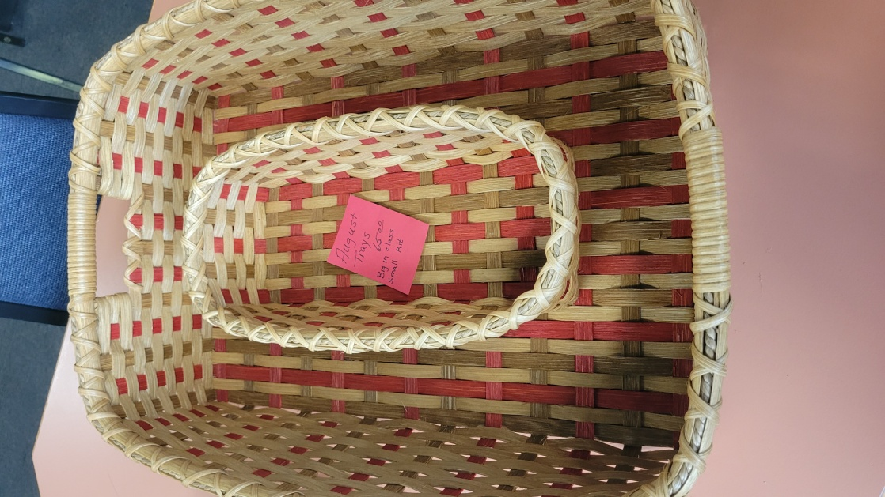

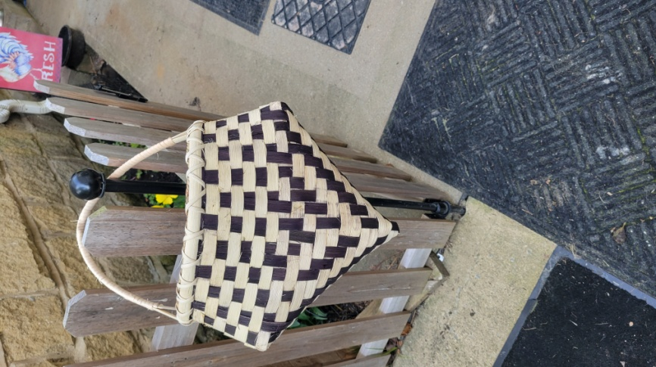

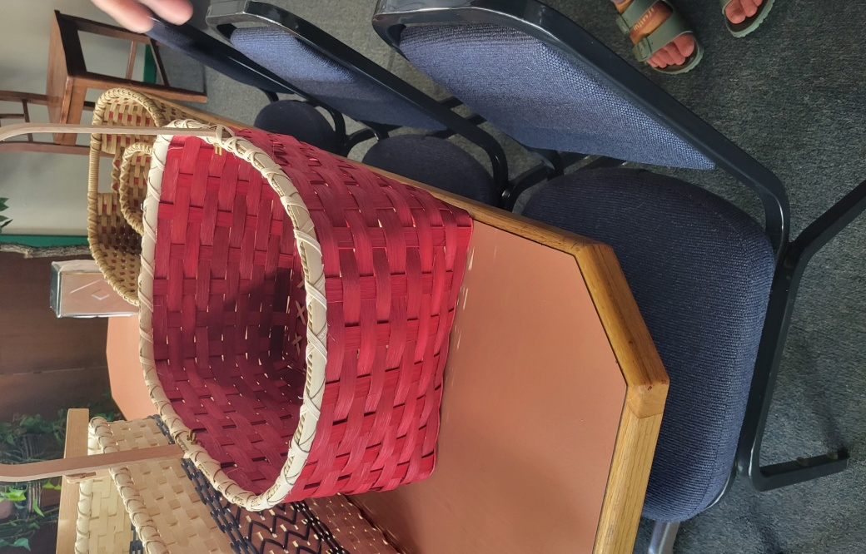

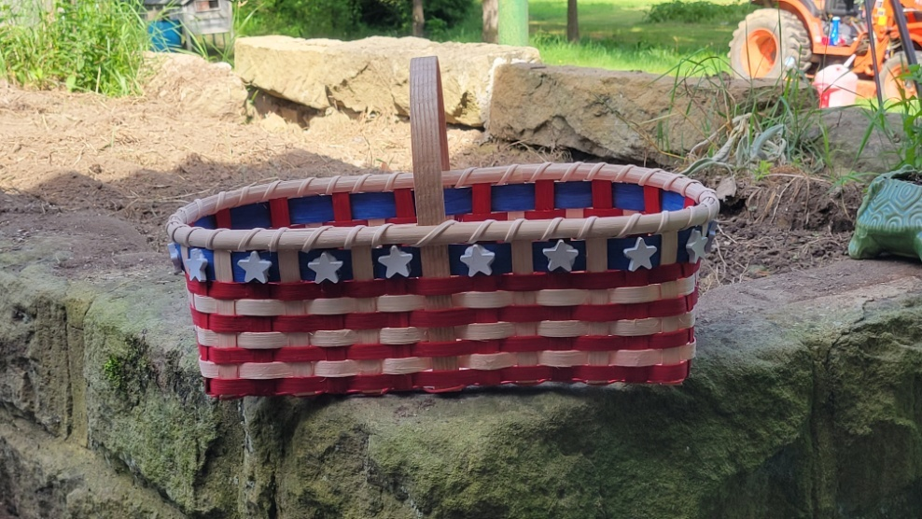

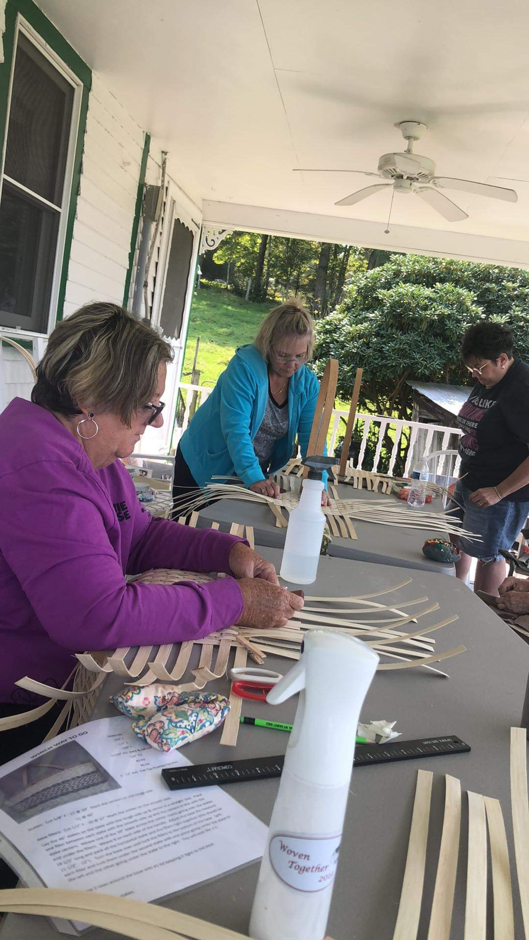

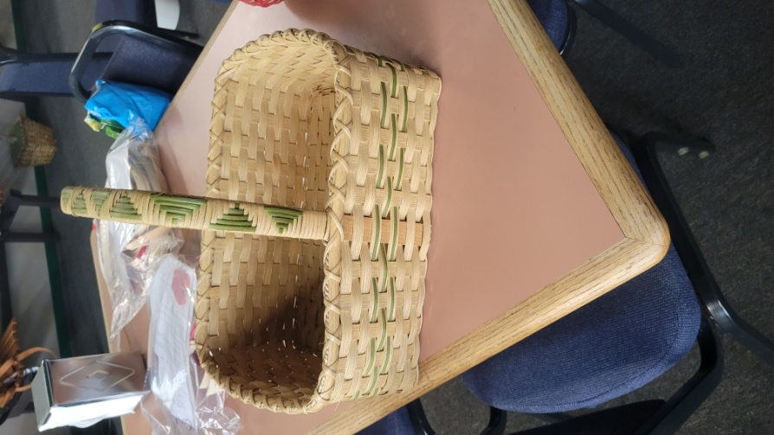

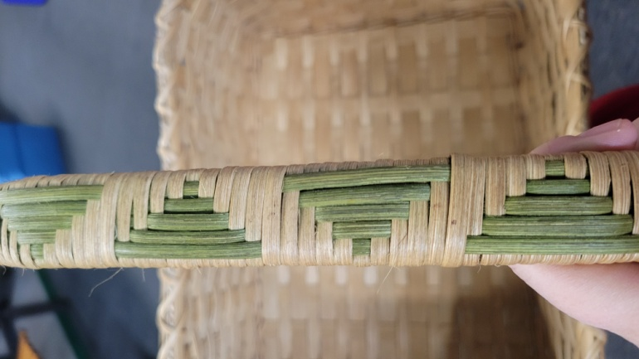

**HOMESPUN BASKET WEAVERS**

We will be hosting a one-day weave-in on Saturday, October 15, at the Greene Center located just off the Kenna exit of I-77 (about 20 minutes north of Charleston).  Attached is a flyer about the event; it has a registration form included.

 The Homespun Basket Weavers Guild meets in Ripley, WV, on the 3rd Monday of every month at 6:00pm.  Bring your tools and join us for an evening of weaving and conversation.  For more information, call Karen Burdette at [304.988.2770](tel:304.988.2770).

Best regards,

 Jan Hensley

WESTERN WEAVERS

The Western Weavers are meeting again. We have about 5-6 members who came back after COVID. We lost a few because of moving, sickness, etc.

We are going to attempt to make egg baskets (since some of us aren’t even sure we still know how to weave) and will meet on the second and fourth Tuesday of each month at 1 PM at Highlawn Church of Christ in Huntington.

Come and join us.

Nancy Sealey

RECIPES… GIVE THEM A TRY.

I decided to send you my Mom's recipe for Sour Cream Biscuits for the newsletter.  I had forgotten about these golden gems until I found a note in my Mom’s own handwriting tucked inside her worn and tattered Ball Blue Book (which was second only to the Bible to the farming wives of my Mom’s generation!).  Memories of these delicious biscuits came flooding back: the smells that filled the kitchen, the crunchy crust.  Sometimes Mom would add shredded cheddar cheese to the batter or crumbled sausage (on the rare occasion there was any left over after feeding a family of 7!).  I’ve since introduced them to the next generation by making them for my daughter and her husband; they love them as much as I do!

Sour Cream Biscuits

1 1/4 cup of sifted, all-purpose flour

1 stick of butter (softened to room temperature)

8 oz. container of sour cream

Mix all ingredients together; drop by large spoonsful on a baking sheet.  Bake at 375 degrees until golden brown around the edges.  Let cool completely in the pan.

My Mom’s notes: salted or unsalted butter works; no need to grease the pan, check every 2-3 minutes after the first 8 minutes; brush tops with melted butter.

Hope your family and friends enjoy them as much as mine does!

Submitted by JAN HENSLEY

++++++++++++++++++++++++++++++++++++++++++++++++++++++++++++++++++

GRAPE SALAD

4 Lbs Seedless Grapes.

8 oz Cream Cheese.

8 oz Sour Cream.

½ cup Sugar.

1 tsp Vanilla

2 Tbs Brown Sugar

1 Cup Pecan Pieces

Mix cream cheese, sour cream, white sugar and vanilla in a large bowl. Add grapes and mix

well. Top with brown sugar and pecans. Cover and refrigerate. When

ready to serve, stir and enjoy!

Submitted by Lara Lawrence

**WVBA Membership**

**December 31, 2021– December 31, 2022**

**(Please print)**

Name___________________________________

Address _____________________________________

City ___________________________ State ____ Zip+4 __________

Phone _________________________

E-mail_____________________________________

____I am a member of a West Virginia guild.

(Name of Guild) _____________________________________________________________

____ I am NOT a member of a West Virginia guild.

**Basketry Business Name ______________________________________________________**

(A business that sells basket supplies, basketry related items, or baskets)

____ I have joined as a teacher/business member and I would like my basketry business listed in the annual membership booklet.

**Basketry Business Phone # _____________________________________________________**

**Basketry Business Web Site ____________________________________________________**

New Member ___ Renewal ____

Are you a basketry teacher? ___ yes ___ no

Are you a vendor? ___ yes ___ no

Membership is for: (Please check those that apply.)

__ **Individual membership** $15.00

Entitles you to Newsletter, and receive Convention booklet.

__ **Individual under 18** on Jan. 1 or 80+ years $10.00

__ **Teacher/Business Membership** $20.00. Entitles you to the same as individual membership plus is mandatory to teach classes, vend, or participate in the Market Place at Convention.

**Paying by __ Cash __ Check # _____ Please make checks payable to WVBA**

**Send check and application to :**

**Nancy Sealey**

**2768 Emmons Ave.**

**Huntington, WV 25702**