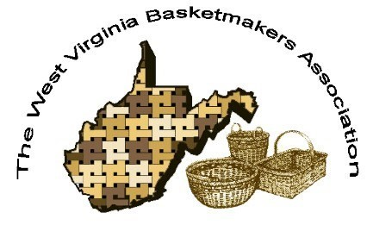

WVBA REEDER
JULY 2026

CONVENTION 2026
October 23-25, 2026
Battlers Knob LLC
(former Alderson Broaddus Campus)
Philippi, WV

2026 WVBA OFFICERS
Jan Hensley, President Melissa How ell, Interim VP Sharon Scott, Treasurer Nancy Sealey, Secretary

www.wvbasketmakersassociation.com

WVBA NEWSLETTER
Message from the President: I
Greetings WVBA members,
It’s hard to believe that we are already a month into Summer! Hope your Summer is in full swing by now, that you’re keeping cool, and enjoying fresh produce from your garden or local farmers’ markets. If you are looking for a great broccoli salad to use up your garden produce, I recommend the “Healthy Broccoli Salad” recipe at https://www.hummusapien.com/healthy-brocccoli-salad. The recipe is low-fat and uses plain yogurt for the dressing instead of mayonnaise. It’s really yummy!

CONVENTION UPDATE (Missy Howell and Sue Mullens, Co-Chairs)
Plans for the fall convention are moving forward rapidly! We have 4 new teachers and 4 returning favorites from KY, WV, WI, NY, and NC. Registrations are coming in from all over: OH, WV, MD, PA, VA, NC, and MI. Some classes are already sold out!
We are adding some new events this year (traveling basket and participants’
marketplace) as well as some of the favorites (silent auction and raffle items). Follow
the link below to review this year projects.
https://wvba-2026-convention-online.cheddarup.com
Please forward this link to anyone or any group that you are following on Facebook. The registration and membership forms are available for download, as well as the WVBA 2026 Convention brochure, “Arrive as Strangers, Weave as Friends”.

We do not have vendors set up during the convention this year; however, if you place
your order in advance with Kay Kass, you can save shipping costs! The link to her
website is:

https://form.jotform.com/261343803096153

(This link takes you to Kay Kass’s order form for supplies. (Keep scrolling down.) It is for reed and leather handles that you must preorder. She will be bringing other miscellaneous basket items with her for purchase but these items on the order form must be preordered.)

Do not hesitate to call should you have any questions or need additional information.

Warm regards,
Jan Hensley
304.389.2907

************************************************************************************************************************

JUST FOR FUN
BASKET WORD SCRAMBLE

1.hasres__________________________________________
2. vaewe_____________________________________________
3. ektbsa_____________________________________________
4. tcu________________________________________________
5. entakunct__________________________________________
6. rkcape_____________________________________________
7. nietw______________________________________________
8. pest pu____________________________________________
9. kramte_____________________________________________
10. ebsa______________________________________________
11. hlsa_______________________________________________
12. cukt_______________________________________________
13. cnicpi______________________________________________
14. dere_______________________________________________
15. bidreb______________________________________________
16. anlrtdiaoti__________________________________________
17. sucotnuion__________________________________________
18. geg________________________________________________
19. nogilic_____________________________________________
20. mri________________________________________________
21. wngtini_____________________________________________
22. eachs evawe________________________________________
23. dehnal_____________________________________________
24. hngterce____________________________________________
25. dowo______________________________________________
26. gaptnil_____________________________________________
27. liwtl_______________________________________________
28. ksatse______________________________________________
29. eskpso_____________________________________________
30. resveaw____________________________________________

SUBMITTED BY LARA LAWRENCE

NOTES FROM OUR MEMBERS

The Inaugural West Virginia River Valley Weave is in the books. Beautiful Weather, good food, beautiful baskets and fellowship was had by all.
This event was held March 19-21 at Beautiful GrandVue Park in historic Moundsville, WV. There were 4 teachers (Kathy Petronzio, Marilyn Parr, Pat Mercer and Linda Elschlager) and 32 attendees.
Also, please save the date for next year’s Weave – April 1-3, 2027.
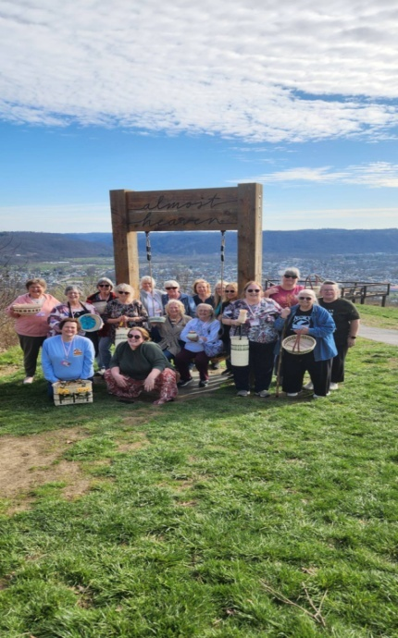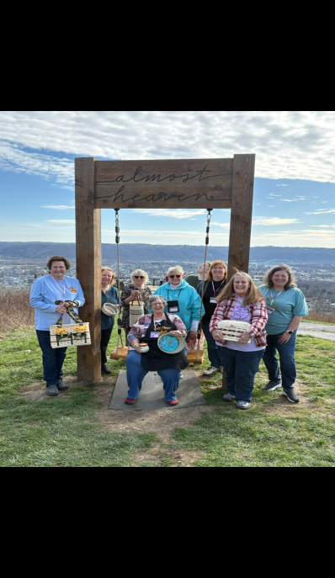
Congratulations to Dianne Gellner for having the winning ticket for our raffle. All proceeds from the raffle are being donated to T2T (Tunnel to Towers) to help fund all the services they provide for wounded and homeless Veterans. We were able to raise $508.00 for this very worthwhile cause. Many thanks to all who supported this.
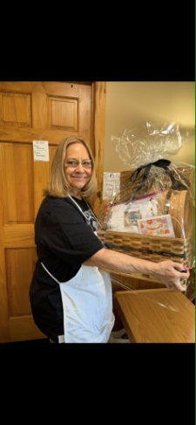
SUBMITTED BY LINDA ELSCHLAGER

*******************************************************

Mid-June, I returned from my 2nd year of teaching at BABS (Bluegrass Area Basketry Symposium).

I've attached 1 photo from each class.

BABS was June 9-14 (5 days of weaving) at General Butler State Park in Carrollton, KY. I taught classes each day: Spiraling Arrows, Here Comes the Sun, Deeper into the Garden, Down by the Pond, and Deep Pockets.
Next year BABS is moving to Somerset, KY.

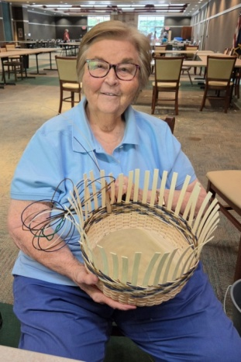
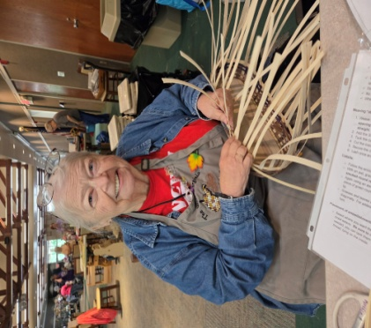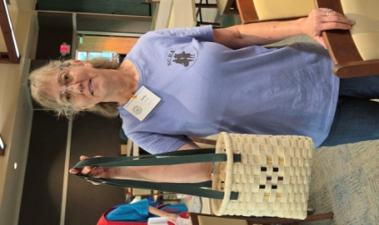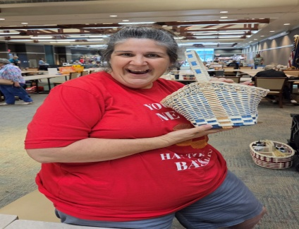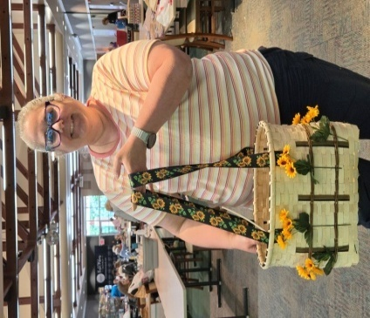

SUBMITTED BY PAT MERCER
***********************************************************************************************************

Each month, we have a class in Wheeling that meets at the Greater Wheeling Soup Kitchen. Experienced and beginners are all welcomed.

Here are a few pics of May's twilling project.

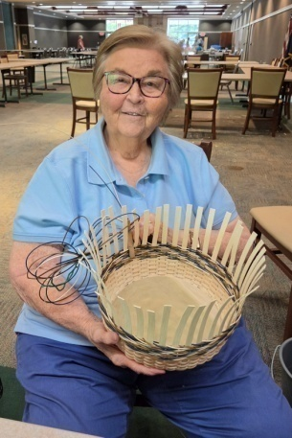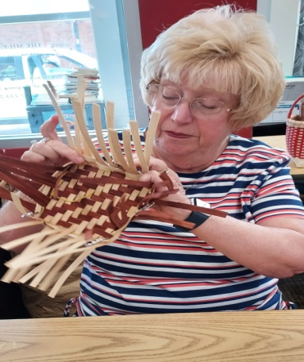
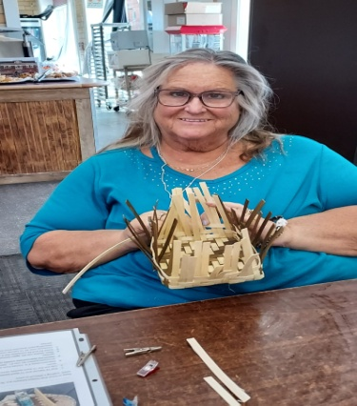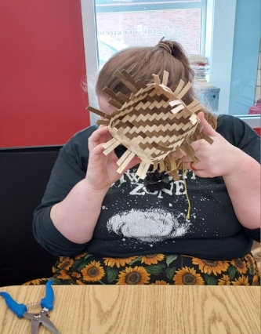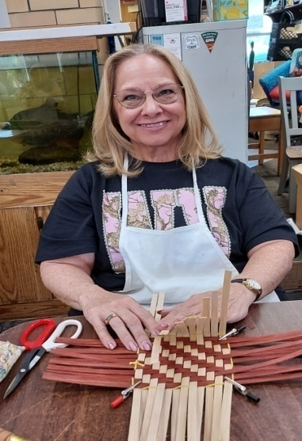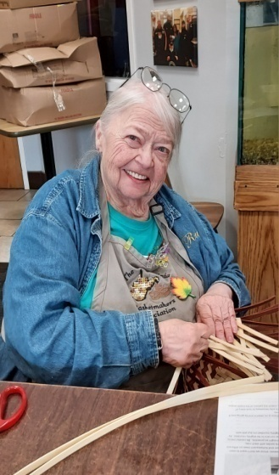

SUBMITTED BY PAT MERCER
********************************************

I have 2 announcements. #1 Heritage Basketry Guild had a weave day on Saturday, July 25th. Our teacher for the event was Lorelea Roberts. She proposed 3 baskets. Lunch was pot luck.. #2 Deadline for HBG Fall Weave is approaching the end of the month. It is held in Fairborn, Ohio (Dayton) from September 10th thru the 12th. Info is available online or FB at Heritage Basketry Guild Fall Weave. We still have room for you!

SUBMITTED BY PHYLLIS LYONS

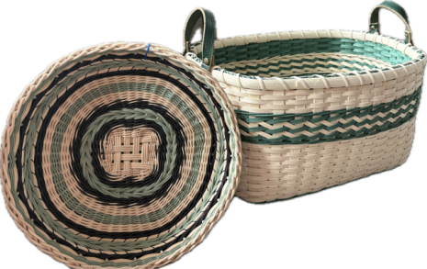
I am happy to share with our West Virginia weaving friends some of the things we have done and are planning on doing in 2026. We are a small guild which has struggled as many have since COVID, however, we have had a productive year so far and are planning exciting things for the remainder of the year. We meet the second Saturday of the month except May and October when we meet the third Saturday. Our meetings are held at the Lighthouse Publishing, 5179 Business 220, Bedford, PA. Each meeting we have planned an easier basket for beginners and have woven Gina Kieft’s Empress and Hurricane for those wanting something more challenging.
May 1-3, we held our Weaving Your Cares Behind retreat with instructors Candy and Dave Barnes, Bonnie Rideout and Cheryl Thomas and Angie from Country Seat vending. Other than a car with a dead battery and a lost cell phone clocked at 60 mph in a 55 mph zone, the retreat was very successful and all problems were solved.
We normally do not meet in July and August, however, Linda Elschlager will be leading us in classes yet to be announced in September. Julia Umberger, will be teaching her basket designed around a galvanized bucket in October. In November we are taking a break from weaving to make a sea glass tree taught by member Diane Coup.
Everyone is invited to join us and for further information contact Karon Ritchey at karon.s.ritchey@gmail.com.
These are two baskets designed by our member, Bev Geller, that were taught as beginner baskets.
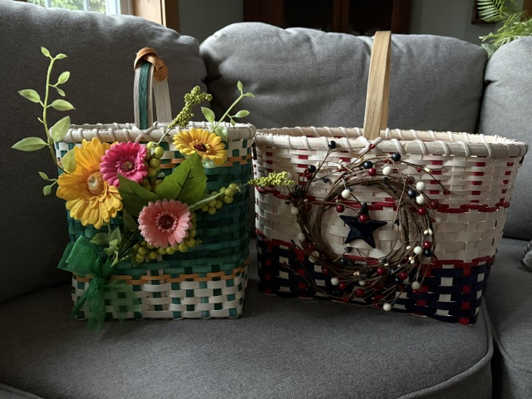

Thank you,
Karon Ritchey, President of Basketweavers of Bedford County

SUBMITTED BY KARON RITCHEY

*************************************************************************************

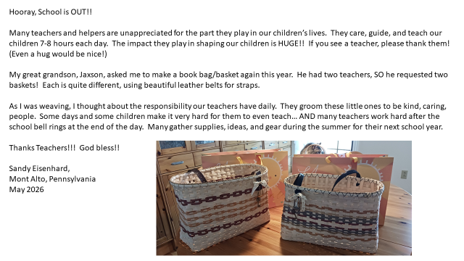

Weavers help weavers!
While on vacation last week in Myrtle Beach, I realized that I hadn’t brought all of the reed I needed to do some small baskets by the pool in the evenings. I just needed 8 of 21” pieces of #1 round to twine around small wood bases. I took a long shot, posted the need on a Basketweaver’s FB page and immediately someone only 2 miles from me offered up the reed. I went to her house, we chatted for a bit, she showed me some of her baskets, we saw how much we have in common, and I have made a new friend in my vacation town. 
This made me think about how some often seem to be in a basket skills competition with each other, worry about copyrights, making money, and being the best. We were just two strangers sharing our love of basket weaving, sharing stories, (and reed), making friends we may never see again, all because of my forgetfulness and her kindness.
As we say, “It’s a hobby, not a job”, so enjoy your hobby.

SUBMITTED BY DEBI HERBERT

*****************************************************************

North Central Basket Guild.
We just wanted to show some baskets we have worked on past few months. Elaine Sinclair taught us the following baskets. We did a spring basket with flowers in May. A patriot basket in June. For July we will use sea grass to make a lovely basket and it will be taught by Pat Gray.
We hope you all are enjoying your summer. Happy to celebrate America's 250 yrs this year.
Got a clean joke for ya.
What do you call a French man wearing sandals?
Phillippe Philloppe.

May God bless you all!

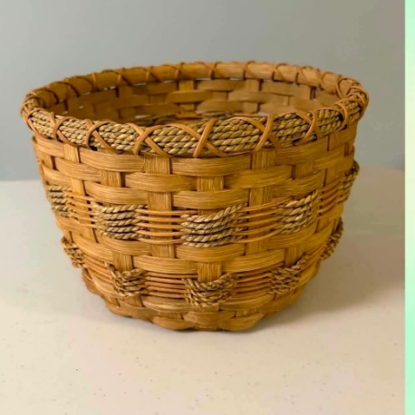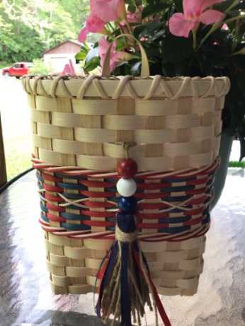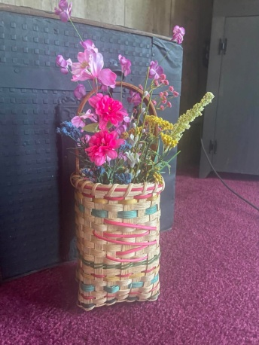

SUBMITTED BY SHERRI MORAN

The Western Weavers are very happy to announce that we have 5 brand new weavers who have joined us over the last few months and they are doing great and learning a lot.
Over the last few months we have painted bases and built our basket on them and made oui jars at our Guild meetings. (Below are just a few of our pictures.)
We meet once a month on the fourth Tuesday of the month from noon to 3 PM at the Barboursville Public Library. If you are going to be in our area give us a call and come and join us. We always welcome new members and guests.
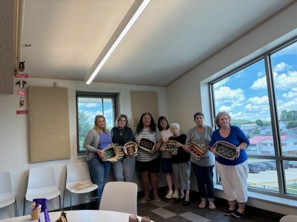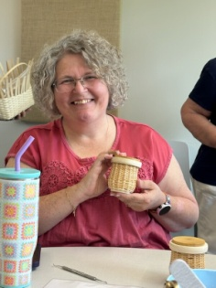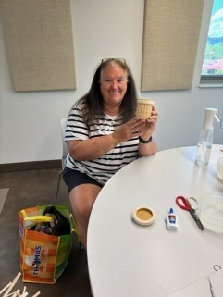
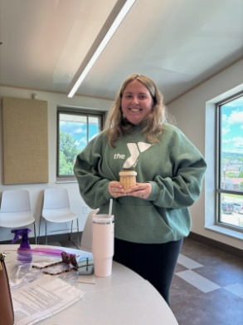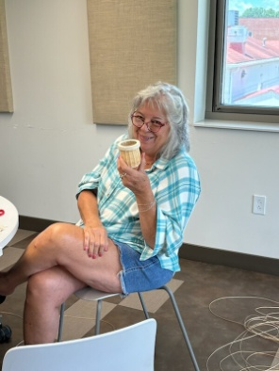

SUBMITTED BY NANCY SEALEY
***********************************************************************************

NEWSLETTER/WEB SITE/MEMBERSHIP
Thanks to everyone who submitted info for this newsletter. Everyone did a great job of sending info for this newsletter. If I happened to miss anyone’s submission, I am so sorry. Please resubmit and I will put it in the next one.
Without your input we cannot have a newsletter.
Our next newsletter will come out in October 2026. If you have input prior to that, please email to me at any time but make sure to mark WVBA Newsletter in the subject line.
Please keep in touch in you have an address, phone number or email change so we can keep our membership/newsletter list current.
Membership dues are due for 2026.
Thanks to those who have sent theirs in.
Please check our web page for upcoming events. If your group sends that info to me, I will have it posted.
www.wvbasketmakersassociation.com
Thanks again for your info
Nancy Sealey
Nana276815@gmail.com

Answers to Basket Word Scramble
(Sorry for any errors in this puzzle. They can be attributed to the editor.)

Shears
2. Weave
3. Basket
4. Cut
5. Nantucket
6. Packer
7. Twine
8. Step up
9. Market
10. Base
11. Lash
12. Tuck
13. Picnic
14. Reed
15. Ribbed
16. Traditional
17. Continuous
18. Egg
19. Coiling
20. Rim
21. Twining jj
22. Chase weave
23. Handle
24. Gretchen
25. Wood
26. Plaiting
27. Twill
28. Stakes
29. Spokes
30. Weavers

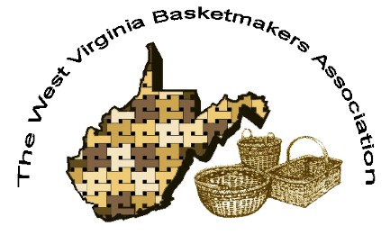
WVBA Membership
January 2, 2026 – December 31, 2026
(Please print)
Name_______________________________________
Address _____________________________________
City ___________________________ State ____ Zip+4 __________
Phone _________________________ E-mail_____________________________________
____I am a member of a West Virginia guild.
(Name of Guild) _____________________________________________________________
____ I am NOT a member of a West Virginia guild.
Basketry Business Name ______________________________________________________
(A business that sells basket supplies, basketry related items, or baskets)
____ I have joined as a teacher/business member and I would like my basketry business listed in the annual membership booklet.
Basketry Business Phone # _____________________________________________________
Basketry Business Web Site ____________________________________________________
New Member ___ Renewal ____
Are you a basketry teacher? ___ yes ___ no
Are you a vendor? ___ yes ___ no
Membership is for: (Please check those that apply.)
__ Individual membership $20.00. for 2026 Dues.
Entitles you to Newsletter, and receive Convention booklet.
__ Teacher/Business Membership $25.00. Entitles you to the same as individual membership, plus is mandatory to teach classes, vend, or participate in the Market Place at Convention.

Paying by __ Cash __ Check # _____ Please make checks payable to WVBA
Send check and application to :
Nancy Sealey
2768 Emmons Ave.
Huntington, WV 25702

