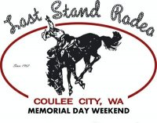
MUTTON BUSTIN’ COMPETITION 2019
Friday, May 24th
7:00 pm

Rules and Regulations:

- All children must be between the ages of 3yrs & 8yrs and weigh no more than 60 lbs. Weigh-in is required at check-in! NO EXCEPTIONS!
- A parental consent form must be signed at the time of competition. (See attached.)
- **An entry fee of $20.00 must be paid by Friday, May 24th. Price of the entry fee includes admission to the Bull-a-Rama for the participant only and a mutton bustin’ t-shirt.
- Helmets must be worn by all contestants and will NOT be provided. (Bicycle helmets are acceptable.)
- There will be two groups of competitors: a group of 3-5 yr olds and a group of 6-8 year olds.
- Forty (40) spots will be filled on a first come first serve basis.
- Scoring Procedures: Contestants must ride their sheep for 6-seconds in order to receive a score from the judge(s). Scoring is based on a 100-point scale – with 50 points possible for the rider and 50 points possible for the sheep. If the rider falls off before 6 seconds, no score is given.
- Prizes will be awarded to the highest score in each age group (3-5yrs and 6-8yrs). In the event of a tie, each contestant will ride an additional sheep to determine the winner.
- Contestants must report to the Rodeo Grounds no later than 6:30 pm on Friday, May 24th.
10. Each contestant will receive a wristband, upon check-in, on Friday night, however, parents will need to enter through the front gate and purchase a ticket.

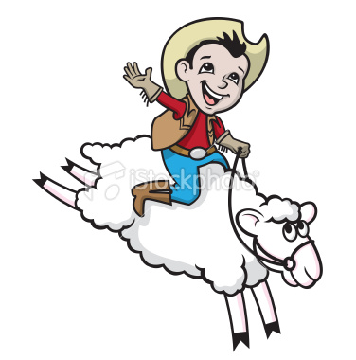
**Absolutely no late entries!!! At 7:00pm or whenever the first sheep has been ridden, WHICHEVER COMES FIRST, we will no longer be accepting riders!!!

Each mutton buster is invited to participate in the Coulee City Parade as part of the Mutton Bustin’/Last Stand Rodeo Association group on Saturday, May25th at 11:00 am. We will meet at the Parade check-in tent near the Coulee City Medical clinic, no later than 10:30 am on Saturday morning. Be sure to wear your mutton bustin’ t-shirt! ☺

