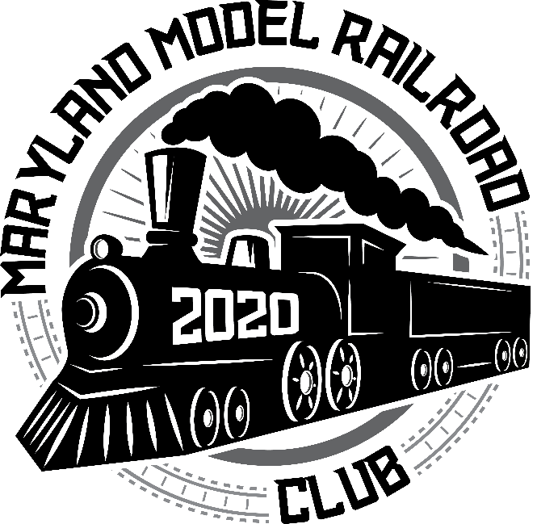
TRAIN SHOW
SATURDAY, DECEMBER 11,2021
9AM to 2PM ADMISSION $5.00
KNIGTHS OF COLUMBUS
BOSWELL HALL
BOWIE, MARYLAND
MARYLAND MODEL TRAIN CLUB
Need Tables? Write ChessieTrain@comcast.net and join the fun.

