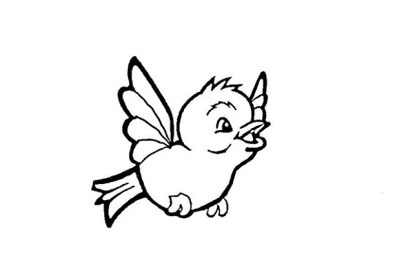
Our Lady of Pity
Pre-School CIC
Rigby Drive, Greasby, CH49 1RE Tel: 0151 677 6813
management@ourladyofpitypreschool.co.uk
accounts@ourladyofpitypreschool.co.uk

Food hygiene
Policy statement
We provide and/or serve food for children on the following basis:
- Snacks.
- Packed lunches.
We maintain the highest possible food hygiene standards with regard to the purchase, storage, preparation and serving of food.
We are registered as a food provider with the local authority Environmental Health Department.
Procedures
- All our staff who are involved in the preparation and handling of food have received training in food hygiene.
- The Lead Assistant carries out daily checks on the kitchen to ensure standards are met consistently.
- We use reliable suppliers for the food we purchase.
- Food is stored at correct temperatures and is checked to ensure it is in-date and not subject to contamination by pests, rodents or mould.
- Packed lunches are stored in a cool place; un-refrigerated food is served to children within 4 hours of preparation at home. Parents are advised to provide a cool block in childrens lunch boxes.
- Food preparation areas are cleaned before and after use.
- All surfaces are clean and non-porous.
- All utensils, crockery etc. are clean and stored appropriately.
- Waste food is disposed of daily.
- Cleaning materials and other dangerous materials are stored out of children's reach.
- Children do not have unsupervised access to the kitchen.
- When children take part in cooking activities, they:
- are supervised at all times;
- understand the importance of hand-washing and simple hygiene rules;
- are kept away from hot surfaces and hot water; and
- do not have unsupervised access to electrical equipment, such as blenders etc.
Reporting of food poisoning
Food poisoning can occur for a number of reasons; not all cases of sickness or diarrhoea are as a result of food poisoning and not all cases of sickness or diarrhoea are reportable.
- Where children and/or adults have been diagnosed by a GP or hospital doctor to be suffering from food poisoning and where it seems possible that the source of the outbreak is within our setting, the manager will contact the Environmental Health Department to report the outbreak and will comply with any investigation.
We notify Ofsted as soon as reasonably practicable of any confirmed cases of food poisoning affecting two or more children looked after on the premises, and always within 14 days of the incident

